**Procedure:**  
**1. Open engine hood. Remove fasteners/rivets from lock carrier cover by pressing the center stud into the rivet, then pulling it out. There are a total of eight (8) rivets. Pull the lock carrer cover off.**  
  
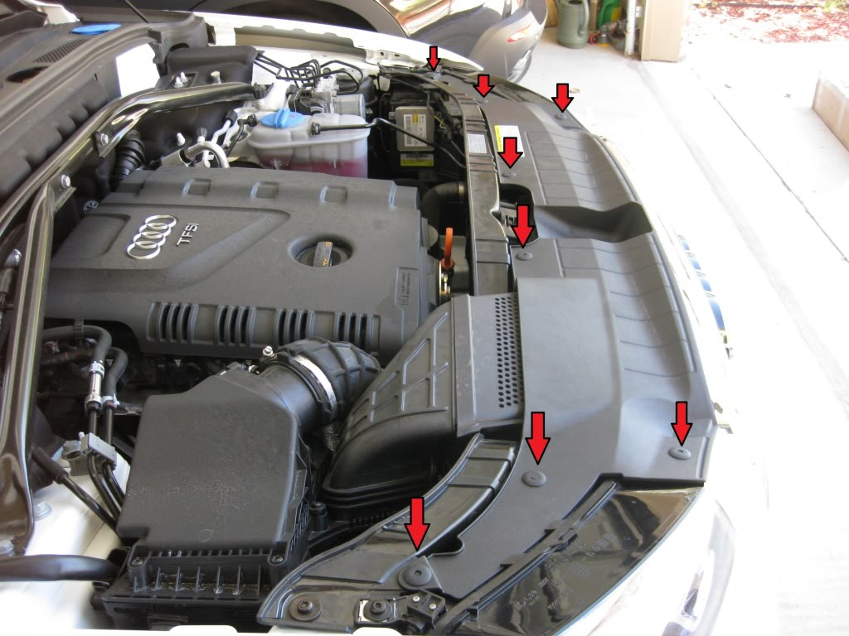  
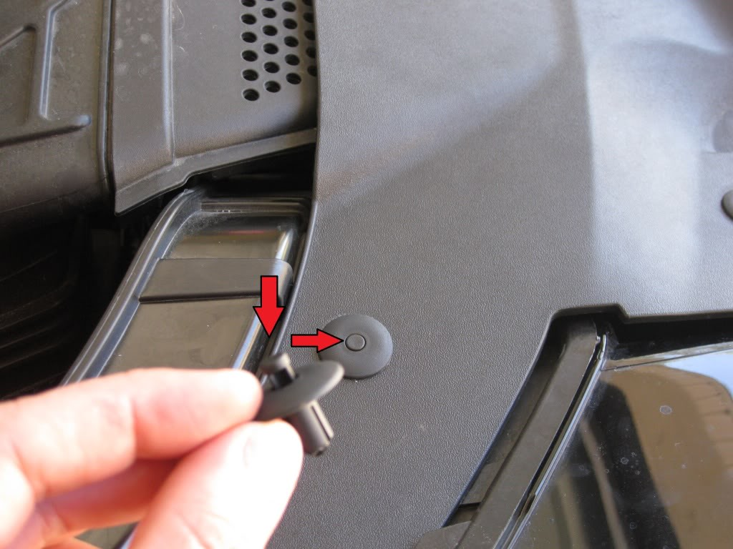

**2. Remove the two (2) torx screws shown below.**

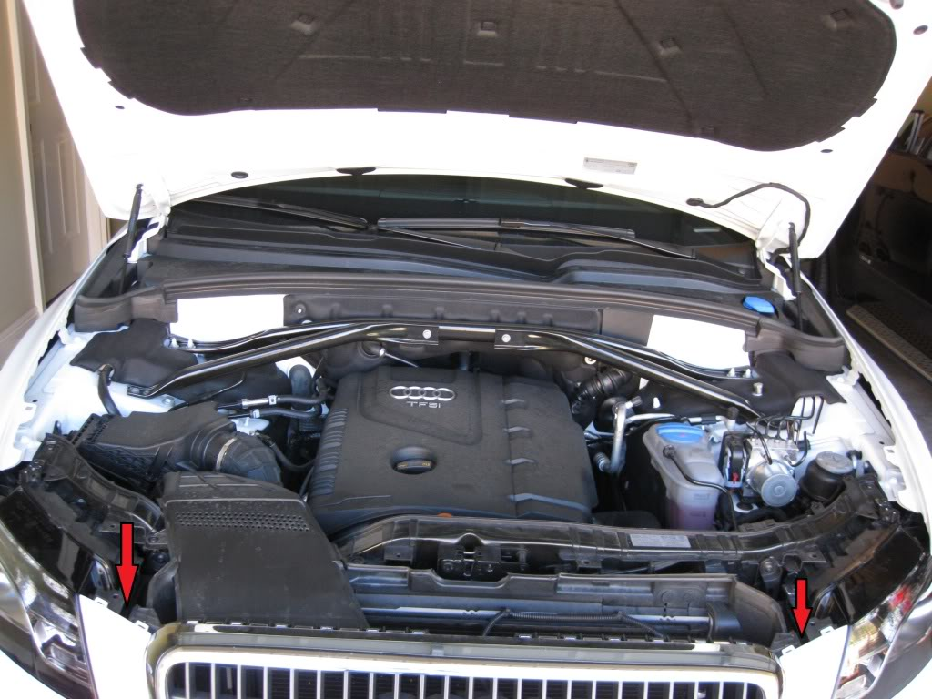

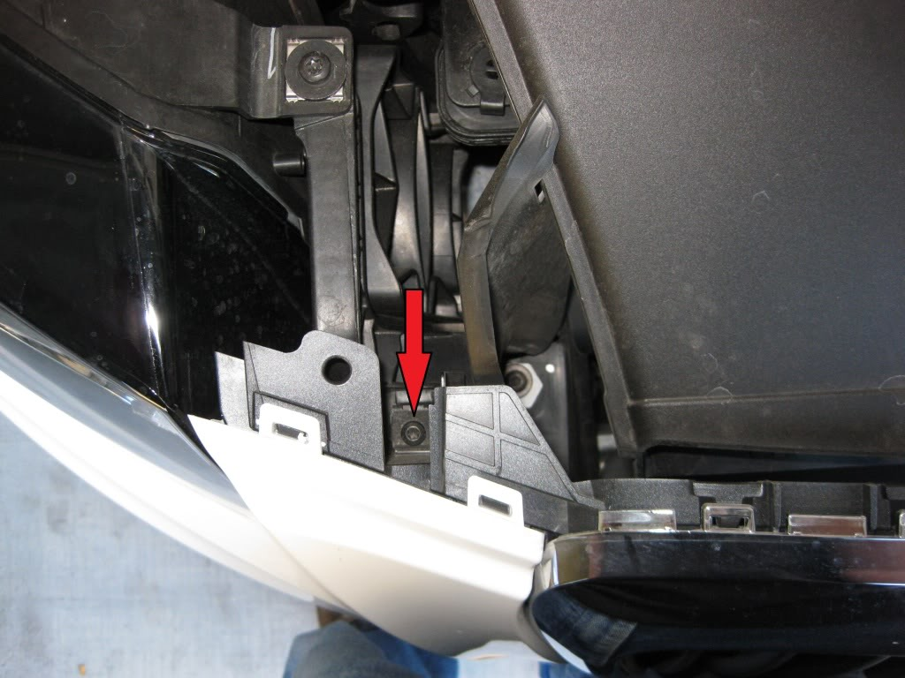  
  
  
**3. Remove approximately fourteen (14) torx screws from the bottom closure plate at the shown locations.**  
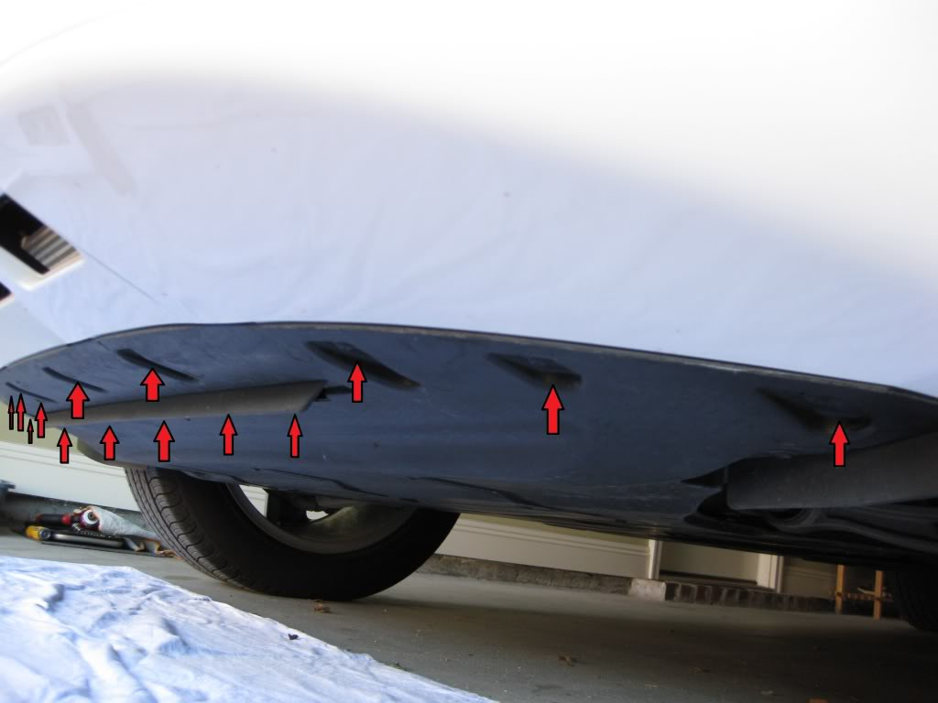

**4. Remove six (6) fastener screws (3 on each side) from the bottom closure plate (not pictured). Allow the bottom closure plate to flip down.**  
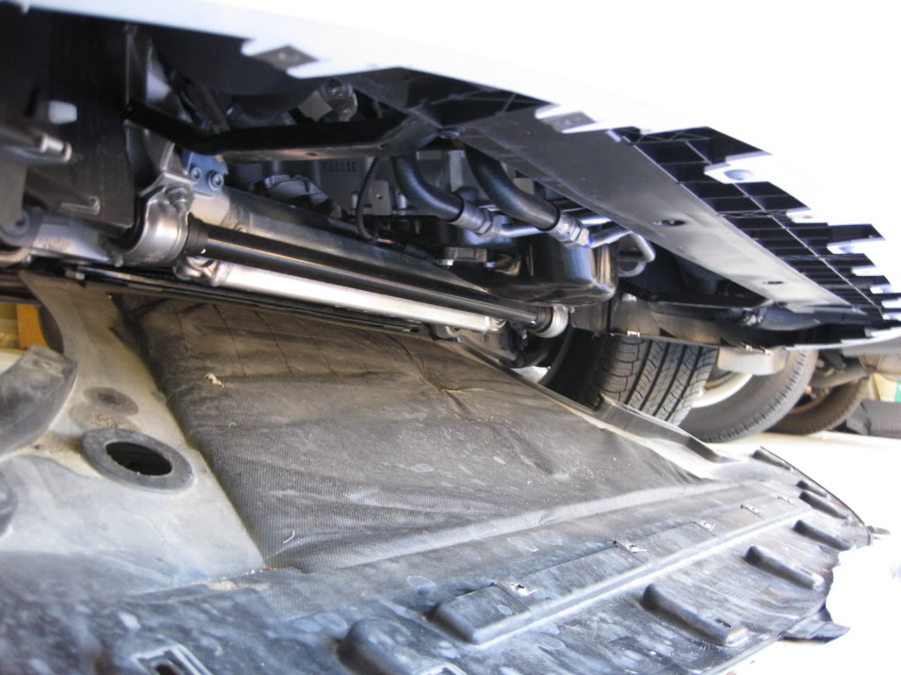  
  
**5. After flipping down the bottom closure plate, remove four (4) more torx screws at the shown locations.**  
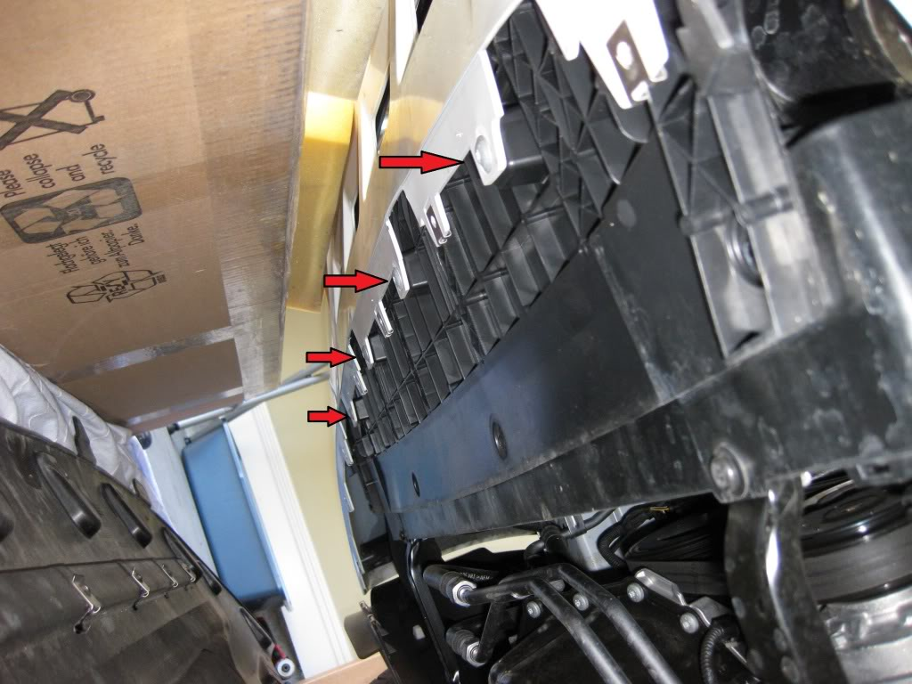  
  
**6. On each side of the front wheel well, remove three (3) torx screws (total of six (6) both sides) shown at the following locations.**  
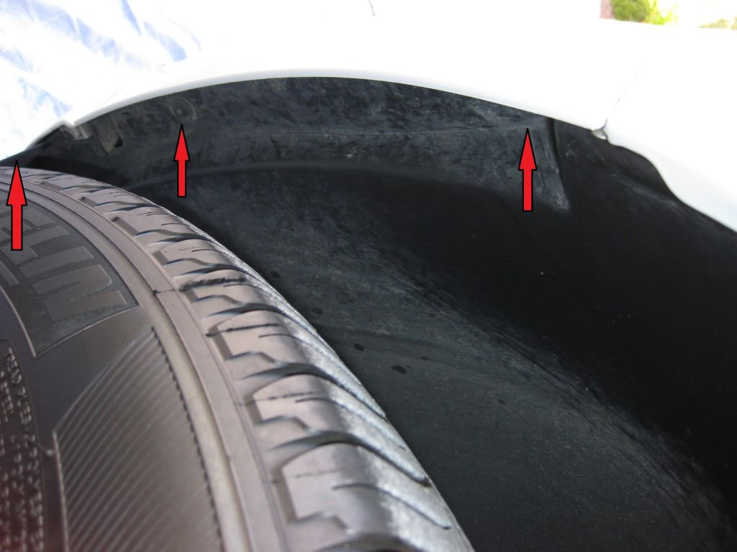  
  
**8. Pull back the wheel well liner and disconnect the fog light connectors. (not pictured).**

**9. Carefully pull off the bumper towards the front of the vehicle. Tab locations are shown below.**  
