Method – ELSE
For schools where children teach themselves

Sugata Mitra
School 0f Education, Communication and Language Sciences
Newcastle University
United Kingdom

May 2010

The Hole in the Wall (referred to as HiW in the rest of this article) experiments were first implemented in 1999, when a computer with an internet connection was embedded into a wall, for children to discover and use unsupervised. The wall adjoined a slum; and only a month later, it was evident that the children had taught themselves to use the computer and also picked up some skills in English and Mathematics. This kind of design was then set up in more and more remote areas across India with almost identical results. These were computers embedded in walls or kiosks in easily accessible and hightly visible public spaces, facilitating peer interaction, discovery and learning in groups of children.

We concluded that groups of children from disadvantaged and remote settings can learn to use computers and access internet resources, on their own, if given appropriate free, public and unsupervised access.

These earliest experiences also showed that children could develop some skills in English and Mathematics. What came through unequivocally in this and further work on self organizing systems in education was that groups of children, irrespective of who or where they are, or what language they speak in; given free and public access to computers and the Internet can:

- Become computer literate on their own, that is, they can learn to use computers and the Internet for most of the tasks done by lay users.
- Teach themselves enough English to use email, chat and search engines.
- Learn to search the Internet for answers to questions in a few months time.
- Improve their English pronunciation on their own.
- Improve their mathematics and science scores in school.
- Answer examination questions several years ahead of time.
- Change their social interaction skills and value systems.
- Form independent opinions and detect indoctrination.

We then went on to show that the quality of traditional schooling reduces with a clear decline in performance, running concurrent with the geographical remoteness of schools from the urban centre of New Delhi. A similar decline is also visible in the UK as one goes to more economically disadvantaged areas. The reasons for this have been attributed to the lack of and unwillingness of teachers to work in these areas.

Finally, we found that the presence of a ‘friendly, but not knowledgeable, mediator’ can enable children to reach similar levels of learning as in formal advantaged schools with trained teachers. We went on to set up a ‘cloud’ of ‘eMediators’, mostly retired school teachers with broadband access from their homes. Schools can access this ‘cloud’ over Skype and children can interact with the mediators over free video conferencing.

Interestingly, in the hands of good teachers, these methods can be powerful motivators for children, resulting in better performance. What started out as a solution for remote areas turned out to have universal applicability.

Both HiW and the work done later are based on the concept of Minimally Invasive Education [MIE], a pedagogic method that motivates groups of children to learn in an environment with little or no intervention from teachers or other adults and formed the basis of the design of the ‘HiW’ computers.

In what follows, we have described what a school might do in order to use ‘Method ELSE’.
A Handbook for school administrators

This handbook outlines the technical and pedagogical methods discovered through experiments conducted since 1999. These methods have evolved through the unsupervised access experiments called ‘hole in the wall’ and subsequent development of Self Organised Learning Environments (SOLEs) and remote mediation over the Internet forming Self Organised Mediation Environments (SOMEs). These techniques and facilities can be constructed in any school and will result in significant improvement in children’s learning and examination performance. We will refer to this as ‘Method ELSE’, short for ‘Methods for Emergent Learning Systems in Education’.

Principles

The basic theory of this method is derived from Physics. The following excerpts from Wikipedia may be useful for understanding the concept:

“Self-organization is a process of attraction and repulsion in which the internal organization of a system, normally an open system, increases in complexity without being guided or managed by an outside source. Self-organizing systems typically (but not always) display emergent properties.”

Some definitions may further clarify these concepts:

Self Organising Systems: A self-organising system is one where the system structure appears without explicit intervention from outside the system.

Critically interacting components self-organise to form potentially evolving structures exhibiting a hierarchy of emergent systems properties.

Emergence: The appearance of a property not previously observed as a functional characteristic of the system.

The author’s work were the first attempts at applying these principles to primary education in the connected environments of the 21st century.

In what follows, we have described a step-by-step process that can be followed by school administrators to implement Method ELSE.

If you are designing a school or are in charge of improving the quality of education in a school, you would take the following steps.

Step 1: Set up a SOLE

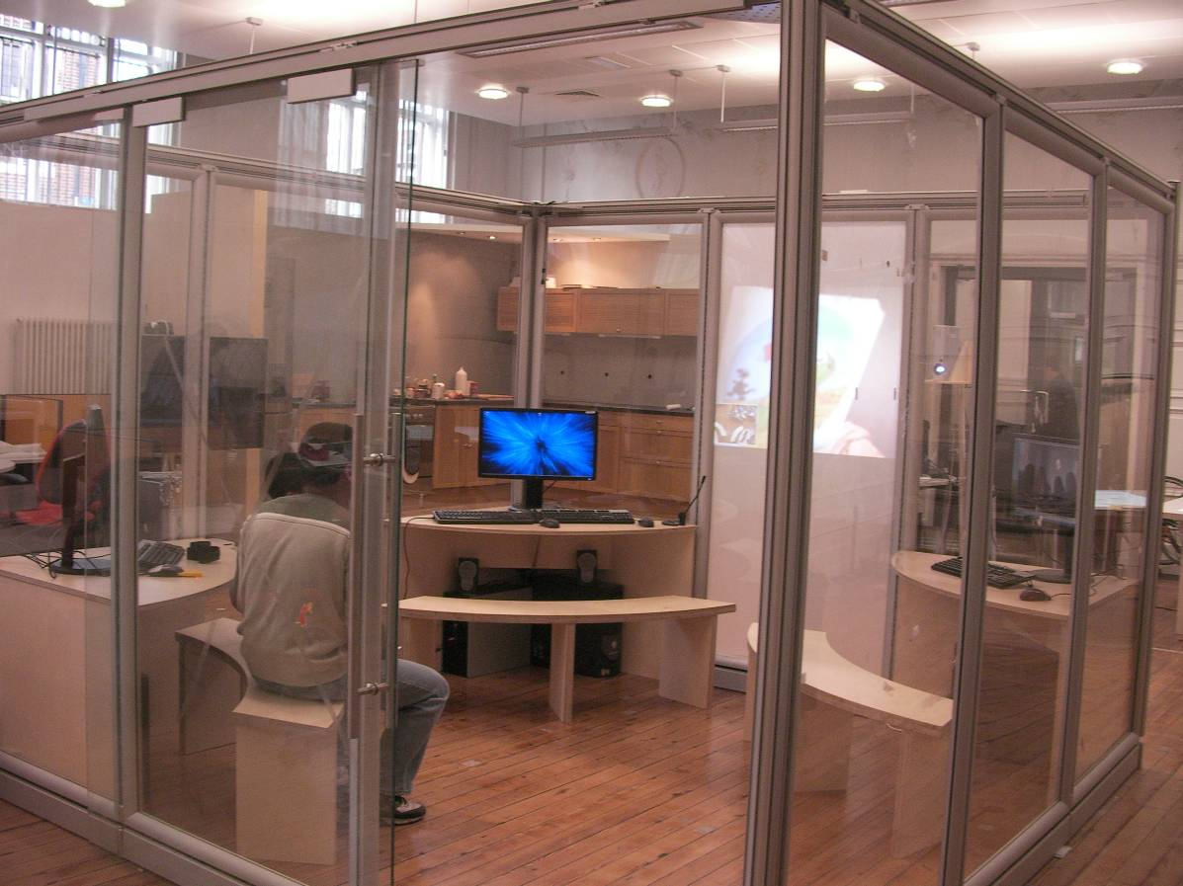
Example of a SOLE for 12-15 children

- Identify a location in the school, typically a room, that is highly visible to passing adults, for example, the principle of the school, the teachers, parents coming to pick up children, other children.
- Create glass walls for the room such that the entire area is visible. Put in bright CFL lighting and paint the walls in light, cheerful colours. The flooring should be easy to clean and dust free.
- Design furniture that enables groups of 6-12 year old children (usually 4 to 6 in a group) to interact with a computer without over crowding.
- About 6 items of furniture will enable a class of 24-30 children to use the facility.
- Design the furniture such that there are no sharp edges anywhere. All furniture should be easy to clean and, preferably, washable.
- Purchase desktop computers, one for each group of 4-6 children. The computers should have fast processors, a large (at least 19 inch) LCD monitor, speakers, wireless keyboards and wireless mouse. Fix the speakers securely.
- Place the CPU of each computer in a safe place under the tables. The power switches of the computer and the connecting cables for power, monitor etc. should not be accessible to the children. Place monitors on a stand such that they are raised, at least 12 inches over the surface of the table. This will ensure that the monitors are clearly visible from the outside when children are using them and are not blocked from view by their heads or bodies.
- Ensure that all the computers have broadband Internet access at speeds of 2Mbps or more if possible. Do not use firewalls, unless unavoidable. Wireless broadband is recommended.
- All electrical wiring and outlets should be concealed but easily accessible when required. It should not be necessary to crawl under tables to access connections.
- Install any freeware, such as Open Office, for the children to work with. Software for painting, such as MS Paint or Adobe Photoshop or equivalent freeware is a must.
- One of the computers in the SOLE should have a web cameral and microphone installed. The camera should be permanently mounted such that it enables a full view of the SOLE. A camera with pan and tilt facilities and a built in microphone is recommended (for example, the Logitech Sphere camera). A person accessing the SOLE over, for example, Skype, should be able to see most of the children if they gather around the computer with the camera.
- Install adequate and appropriate power conditioning and back up. An UPS is recommended in areas where electricity supply is not reliable. A generator, or solar panels and batteries should be used in areas that have no electricity.
- Keep a small table and chair in the SOLE for an attendant.
- Check to see that all monitors are clearly visible from outside the SOLE.
- The SOLE would typically be set up by a vendor who would also provide a technical person for attending to any problems. This person should be capable of attending to electrical, electronic, software and connectivity problems.

Step 2: Management of the SOLE

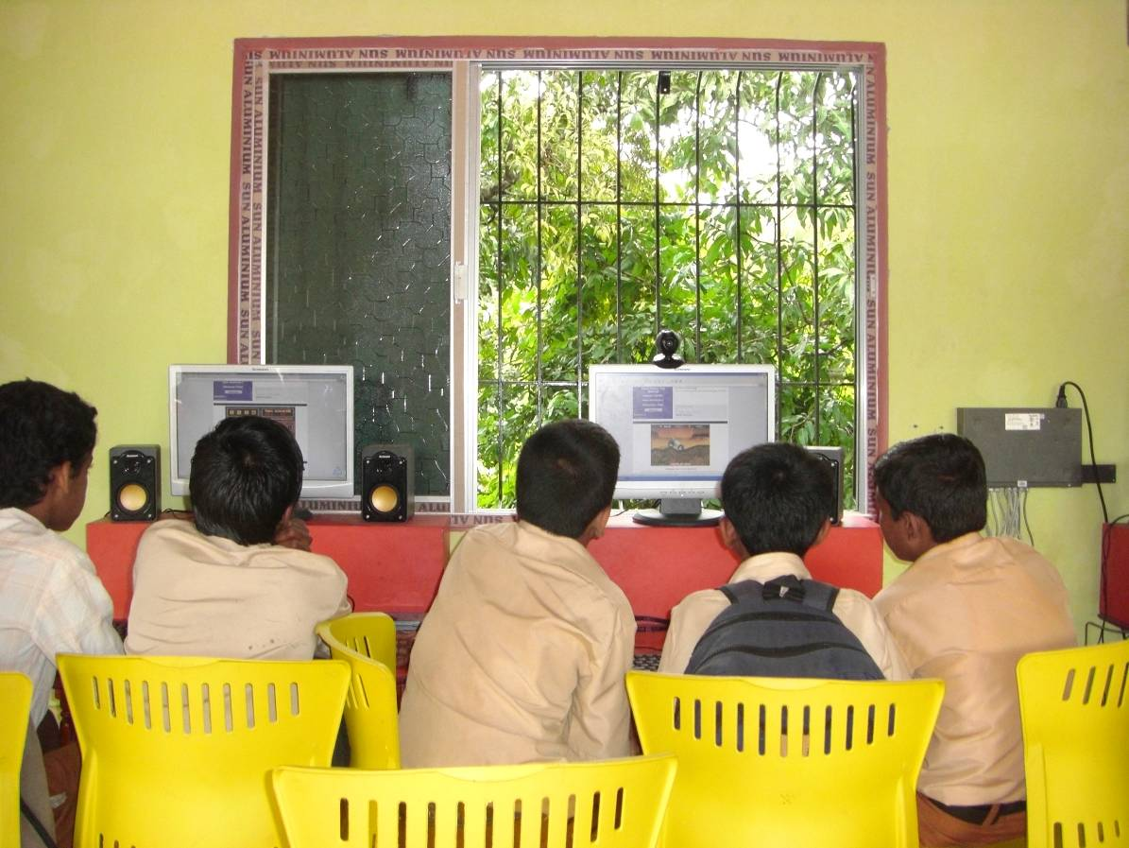
A SOLE in use

- At least one teacher should be trained in applying self organizing systems concepts in children’s education. They should understand the principles and should have practiced using them. You can contact the author at Sugata.mitra@newcastle.ac.uk or Sugata.mitra@gmail.com for guidance on how to train the teacher(s).
- There should be one attendant at the SOLE at all times. The attendant is best described as a ‘friendly but not knowledgeable’ mediator. An ideal attendant would be an educated grandmother in her 50’s or early 60’s. The attendant would ensure that children are safe, resolve disagreements, call for help when required and, in general, keep an eye on things, particularly when no teacher is present. The attendant will not teach, suggest or direct the children’s activities in any way. However, she (or he) will intervene in the unlikely event of inappropriate material being accessed by the children. The key role of the attendant is to admire children’s learning and encourage them to go further.
- The SOLE should be open for use about one hour before school and up to two or more hours after school hours. It should, preferably, be available on weekends and holidays as well. No adult should be allowed to use the SOLE unless there are, at least, 4 children present. Any adult using the SOLE will need to take permission from the children and the attendant before using the facility and their times of usage and identity should be recorded. The SOLE is predominantly for use by children from the school, that is, aged 5-17 years. The chief users should be between 6 and 12 years old. The keys to the SOLE should be with the attendant and (s)he should know how to switch everything on and off.

Step3: Using the SOLE

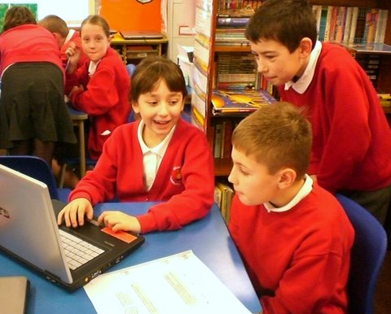
Collaborative discoveries in SOLEs

- Timetabled usage: Each class should have at least one session of about 90 minutes in the SOLE, timetabled every week. During this time, a teacher will engage the children with a question that they need to answer using the SOLE. Examples of questions could be ‘who built the pyramids and why?’, ‘what are fractals?’, ‘what are they looking for with the Large Hadron Collider in CERN, Geneva?’, ‘who is Gandhi and what did he do?’, ‘Where is Botswana and what is it famous for?’ etc. For each session, the children would make groups of around 4 each, of their own choice. Children are allowed to change groups, talk to each other, talk to other groups and walk around looking at other’s work. There are very few rules. The teachers role is minimal and (s)he should stay out of the children’s way. Since an attendant is present, (s)he can leave the SOLE if desired. About 30 minutes before the end of the session, the groups should produce a one-page report where they describe what they have found. The teacher can then expand on this in a later class. Use this method for 8-12 year olds.
- Curricular usage: These are similar to the above except that the driving question is one from the school leaving examination (for example, CBSE in India or GCSE/SAT in the UK). If this is done regularly with children of 12-15, there will be improvements in their examination results. Children seem to enjoy attempting these questions on their own, preferably in the absence of the teacher, and they seem to retain the answers very well.
- Aspirational usage: In these sessions, children listen to a short lecture from an interesting site on the Internet, for example, TED talks. They then research the talk in groups and present their findings. If they listen to interesting people on a regular basis, there is evidence that there are positive effects on their aspirations and general knowledge.
- Free usage: The SOLE should be open to use by any child in the school outside of school hours. It should be made clear to them that they can use this time to play games, chat or do whatever they want to. As usual, working in groups is to be encouraged strongly.
- Remotely mediated sessions: During these times, the SOLE is used for connecting to ‘eMediators’. This can have a strong and positive impact on culture and English if used correctly. This is described below.

Step 4: Remote Mediation

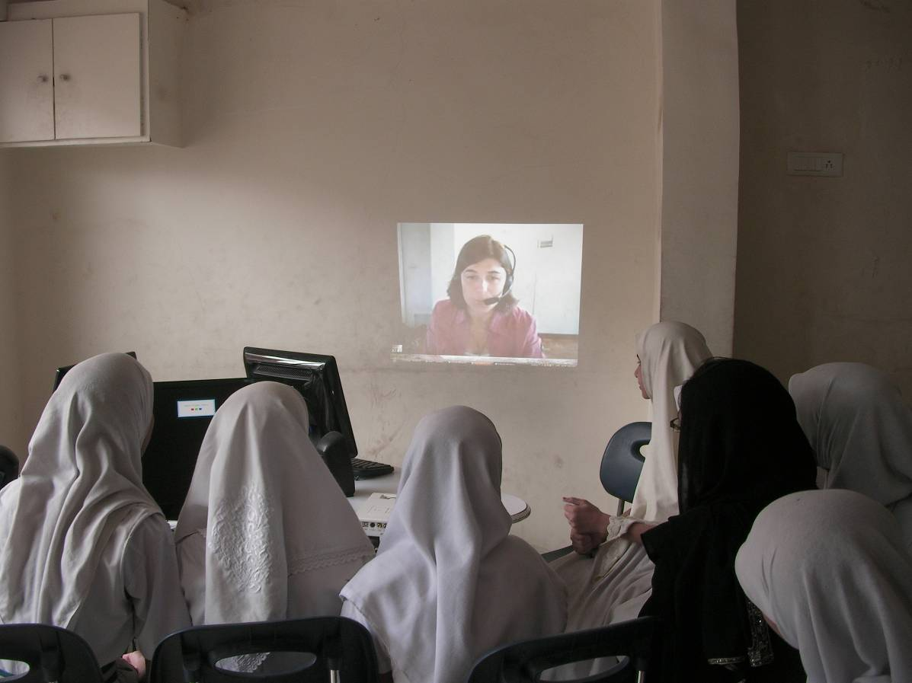
Children interacting with a remote mediator

Experimental results show that children working in groups and left to themselves to use the Internet can quickly and effectively attain educational objectives. However, there are limits to their understanding and performance. If they are encouraged by a friendly but not knowledgeable mediator, they are able to reach levels of ‘taught’ children in good schools. Such mediation is possible at a distance.

- Connect to a ‘cloud’ of eMediators. These are usually experienced teachers willing to provide an hour or more of their time conducting sessions in SOLEs. They form a Self Organised Mediation Environment (SOME). The technology used is Skype video conferencing. To understand how this works see www.solesandsomes.wikispaces.com.
- To organize sessions using this method, you should, at this time (May, 2010) contact suneeta.kulkarni@gmail.com and she will inform you of the current status and help you timetable sessions.
- Once a SOME session is scheduled, connect to Skype using the computer with the web camera and dial your eMediator, who should be online at that time. It is a good idea to teach the children and the attendant to do this.
- Once a video connection is set up, the remote mediator will take over and conduct the session.
- Use this method for very young children 5-7 year old. The mediators read out stories to the children and the ensuing conversation will improve their English as well as their social skills. Basic English literacy is absolutely essential for Method ELSE to work.
- SOME sessions can also be used for older children to interact with experienced teachers for subject related queries or difficulties.
- SOME sessions work better if the image of the mediator is projected in life size on a wall of the SOLE. However, this can be expensive as it would require a projector. Otherwise, the mediator’s image on a clearly visible monitor will do, particularly if the ‘full screen’ mode is used on Skype.
- Clear audio is absolutely essential, as is a noise free environment so that the mediator can hear the children clearly.
- It would help considerably if the children wear a name badge in large letters on their dress, so that the mediator can read their names.
- It is necessary to connect exactly on time and to let a mediator know well in advance, if you cannot connect at a scheduled session. Otherwise they will lose interest in your school.

Practitioner Observations

This part is written by Emma Crawley, St. Aidan’s Church of England School, Gateshead, UK. Emma is an experienced practitioner of Method ELSE
June 2010

- Valuable time for you to observe the class dynamics
- You may be surprised by groups chosen and the roles taken by individual children within each group
- Children fall into a natural role easily without role being given
- There is no pressure for the children to perform as individuals which gives children confidence to ask questions and follow their own curiosity
- Children discuss ideas, make connections and extend their knowledge to new areas
- Children can give reasons for group choices, movements between groups and improvements which can be made to the way they work

Developments with frequency of use

- Children begin to question their attitude towards others and their peers’ perception of them which improves group performance
- They start to find key words in a question or topic rather than type in a whole question
- They begin to skim texts to find specific information, refining searches and choosing key words
- The children automatically check other sites to make sure information is correct
- They begin to share notes they have gathered more freely, recognizing a common goal
- They begin to follow leads which interest them and become more curious to find out more
- Discussing the children’s notes and extending their understanding through questioning at the end of each session deepens the children’s understanding and allows the teacher to stretch the learning further
- The children begin to freely offer ideas as to where they would like their learning to lead them

Impact on Other Areas of Learning

- The children begin to apply research skills independently to work at home, in other lessons or wherever the internet is available.
- As a practitioner, you may choose to apply the group method to other areas of the curriculum and question your reasons for choosing partnerships or groups within the class yourself
- The children become fast and efficient at producing detailed reports on topics and become familiar with text organization and the inclusion of pictures, photographs and diagrams
- You will see an improvement in the quality of class cohesion as team work develops
- The relationship between the teacher and children becomes stronger as the children have the confidence to ask questions, discuss current affairs and suggest areas of learning which they know will be welcomed, discussed and shared

What to expect

- Be patient, you will have to hand control over to the children for their own learning, trust them
- At first they will get excited and move around a lot because it’s a novelty, this will become less chaotic the more the method is used
- Noise levels will rise and fall but the children need to talk and discuss what they find
- There is generally a calm, relaxed atmosphere in the classroom
- Take the opportunity to observe the group dynamics, make notes but try not to get involved
- If the children begin to argue or complain about others, hand the control straight back to them by reminding them of the group rules
- Never stop a session because the children seem distracted or removed from the learning, this is not the case. The children become more relaxed and quicker at research but this is due to experience of the method and not complacency.

Finally!

Method ELSE using these steps will help you to set up, manage and use your SOLE for the benefit of the children of your school.

Schools using SOLEs have distinct advantages over ones that don’t and this can be used for purposes of advertising your schools to parents, governments and the community.

