ARE THERE VIABLE CONNECTIONS BETWEEN MATHEMATICS, MATHEMATICAL PROOF AND DEMOCRACY?

D. F. Almeida
D.F.Almeida(at)ex.ac.uk
University of Exeter and Canterbury Christ Church University, UK

This paper is based on a plenary talk given by the author at the Association of Mathematics Education of South Africa (AMESA) in March 2010

“The curriculum is at the heart of the education and training system. In the past the curriculum has perpetuated race, class gender and ethnic division and has emphasized separateness, rather than common citizenship and nationhood. It is therefore imperative that the curriculum be restructured to reflect the values and principles of our new democratic society.” (Foundation Phase Policy Document, 1997, p1 )

Introduction
This paper aims to answer three interconnected questions.
- What is mathematics and mathematics education in the context of South Africa? And what implicit connections are there between mathematics education and democracy?
- What is democracy?
- Can the school curriculum be engineered so as to make mathematics a tool of democratisation?

The questions ‘What implicit connections are there between mathematics education and democracy?’ and ‘Can the school curriculum be engineered so as to make mathematics a tool of democratisation?’ have been interrogated by leading mathematics educators such as Skovsmose (1990), Ernest (2000) and D’Ambrosio (undated) in the recent past. These two questions, save for an explicit reference to mathematical proof, are also explicitly present in the South African secondary school mathematics National Curriculum policy statements (National Curriculum Statement, 2003; Revised National Curriculum Statement ,undated) .
The second question – ‘What is democracy? - has been asked countless times since the coining of the term by the ancient Greeks. Democracy has been continuously yearned for by peoples under the yoke of oppression. The word ‘democracy’ occurs five times and the word ‘democratic’ occurs ten times in the South African Revised National Curriculum Statement Grades R-9 (Schools) (Revised National Curriculum Statement, undated). So it appears that the second question does not need asking in South Africa as the concept of democracy has vibrant currency. Nevertheless it is pertinent to ask if the concept of democracy has been understood and applied in a mass participative sense both in South Africa and elsewhere in the world. This is especially so as it has not been that long since democratic rights have been afforded to the majority of the peoples in Africa and elsewhere.

To underline the need for such a discussion there is anecdotal evidence that the founders of the concept of democracy in ancient Greece asked themselves the question “Who should have democratic rights?” and appeared to answer it as follows “The rich and powerful should have these rights but certainly not the slaves?”. The history and evolution of democracy evidences many strata of people - women, those without property, black people, etc- disenfranchised and not afforded democratic rights. From a personal perspective I recall that in the late 1970’s and early 1980’s when the anti-racist movement in the UK was at its height middle ranking police officers would materialise seemingly out of nowhere in peaceful demonstrations, home in on selected individuals, and in no uncertain terms and under threat of deportation, warn them to desist from this democratic right to protest.

Additionally I argue that democratic rights are to be endowed not only on individual human beings but also on individual nation states in the wider arena of the global parliament. We are a long way from that as this report indicates:

“Governments, whether elected or not, without reference to their own citizens let alone those of other nations, assert their right to draw lines across the global commons and decide who gets what” (Monbiot, 2009)

This is not a description of the colonial nations carving up Africa, Asia and America for themselves in the manner of the treaty of Tordesillas but a commentary by George Monbiot of the UK Guardian newspaper on 19 December, 2009 of the behaviour of the developed nations at the recent Copenhagen summit on the global environment who proposed and insisted on solutions that were beneficial to them but not to the developing nations.

If all of this seems too political then I seek refuge in the position taken in the South African education policy statement

“Mathematics is .... a purposeful activity in the context of social, political and economic goals and constraints. It is not value-free or culturally-neutral.” (Revised National Curriculum Statement, undated, p 21 ):

For the record this paper is a development of an article constructed by my colleague Jose Maria Chamoso and myself (Almeida and Chamoso, 2001) on possible connections between mathematics teaching and learning and democracy. That article stemmed from my brief involvement in an EEC Comenius Project on mathematics teaching and democratic education undertaken by mathematics teachers from four European countries and which was strictly restricted to the European arena. It is my contention that such zonal restrictions in discussing the nature and practice of democracy are misguided. I believe that one cannot talk about democracy if there is a focus only on a proportion of the constituency or of the planet. Furthermore the global nature of our existence on the planet suggests that a discussion on democratic themes in mathematics requires an international perspective and that this international perspective requires an acknowledgment and understanding of the colonial past with a view to future progress. This is epitomised by the quotation by Monbiot (2009) above and supported also by D’ Ambrosio (undated)

“It is an undeniable right of every human being to share in all the cultural and natural goods needed for material survival and intellectual enhancement. This is the essence of the United Nations’ Universal Declaration of Human Rights to which every nation is committed. The educational strand of this important profession on the rights of mankind is the World Declaration on Education for All (UNESCO 1990) to which 155 countries are committed. Of course, there are many difficulties in implementing United Nations resolutions and mechanisms. But as yet this is the best instrument available that may lead to a planetary civilization, with peace and dignity for all mankind. Regrettably, mathematics educators are generally unfamiliar with these documents. …..It is impossible to accept the exclusion of large sectors of the population of the world, both in developed and undeveloped nations. An explanation for this perverse concept of civilization asks for a deep reflection on colonialism. This is not to place blame on one or another, not an attempt to redo the past. Rather, to understand the past is a first step to move into the future.” (p237)

These words correspond strongly with the words of the 1996 constitution of the Republic of South Africa and which are reproduced in the section ‘The Constitution, Values, Nation building and the Curriculum’ of Revised National Curriculum Statement (undated)

“Heal the divisions of the past and establish a society based on democratic values, social justice and fundamental human rights” (p 7)

Now that I have claimed the importance on examining the concept and nature of democracy I will defer my discussion on this issue until a preliminary enquiry on what mathematics and mathematics education is in the context of schools and its potential in promoting an implicit sense of democratic culture. This is at odds with the implicit absolutist’s prescription for mathematical activity which insists on definitions first before the constructing mathematical knowledge but I posit that one can give a better definition of a concept by giving examples and non-examples.

What is mathematics and mathematics education in the context of South Africa? And what implicit connections are there between mathematics education and democracy?

By mathematics we mean, of course, school mathematics, which is a re-contextualised and re-formulated subset of academic mathematics and which consists largely of medieval developments (numbers, algebra, geometry). The principal aims of school curricula across the world appears to be two-fold: the inculcation of quantitative literacy to enable the learner to manage their future working lives and, then, the academic empowerment of those that want to further their mathematical or scientific education. We must accept that academic mathematics is principally about extending the boundaries of knowledge and/or solving practical problems from the scientific, military, and economy sectors. However there is a connection between school mathematics and academic mathematics that is relevant here. And this stems directly to a failed philosophical project in the academic domain that sought to establish mathematics as a self-coherent, self-justified and immutable body of knowledge - we see this from the work of Plato, the Hilbert programme, and the French led Bourbaki group. However this project was rent asunder in 1931 when the logician Godel proved that it was impossible for mathematics to prove its own consistency. The position that academic mathematicians (are forced to) adopt now of their discipline is that it involves mathematiziation: to mathematise is to search for and describe patterns, to generalise, to make predictions, to revise conjectures and to prove. That is, “mathematics is what mathematicians do” (Grunetti and Rogers, 2000). Saunders Mac Lane, one of the foremost pure mathematicians of the last three decades specifies that mathematiziation involves the flow of ‘intuition, trial, error, speculation, conjecture, proof’ (Mac Lane, 1994).

This process for the construction of mathematical knowledge is the connection between academic and school mathematics. For in classrooms across the UK one might find a flow diagram similar to the one below for investigations (Almeida, undated)

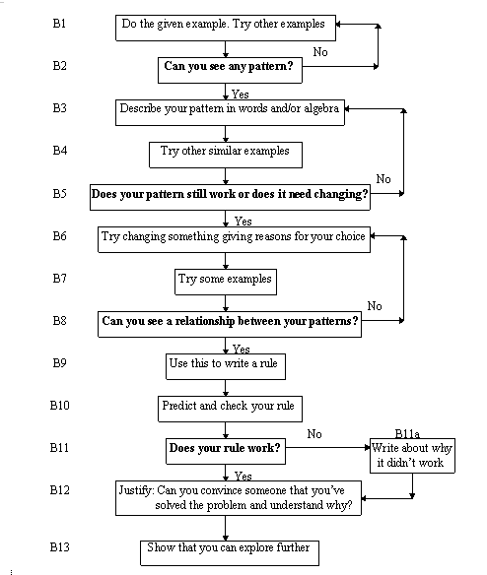

Of course academic mathematicians delve deeper, use more abstractions, and have greater formalities at the proof stage. However, besides the formalisms, there is undoubted the commonality in the flow:

Describe patterns > generalise > to make predictions > test predictions > revise conjectures > justify, explain, prove

The end point of this flow is important: mathematics is not just about identifying what is true or what works but also about explaining why it is true or why it works and convincing others that it is true and that it works. That is, mathematics is intrinsically about proof and the community acceptance that it is a convincing proof. It is worth repeating that doing mathematics, for both professional mathematicians and for school pupils, involves making generalisations and conjectures and then trying to justify and proving these in the sense of an explanation of the phenomena. Proof is a means of explaining and of convincing the community that a proposal about mathematics is true and getting their agreement after a period of interrogation of the proof argument. This has a democratic flavour.

A caution about proof activity in the classroom needs to be made at this point. In the classroom the teacher and pupils may seek explanatory proofs of the conjectures that the sum of two odd numbers is always an even number, that the sum of the three angles in a triangle is always 180 degrees, etc. In academic mathematics they seek the proof of the Goldbach conjecture that every even number is the sum of two prime numbers and the Four colour theorem that just four colours are required to distinguish all regions in any map. However there is a difference between the level and type of proof required in the two domains. The abstract formalisms in academic mathematical proofs involve a higher order of thinking than those available to many primary and secondary learners. At the fundamental level there is evidence that concrete-operational learner is not capable of abstract reasoning and deduction (Semadeni, 1984). The prototypical proof-practices of a pupil in the mathematics classroom will may be naive and based on analogy with their real experiences: proving by measurement as in science experiments, proving by weight of evidence, etc. However it is important for the teacher to consider such prototypical proofs are legitimate proofs because the learners consider their arguments as a proof – it is the democratic thing to do. Of course the teacher is responsible for carefully developing pupils’ proof practices by careful whole class questioning to higher levels of proof activity - proof by counter-example, proof by a generic example, proof by thought experiment - as dictated by the intellectual levels of the pupils. An attempt to foist academic proof or, for that matter, proof by thought experiment on learners not ready for this level will most likely fail. Two column formal deductive geometry proofs were tried out in UK classrooms in the 1960’s but lack of appreciation of this type of proof by and failure in examination questions by even able students led to their abandonment in the early 1970’s (Bell, 1976). Evidently the mathematics educators of that era had paid little attention to similar episodes in the history of mathematics. For example Augstin Cauchy, in the early 19th century, established the generalised calculus on firm, rigorous foundations utilising a coherent method of analysing infinite processes. However his attempts to foist the new rigour on undergraduate students backfired spectacularly:

“Cauchy’s students rioted violently in protest against his work and his teaching. From their point of view, Cauchy’s rigor was an assault on the humane mathematics that had been touted by the revolutionaries of the 1790s. The students argued that although Cauchy brought rigor to calculus, he did so at the cost of reasonableness.” (Richards, undated, p 32)

Thus we are forced to conclude another democratic principle here: that of treating pupils’ sense of argumentation, reasoning, and reasonableness as legitimate. This is true of engineers and scientists who have their own empirical proof methods. And pupils, like engineers and scientists, will also construct their own samizdat or activity involving informal proof practices: nobody wants to be seen as failures. The sentiments of Cauchy’s students find support in mathematics education by Cobb (1986) who argues that unless the formalisms of mathematics are commonly agreed upon there is a possibility that they will be viewed as the ‘arbitrary dictates of an authority’.

Given the identifications of democracy in inculcating proof practices we need to consider the wider mathematics curriculum in which quantitative literacy features. The way a mathematics curriculum is influenced and constructed is important. Researchers have found that the mathematics curriculum has been variably influenced by five political interest groups: The Industrial trainer group, Technological pragmatists, Humanist mathematicians, Progressive Educators, Public Educators (Ernest, 2000). The table below (from Ernest, 2000) gives the aims of each of the interest groups.

INTEREST GROUP | MATHEMATICAL AIMS
1. Industrial Trainers | Acquiring basic mathematical skills and numeracy and social training in obedience (authoritarian, basic skills centred)
2. Technological Pragmatists | Learning basic skills and learning to solve practical problems with mathematics and information technology (industry and work centred)
3. Old Humanist Mathematicians | Understanding and capability in advanced mathematics, with some appreciation of mathematics (pure mathematics centred)
4. Progressive Educators | Gaining confidence, creativity and self expression through maths (child-centred progressivist)
5. Public Educators | Empowerment of learners as critical and mathematically literate citizens in society (empowerment and social justice concerns)
Table 1

Looking at these descriptions on the five interest groups who could potentially influence a mathematics curriculum, it seems it is only the Public Educators who have democratic education and inculcation as an explicit aim. So it is a surprise to read that the Public Educators may have had the least influence on the mathematics curricula worldwide (Ernest, 2000). However recent reforms in the UK mathematics National Curriculum suggest traces of their influence. In the description of the key concepts in the now defunct QCDA website (we find that a general statement about KS3/4 is that “Mathematics equips pupils with uniquely powerful ways to describe, analyse and change the world” (though what changes are intended is not clear) and one of the aims is to recognise “the rich historical and cultural roots of mathematics” and (QCDA, undated) . The statements in the South African mathematics education policy documents however suggest strong influence of the Public Educator ideology and the statements, unlike those by the QCDA, are unambiguous and with clear intent.

“(The National Curriculum) expects the learner …interpret data to establish statistical and probability models and to solve related problems with a focus on human rights issues, inclusivity, current matters involving conflicting views, and environmental and health issues.” (National Curriculum Statement, 2008, p7)

And

“Mathematics provides powerful conceptual tools to:
- Work towards the reconstruction and development of society.
- Develop equal opportunities and choice.
- Contribute towards the widest development of society’s cultures, in a rapidly changing technological global context” (National Curriculum Statement, 2008, p7)

The South African mathematics education policy documents, in fact, go further. They implicitly perceive the need to view mathematics as an inter-cultural, international enterprise recognising the fact that South Africa is a multicultural nation and that the contribution of each of the constituent elements needs to be acknowledged and studied in a democratic tradition. This is part of the Ethnomathematics perspective envisioned by D’Ambrosio (undated) which aims to restore cultural dignity to all peoples on the planet and to empower them with the intellectual tools for responsible and democratic citizenship. It is a programme that offers the possibility of “more favourable and harmonious relation between humans and between humans and nature”. There are specific directions to this effect in the South African National Curriculum documents:

“Learners in Grades 10-12 come from the many cultures that make up the school-going population of South Africa and must be made aware of the mathematics that is embedded in these cultures. The local environment, for example, local artefacts and architecture, should be studied from a mathematical perspective. Ethnomathematics in South Africa and beyond contributes to the growing body of knowledge in this area” (National Curriculum Statement, 2008, p9)

“Contexts should be selected in which the learner has to count, estimate and calculate in a way that builds awareness of other Learning Areas, as well as human rights, social, economic, cultural, political and environmental issues. For example, the learner should be able to compare counting in different African languages and relate this to the geographical locations of the language Groups”
(Revised National Curriculum Statement , 2002, page 62)

In these statements we also evidence the humanist perspective where cultural values, preferences and interests of the social groups account for the dynamic of the creation of mathematical knowledge. This view is supported by Grunnetti and Rogers (2000) who explain that mathematical ideas are transmitted by individuals in a culture and thus mathematical concepts and processes are/may be different in different culture (for example, the Babylonian base 60 as opposed to the base 10 in the Indo-Arabic number system) and so the a priori acultural existence of mathematics is untenable. Thus we witness in these statements of the bold programme of Ethnomathematics envisioned by D’Ambrosio (undated) which aims to restore cultural dignity to all peoples on the planet and to empower them with the intellectual tools for responsible and democratic citizenship.
It can be argued that the recognition and study of multi-cultural mathematics is naturally implied by the Ethnomathematics programme and, furthermore, is essential for healing the past in many developing nations. I re-iterate here the words of D’Ambrosio (undated) mentioned earlier:

“It is impossible to accept the exclusion of large sectors of the population of the world, both in developed and undeveloped nations. An explanation for this perverse concept of civilization asks for a deep reflection on colonialism. This is not to place blame on one or another, not an attempt to redo the past. Rather, to understand the past is a first step to move into the future.” (p 237)

What is democracy?

In the discussion on mathematics and mathematics education I made references to democracy on the basis of an implicit or common understanding. It can be proposed that this, in turn, is usually founded on an instinctive feeling about human rights and a sense of justice – it has something to do with personal freedoms. This is comparable to the way we sometimes get the general meaning of a word not by its definition but by noticing its usage. However I argue that this vague perception is insufficient for the purposes of identifying how mathematics education can fully assist the inculcation of democratic principles in learners.

It is pertinent here to point out that mathematics education for all as a basic right has a short history – perhaps no more older than 60 years – and this is why all National Curricula go to non- trivial lengths to explain what they mean by mathematics education. Similarly the idea of democratic rights for all adults without restrictions based on property ownership, race, gender, etc is also similarly that young. It would not be stretching the mark to say that the world is still grappling with what exactly democracy means or entails. The centuries old question: “Who should have democratic rights?” still has currency. The question “What are democratic responsibilities?” seems to be sidelined in many countries. It is therefore necessary to understand what democracy means in practice for adult citizens so that it may be possible to identify how mathematics teaching in schools can best help pupils prepare to become active and influential participants in the democratic process.

From a reading of history there broadly appears to be three different conceptions of democracy. The first – one that addresses the individual - derives from ancient Greek traditions in which (selected) citizens are required to participate in discussions about public affairs. It was expected that all proposals and policies would be interrogated by the citizens till some form of consent and compromise was reached, for that is the way sound equitable judgements could be made that would have maximum positive effect on the community. Indeed it was considered to be the duty of all (selected) citizens to participate in public affairs. There is anecdotal evidence that Pericles, a Greek statesman in the 5th century BC stated:

“We alone, regard a man who takes no interest in public affairs, not as a harmless person, but as useless. Whilst few of us are original in our thinking, we are all sound judges of a policy. In our opinion, the greatest obstacle to action is not discussion, but the lack of knowledge gained by discussion before action is taken.” (Cited in Hannaford, 1998, p 181)

Alas not many countries in the world have followed Pericles edict in making it a duty to not only vote in elections of representatives but also participate in local government. There are around 18 nations who make it compulsory for citizens to vote in national elections and I know of none that make it compulsory for citizens to participate in the local council, assembly, or parliament. The instances of national elections with poor electorate turn out are also testimony to poor democratic responsibility.

The second conception – one that addresses constituent groups in a nation state – is the one that is practiced in modern times and is derived from the model in the USA: government of the people, for the people, and by the people. In this model the citizens elect a representative to participate in discussions about public affairs for a period of several years before the said citizens judge whether or not the representative has done a satisfactory job. In this model the citizens largely abrogate their duty to participate in discussions about public affairs in between elections – they are useless according to Pericles.

The third conception is about democratic freedoms and respect for the individual. All citizens have equal rights and freedoms. These freedoms are well known: freedom from oppression, freedom of expression, freedom from hunger, freedom to worship, etc. This conception is about what democracy does but not how it should be delivered. It is assumed that the first two conceptions will deliver these freedoms. It is also assumed that in all conceptions there are periodic, transparent, and honest elections of representatives who serve the people but in the first conception the citizen is duty bound to attend the regular local council meetings.

In terms of the commonly accepted notions we can therefore set down the key features of democracy as a political tradition as follows:

Democracy as a political system

Democracy is a system that is based on a set of moral axioms endowing each citizen with defined and undeniable rights. This includes the right to vote.

Representatives for local or national parliament are elected by the citizens

Elected representatives treat all citizens as equal partners in governance.

All the policy statements of elected representatives are open to scrutiny and debate. The policies of elected representatives are confirmed as satisfactory only by the free understanding and majority consent of citizens
Table 2 (Adapted from Hannaford, 1998)

The key point in this table is the last, for, in the absence of the Pericles vision, it sets out the democratic responsibilities of the citizen.

I would like to make one additional point with respect to a viable democratic tradition for the 21st century. And that is one cannot talk about democracy if you restrict the audience to only a proportion of the constituency or of the planet. I argued that the global nature of our planet requires an inter-cultural, international democratic perspective and that this perspective requires an acknowledgment of the colonial past with a view to future progress. This implies that multi-cultural mathematics and the history of mathematics need to be considered in the classroom.

I will assume that we agree that a democratic tradition is necessary and beneficial for the organisation of any society. However we also need to briefly identify some weaknesses in the democratic tradition that could potentially be addressed by mathematics education. We need to do this for the sake of objectivity and because we want to avoid these mistakes in the classroom. One of the ways that the government or elected representatives convince the citizens that their policies are the correct ones is by producing reports which include a mass of numerical and statistical data. There are many instances where this data is misleadingly summarised. An example of this was a graph showing a dramatic fall in the unemployment rate in the UK in the early 1970’s: the difficulty with this was that the vertical axis scale was stretched by a very large factor compared with that of the horizontal axis and, in fact, the fall of unemployment was statistically insignificant. The critical awareness – commonly called quantitative literacy – to realise something was amiss seemed to be missing amongst a large section of the adult voting population at the time (and may still be). In effect the elected representatives were able to pull the wool over the eyes of those that elected them. We can point to the UK government’s financial de-regulation policy in the 1980’s which fuelled easy to obtain endowment mortgages without impelling lenders to explain the risks – these risks became manifest 15 years down the line and led to many hundreds of thousands of people losing substantial amounts of money. More recently the government claimed (BBC, 2000) that new the Race Relations (Amendment) “is about ensuring equality for everyone regardless of their skin colour, their surnames or other irrelevant factors”. This is not supported by a mass of statistical data on employment but the label ‘multicultural and fair society’ is still bandied about.

“(The) employment gap between the ethnic minority employment rate (59.9%) and the overall population rate (74.1%) is 14.2 percentage points.........In terms of occupations, ethnic minority people tend to be under-represented in higher level occupations and over-represented in lower level occupations. For example, only 18% of managers and senior officials are from ethnic minority groups. Nearly 58% of all cashiers and checkout operators were from ethnic minority groups, as were 54% of nursing auxiliaries and assistants, 49% of chefs and cooks, and 48% of care assistants and home carers.” (BITC, undated)

So a weakness of the current democratic tradition is the lack of so-called quantitative literacy amongst the electorate so as to be able to judge the performance of the elected representatives. Critical quantitative literacy should be part of all mathematical national curricula. As Alan Schoenfeld (undated) says:

“(quantitative) literate citizenship calls for making a plethora of informed decisions…… about the nonsense spewed by politicians” (p 53)

To enable them to make these informed decisions in later civic life, pupils must be encouraged to look critically at information and teacher explanations – they must have critical quantitative literacy. We must, at all costs, avoid convincing pupils about mathematical results on the basis of our higher knowledge and expertise – it is because the teacher said so - for then they are likely not only to learn superficially, if at all, but also critically accept inadvertent errors and misconceptions in text books and later from politicians.

Can the school curriculum be engineered so as to make mathematics a tool of democratisation?

Let me now turn to the issue of how mathematics education can possibly assist with democratic education. As I said earlier pupils in the mathematics classroom are, at their level, mathematicians in that they do some of the things that mathematicians do – namely examine data and patterns, speculate on these, formulate conjectures after generalising from patterns observed, attempt to explain and prove these conjectures. There is evidence that pupils do not generally all engage in the latter activity of explanation or justification of conjectures using the logic of mathematics (Almeida, 2001) – this is generally left to the teacher to provide. Nevertheless the arguments, explanations, justification, and proofs that the teacher provides are not to be accepted by pupils without interrogating the reasoning and asking for clarifications and examples. As pointed out earlier unless there is agreement by the pupils that the proof is understood and serves as an explanation of the conjecture then it will be construed as arbitrary dictates of an authority. And this is not what we want to happen – we want the way that mathematics is taught to engender democratic values.

We, as teachers, need to give pupils explanations of statements even when they’re erroneously considered as sacrosanct truths in mathematics. Let us consider come of these statements in the context of a middle ability mathematics class of 11 year olds
- The sum of two odd numbers is an even number
- The sum of the three angles in a triangle is always 180 degrees
- 0.99999...... = 1
- The shortest distance between 2 points in a plane is a straight line.

We want to motivate learners into a culture of interrogating explanations and proofs till there is whole class community acceptance. A way to inculcate such a culture is to invite the class to consider an explanation which they can interrogate at their level of plausibility and then follow this up with one that involves a different, perhaps higher level of proof. The aim is to invite participation by pupils in the discussions about the proof, to identify the strengths of the proof, to challenge its shortcomings, to see how to improve the proof.

Here are some suggestions for the two sets of proofs for the statements above:

- The sum of two odd numbers is an even number.
- In a calculator add up twenty sets of pairs of different odd numbers. What kind of number is the sum in each case? Odd or even?
- An even number is always in the two times table – it can be represented by two equal arrays as a 2 × something rectangle. An odd number is not in the two times table – it can be represented as a 2 × something rectangle with 1 × 1 square appended to it:

Two odd numbers can be represented as two different such 2 × something rectangles with a 1 × 1 square appended to it and the two appended 1 × 1 squares can be joined up to make two equal arrays: an even number:

- The sum of the three angles in a triangle is always 180 degrees.
- Ask the class to draw several triangles, measure their angles and compute the angle sums.
- Construct using pencil and ruler any triangle of their choice. Then instruct them make two exact copies of this triangle by careful cutting on two sheets of paper, then label the 3 angles correspondingly as A, B, and C. Label the three congruent triangles as T1, T2, and T3. Draw a straight line on a sheet of paper and place angle A of triangle T1 on the paper in such a way one side making angle A lies on the drawn line. Next place angle B of T2 so that its vertex is coincidental with that of A and its side coincidental with that of T1. Finally place angle C of T3 so that its vertex is coincidental with that of B and its side coincidental with that of T3. The 3 angles lie on straight line and so add up to 180 degrees.

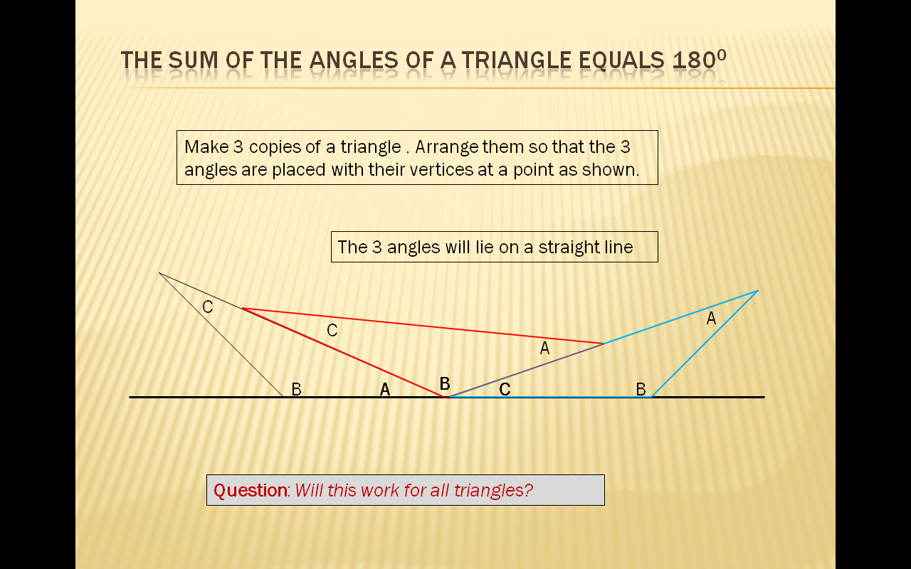

- 0.99999...... = 1
- 1/3 = 0.3333333................................. What do we get if we multiply both sides by 3?
- ii) Instruct the class to use calculators to work out what decimal numbers are produced by 1/9, 2/9, 3/9, 4/9, and 5/9. Using only these 5 answers and no further calculations ask them to conjecture the decimal representations of 6/9, 7/9, 8/9, and 9/9?
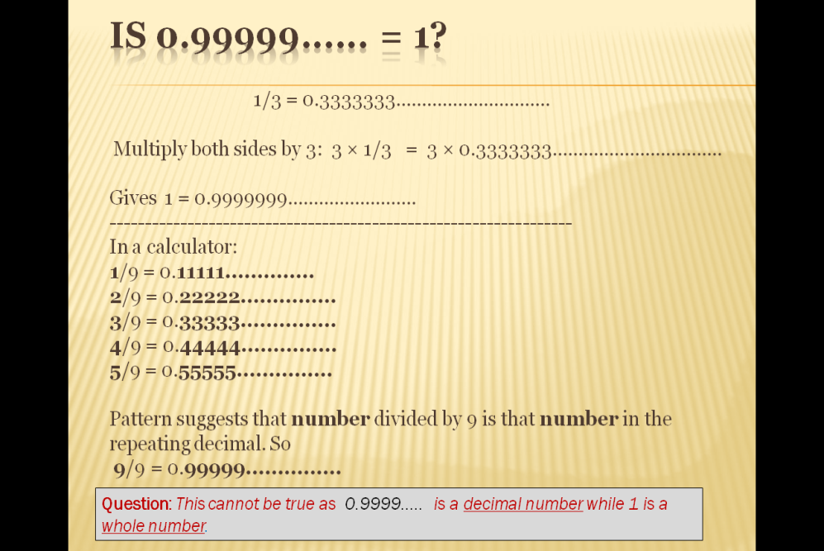

- The shortest distance between 2 points in a plane is a straight line.
- Take a rubber band. Cut it so it is no longer a band. Place two thumb tacks A and B on a sheet of paper on a desk at a distance slightly greater than the length of the rubber line. Tie the rubber line to the thumb tacks A and B and draw a straight line AB. Now stretch any point of the rubber line sideways to a point C. So we have triangle ABC. Which is longer – AC + CB or AB?
- Ask the pupils to figure out the quick way to get from one corner flag of a football ground to the diagonally opposite one.

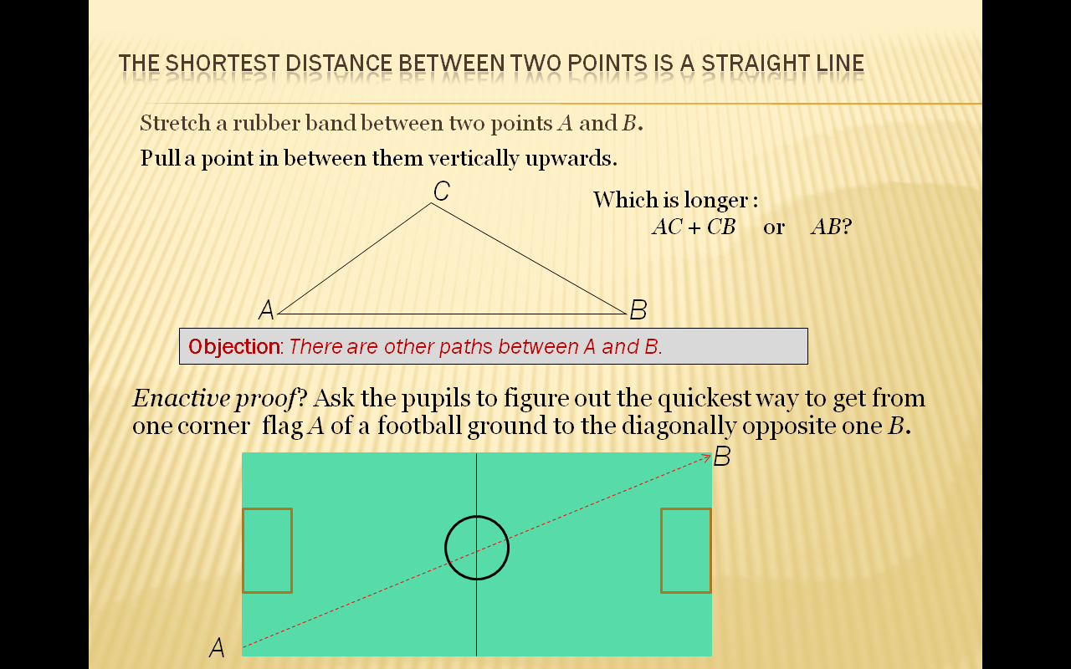
The aim here is not to provide proofs on a plate for learners but to offer explanations that can invite the critical attention – even doubt – of learners. When I once offered the first explanation above for why the sum of two odd numbers is an even number “In a calculator add up twenty sets of pairs of different odd numbers. What kind of number is the sum in each case? Odd or even?”, a 11 year old was not convinced arguing “There might be some really big odd numbers for which rule will not work”. And it is at this point there will be a need for an explanation that uses the structural properties of odd and even numbers – this is where the second explanation might come in. Each of the subsequent explanations offered above can potentially raise critical doubt in pupils who may ask for a better explanation. The important point is that there has been community discussion about the proof, the identification of the strengths and weaknesses of the proof, challenges to the validity of the proof, and perhaps the needs for an improved explanation.

As I proposed earlier, if there is prototypical proof activity by pupils using simple reasoning like naive empiricism then the teacher should consider such proofs as legitimate at the level of the learners. It is incumbent for the teacher to treat pupils as equal partners in the teaching-learning process not just with proof activity but generally. Mistakes and misconceptions should not be ignored as the errors of an intellectual inferior but should be analysed in a diagnostic way to understand the reasoning of the child behind the non-standard conception. For example, when a pupil adds two fractions by adding the numerators and the denominators it may be due to not realising that the algorithm for multiplication cannot be extended to another arithmetic operation – it may be that the teacher did not emphasise that the algorithm applies for multiplication but not for addition. Another related example is when a pupil divides the numerators and the denominators when dividing two fractions. This is not a mistake: the rules permit this but more often than not the teacher may think this a misconception. Were a class discussion to ensue on this issue it would become clear that this method of dividing two fractions is correct but impractical – this algorithm works fine when dividing 8/15 by 2/3 as it produces the correct 4/5 but when applied to the division 4/18 by 3/10 produces the odd looking
_
1.3/1.8

In this example it is possible that both pupils and teacher will have discovered something anew. The teacher and pupils were, arguably, equal partners in the teaching-learning process – and this is a characteristic of democratic activity. There are other possible cases. Another example is row subtraction going from left to right rather than right to left.
Critical thinking is indispensible not only in the investigations of misconceptions but in general in mathematics. As argued earlier pupils should be encouraged to look critically at information and teacher explanations so as to enable them to make these informed decisions in later civic life. This is most clearly evident in statistics where there are opportunities to critically analyse data from a sociological and democratic perspective. In fact the South African curriculum statements are explicit about this:

“The Subject Statement for Mathematics Grades 10-12 expects the learner …interpret data to establish statistical and probability models and to solve related problems with a focus on human rights issues, inclusivity, current matters involving conflicting views, and environmental and health issues” (National Curriculum Statement, 2008, p7)

In this way pupils can become familiar with the critical thinking needed to be active democratic citizens in later life – they can critically interrogate the policy proposals of elected representatives. Bopape (undated) gives relevant examples of such activity in South African classrooms but argues that to have a successful programme of critical statistical education in South Africa will require a re-orientation in teaching methods. I have adapted the following from the Teaching Tolerance website (http://www.tolerance.org/sites/default/files/general/tt_unequal_unemployment_09_h2.pdf)
to give a flavour of the critical thinking of South African pupils envisaged by Bopape in undertaking such mathematical activity:

Unemployment

Use the national statistics on employment rates in South Africa in the cover page and, working in groups of fours, complete the table on page 2. Write down what you, as a group think are the trends for employment based on the data for 2004 and 2009. Write a short summary on what these trends mean.

Next, represent this data in bar graphs of your choice and pie charts.
Finally, one from your group should be asked to present the group findings to the whole class. 7
 | 2004 | 2009 | Difference
Africans
Coloureds
Whites
Average

Facts or trends revealed:
1.
2.
SummaryAfrican Americans 3. 4.
Whites, Non-Hispanic 5. 6.

The view that addressing controversial issues in the mathematics – or any other – classroom may cause unnecessary delays in the delivery of the set curriculum or may be disruptive may have substance but should be countered. What is more important: quantity of information or quality of knowledge? Indeed such problematisation in the classroom is an added advantage for the inculcation of critical thinking on real world issues (Shan and Bailey 1991). This is because pupils can be further encouraged to critically challenge explanations, rules, analyses of data be they non-contextual numerical or statistical within the discipline and rules of mathematics. There are pre-conditions for this, of course, such as the use of effective questioning techniques and appropriate management of class discussion by the teacher.

Mathematically relevant inputs from historical and multicultural sources are, as we have seen earlier, part of the directives of the SANC. These inputs are necessary so that both teachers and pupils – the citizens of tomorrow – can develop the necessary multicultural and international perspectives in mathematics. This perspective is necessary to restore cultural dignity to all peoples on the planet and to empower them with the intellectual tools for responsible and democratic citizenship. These multi-cultural and historical inputs may be disputed by absolutist mathematics educators and those who subscribe to the Industrial Trainer mathematics education aims. Certainly in the UK multicultural mathematics – also known as anti-racist mathematics - was dealt a fatal blow in the late 1980’s by the conservative Prime Minister who in her address to the Conservative Party conference in 1987 who stated:

“And in the inner city where youngsters must have a decent education if they are to have a better future that opportunity is all too often snatched from them by hard left education authorities and extremist teachers. And children who need to be able to count and multiply are learning anti-racist mathematics whatever that may be.” (Thatcher, 1987)

To prevent reactionary criticism I would advise the inputs to be wide ranging, made mathematically relevant, and globally representative. For example they may include numbers and symbols in different cultures and languages, African finger counting, ancient number words used by Lincolnshire shepherds, Chinese arithmetic, Hungarian topological problems, geometry in Islamic and North African art, and Vedic mathematics.

Brief concluding points

In my exposition on mathematics education for schools I had stressed the importance of critical thinking by pupils in discussion of proof in the classroom and in dealing and interpreting numerical data be they non-contextual or related to their own realities and existence. Teachers too have to be critical or critically reflective about the way they teach mathematics in dealing with pupils’ mistakes and misconceptions. The teaching of mathematics has to encourage pupils to think critically. Critical thinking is inseparable from the democratic process. There are, of course, other similarities between mathematics education and democracy which I have implicitly or explicitly already made in this talk.
To make the analogy with democratic values more explicit I now connect up table 2 with corresponding statements about mathematics education that are self evident or have identified in this paper:

Principles in mathematics education | Democracy as a political system
Mathematics is a system of knowledge built up from a set of basic principles. This also applies to numeracy which follows the axioms of the number system, arithmetic, and statistics | Democracy is a system that is based on a set of moral axioms endowing each citizen with defined and undeniable rights. This includes the right to vote.
Teachers of mathematics should treat the students as equal partners in the teaching-learning process. | Elected representatives treat all citizens as equal partners in governance..
All the explanatory arguments of teachers of mathematics should be open to scrutiny and debate. Mathematics teachers’ arguments are only confirmed as satisfactory by the self understanding and the consent of their students. | All the policy statements of elected representatives are open to scrutiny and debate. The policies of elected representatives are confirmed as satisfactory only by the free understanding and majority consent of citizens.
Table 3

I have attempted in this paper to answer the three questions posed at the outset is the following way:
- Mathematics and mathematical proof in the context of schools has to do with the promotion of democratic culture
- Democracy means more than the right to vote. It also means a responsibility to actively and critically participate in the decision making process that guides and governs society. It also means extending the vision of democratic participation to all constituents in the global community.
- The school mathematics curriculum can be engineered so as to make mathematics a tool of democratisation.
To support the last conjecture I have shown how mathematical justifications, explanations, and proofs can be used in the classroom to engender critical thinking in pupils. How misconceptions in pupils work and thinking can be a tool to encourage critical thinking in pupils. How directed analyses of statistical data can be a tool for the inculcation of critical thinking of real world issues. For all of this to happen there has to be a paradigm shift in mathematics teaching. There will be little room for an absolutism perspective of mathematics – which views the subject as value and culture free – and little room for transmission mode teaching which suggest to pupils that mathematics is abstract, rule ridden and without explanation, value and culture free. Instead a progressive method of teaching embracing a constructivist philosophy should be used.

Bibliography

Almeida, D. and Chamoso, J. (2001), Existen lazos entre democracia y matematicas? Uno: Revista de didáctica de las matematicas, Vol 28

Almeida, D. (2001), ‘Pupils’ proof potential’, Int J Math. Educ Sci Technol., vol. 32, no. 1, 53–60

Almeida, D. (undated) ‘Justifying and proving in the mathematics classroom.’ http://www-didactique.imag.fr/preuve/Resumes/Almeida/POME9Almeida.html (accessed 22.6.10)

Bell, A. (1976), A Study of Pupils’ Proof-Explanations in Mathematical Situations, Educational Studies in Mathematics, 7, (23-40)

BITC, undated, http://www.bitc.org.uk/workplace/diversity_and_inclusion/race/facts_and_stats.html
(accessed 23.6.10)

BBC, 2000, ‘MPs debate racism law’ http://news.bbc.co.uk/1/hi/uk_politics/671983.stm (accessed 23.6.10)
Bopape, M. (undated) “The South African New Mathematics Curriculum: People’s Mathematics for People’s Power?” http://www.nottingham.ac.uk/csme/meas/papers/bopape.html (accessed 21.6.10)

Cobb P, 1986, Contexts, Goals, Beliefs, and Learning Mathematics, For the Learning of Mathematics, 6(2), (2-9)

D’Ambrosio, U. (undated) ‘The Role of Mathematics in Building a Democratic Society’, http://www.maa.org/ql/pgs235_238.pdf (accessed 21.6.10)

Department of Education, Foundation Phase Policy Document (1997) Pretoria

Ernest, P. (2000), “Why teach mathematics”, http://www.people.ex.ac.uk/PErnest/why.htm (accessed 21.6.10)

Grunnetti, L. and Rogers, L, (2000), “Philosophical, multicultural and interdisciplinary issues”, in Fauvel and van Mannen, History in Mathematics Education, Kluwer.

Hannaford, C. (1998) Mathematics Teaching is Democratic Education, ZDM 98/6

Monbiot, G. (2009), ‘Copenhagen negotiators bicker and filibuster while the biosphere burns’
Guardian 9 December, 2009, http://www.guardian.co.uk/environment/2009/dec/18/copenhagen-negotiators-bicker-filibuster-biosphere (accessed 21.6.10)

National Curriculum Statement, (2008) Grades 10-12 (General), Learning programme guidelines, Mathematics, Department of Education, Republic of South Africa

National Curriculum Statement, (2003) Grades 10-12 (General), Learning programme guidelines, Mathematics, Department of Education, Republic of South Africa

QCDA (undated), http://curriculum.qcda.gov.uk/key-stages-3-and-4/subjects/key-stage-4/mathematics/index.aspx (accessed 22.6.10)

Revised National Curriculum Statement (undated), Grades R-9 (Schools), Department of Education, Republic of South Africa

Revised National Curriculum Statement (2002) Grades R-9 (Schools), Mathematics, Department of Education, Republic of South Africa

Richards J. (undated) “Connecting Mathematics with Reason” in Steen L. (ed) Mathematics and democracy: The case for quantitative literacy , The National Council on Education and the Disciplines, http://www.maa.org/ql/031-36.pdf (accessed 22.6.10)

Schoenfeld, A, (undated), Reflections on an Impoverished Education, in Steen L. (ed) Mathematics and democracy: The case for quantitative literacy , The National Council on Education and the Disciplines. Available at http://www.maa.org/ql/mathanddemocracy.html (accessed 23.6.10)

Semadeni, Z (1984), Action Proofs in Primary Mathematics Teaching and in Teacher Training, For the Learning of Mathematics, 4 , (32-34)

Shan S and Bailey P (1991) Multiple Factors Classroom Mathematics For Equality And Justice, Trentham Books

Skovsmose, O.(1990) Mathematical Education and Democracy, Educational Studies in Mathematics, Vol. 21, No. 2

Thatcher M. (1987), Speech to Conservative Party Conference,
http://www.margaretthatcher.org/speeches/displaydocument.asp?docid=106941 (accessed 23.6.10)

Footnotes

The Treaty of Tordesillas established in 1494 in the town of Tordesillas, Spain. This treaty established a boundary line dividing the world between Spain and Portugal. This line was approx 480 km west of the Cape Verde Islands – everything East of this line ‘belonged’ to Portugal, everything West ‘belonged’ to Spain. Further details at http://portal.unesco.org/ci/en/ev.php-URL_ID=22294&URL_DO=DO_TOPIC&URL_SECTION=201.html
There are, however, 19 countries that enforce compulsory voting in some or all exceptions: Argentina, Turkey, Greece, and Australia are amongst them. See http://www.aec.gov.au/pdf/voting/compulsory_voting.pdf

