1

ATIVIDADE

|  |  |  |  |  |  |
| --- | --- | --- | --- | --- | --- |
|  |  |  |  |  |  |

|  |  |  |  |  |  |
| --- | --- | --- | --- | --- | --- |
| Z R A D E X |  |  |  |  |  |

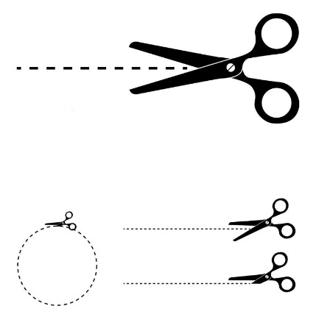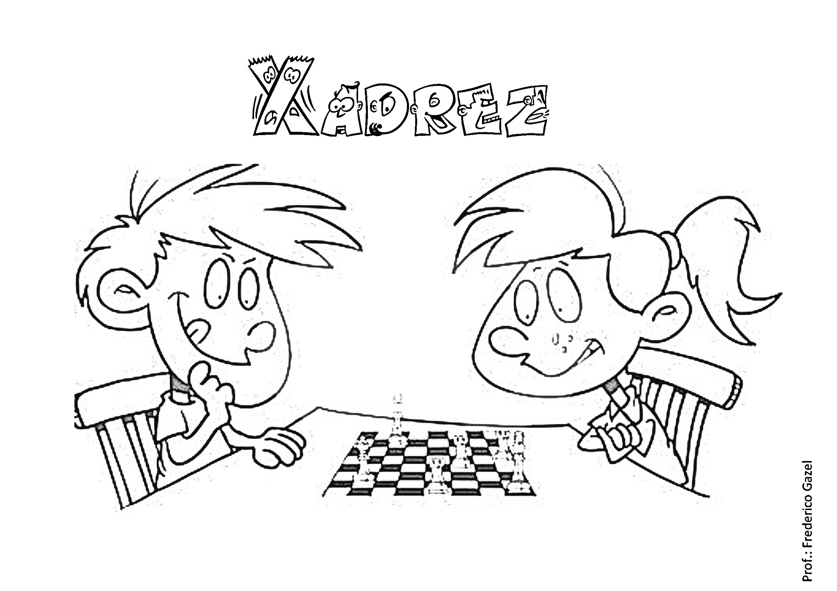

RECORTE AS LETRAS E COLE NOS DEVIDOS LUGARES FORMANDO A PALAVRA X-A-D-R-E-Z.