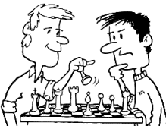
GÊMEOS
ATIVIDADE
N | sN |  | K | mK
sN | N |  | mK | mK
N | N |  | K | K
sN | sN |  | mK | mK
N | N |  | K | K
sN | sN |  | mK | K
- ESCOLHA 6 LÁPIS DE COR DE SUA PREFERENCIA E PINTE A PRIMEIRA COLUNA DE CADA LADO.
- ENCONTRE A IMAGEM IGUAL E COLORA DA MESMA COR!
1

2

1

2

