ATIVIDADE

1 COMPLETE O CAVALO

SEGUINDO A LINHA:

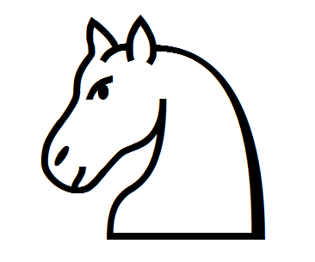

|  |  |  |  |  |  |  |  |  |  |
| --- | --- | --- | --- | --- | --- | --- | --- | --- | --- |
|  |  |  |  |  |  |  |  |  |  |



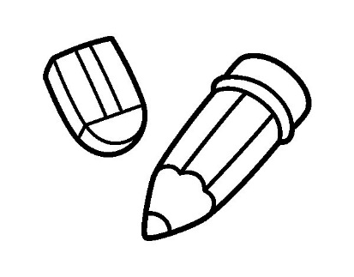

NOME: