**Rei**

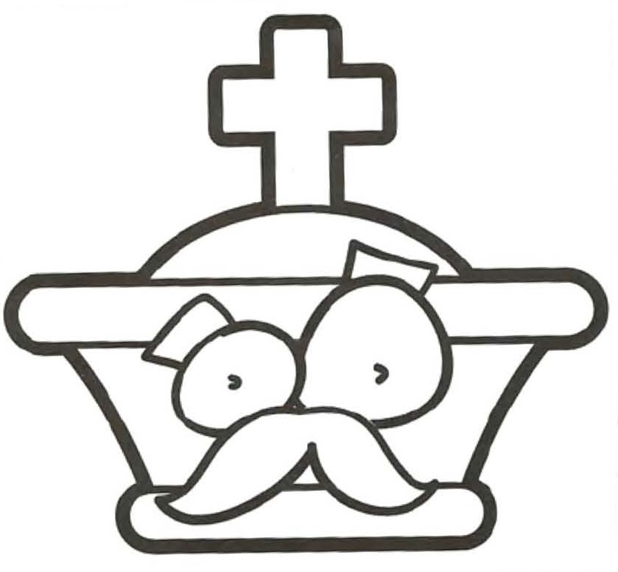

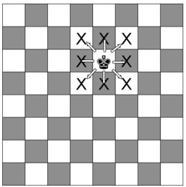 

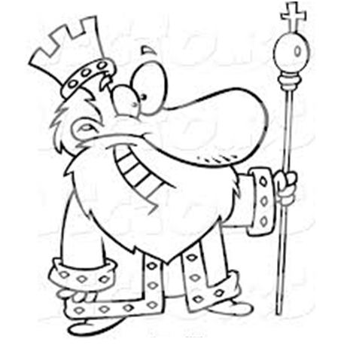

**Dama**

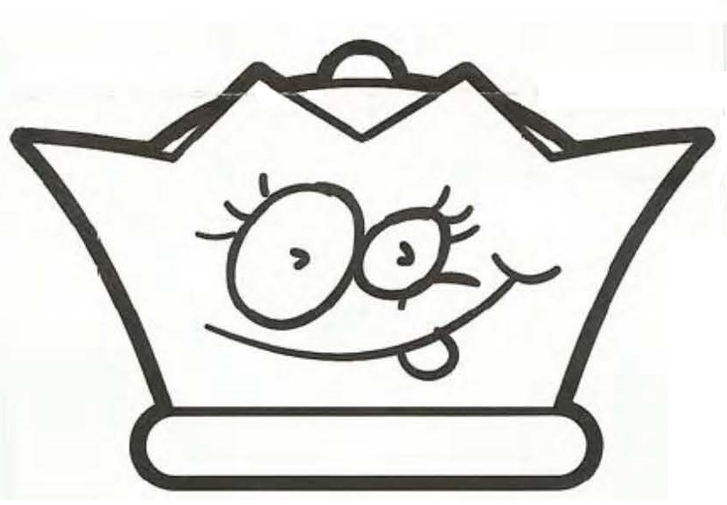

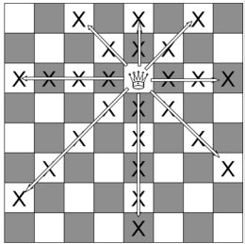 

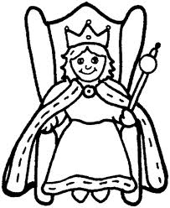

**Bispo**

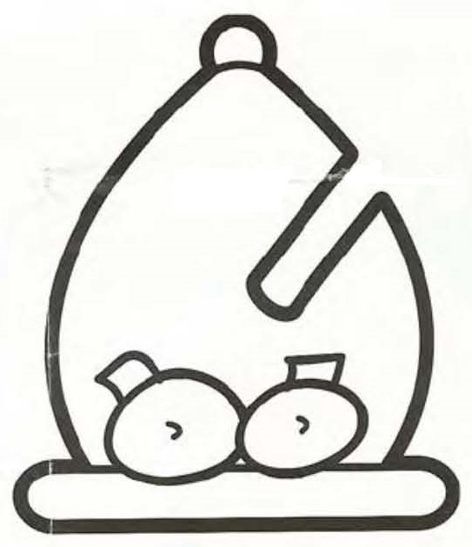

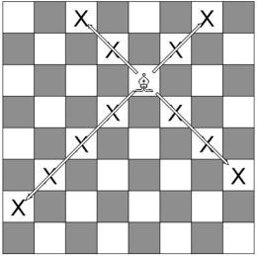 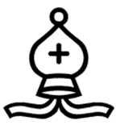

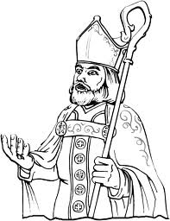

**Torre**

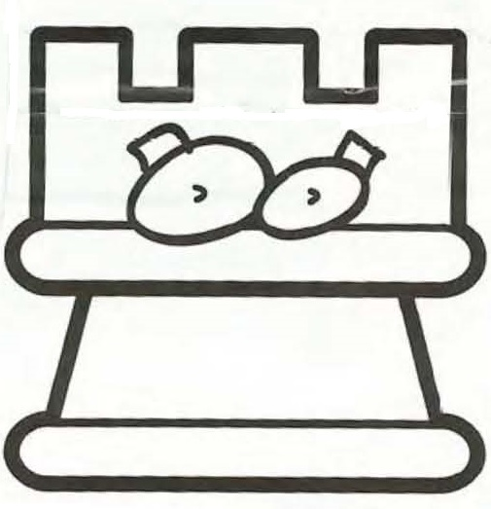

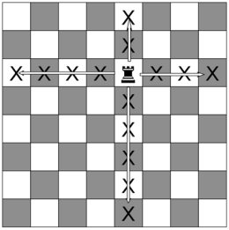 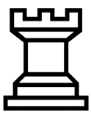

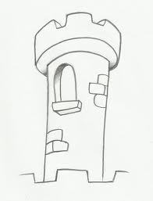

**Cavalo**

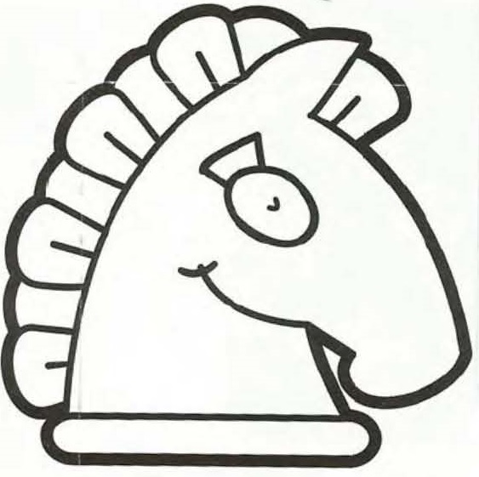

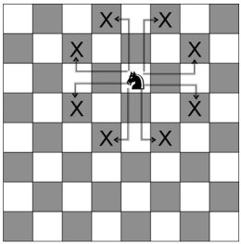 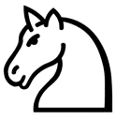

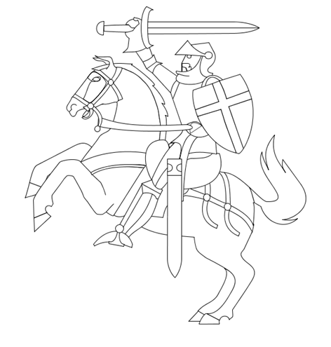

**Peão**

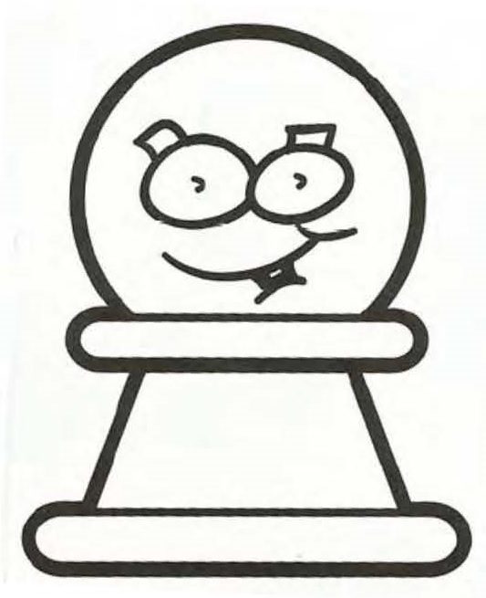

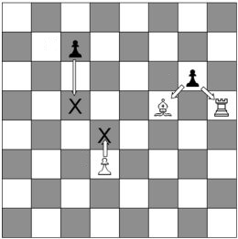 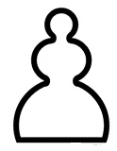

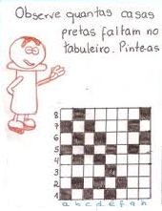

**Desenha as setas necessárias para fazer chegar a peça ao Smile.**

**Utiliza o menor número de jogadas sem rebentar as bombas!**

|  |  |  |  |  |  |  |  |  |  |  |  |  |  |  |  |  |  |  |  |  |  |  |  |  |  |  |  |  |  |  |  |  |  |  |  |  |  |  |  |  |  |  |  |  |  |  |  |  |  |  |  |  |  |  |  |  |  |  |  |  |  |  |  |  |  |  |  |  |  |  |  |  |  |  |  |  |  |  |  |  |  |  |  |  |  |  |  |  |  |  |  |  |  |  |  |  |  |  |  |  |  |  |  |  |  |  |  |  |  |  |  |  |  |  |  |  |  |  |  |  |  |  |  |  |  |  |  |  |  |  |  |  |  |  |  |  |  |  |  |  |  |  |  |  |  |  |  |  |  |  |  |  |  |  |  |  |  |  |  |  |  |  |  |
| --- | --- | --- | --- | --- | --- | --- | --- | --- | --- | --- | --- | --- | --- | --- | --- | --- | --- | --- | --- | --- | --- | --- | --- | --- | --- | --- | --- | --- | --- | --- | --- | --- | --- | --- | --- | --- | --- | --- | --- | --- | --- | --- | --- | --- | --- | --- | --- | --- | --- | --- | --- | --- | --- | --- | --- | --- | --- | --- | --- | --- | --- | --- | --- | --- | --- | --- | --- | --- | --- | --- | --- | --- | --- | --- | --- | --- | --- | --- | --- | --- | --- | --- | --- | --- | --- | --- | --- | --- | --- | --- | --- | --- | --- | --- | --- | --- | --- | --- | --- | --- | --- | --- | --- | --- | --- | --- | --- | --- | --- | --- | --- | --- | --- | --- | --- | --- | --- | --- | --- | --- | --- | --- | --- | --- | --- | --- | --- | --- | --- | --- | --- | --- | --- | --- | --- | --- | --- | --- | --- | --- | --- | --- | --- | --- | --- | --- | --- | --- | --- | --- | --- | --- | --- | --- | --- | --- | --- | --- | --- | --- | --- | --- | --- |
| |  |  |  |  |  |  |  |  |  | | --- | --- | --- | --- | --- | --- | --- | --- | --- | | 8 |  |  |  |  |  |  |  | ☺ | | 7 |  |  |  |  |  |  |  |  | | 6 |  |  |  |  |  |  |  |  | | 5 |  |  |  |  |  |  |  |  | | 4 |  | n |  |  |  |  |  |  | | 3 |  |  |  |  |  |  |  |  | | 2 |  |  |  |  |  |  |  |  | | 1 |  |  |  |  |  |  |  |  | |  | a | b | c | d | e | f | g | h | | |  |  |  |  |  |  |  |  |  | | --- | --- | --- | --- | --- | --- | --- | --- | --- | | 8 |  |  |  |  |  |  |  |  | | 7 |  |  |  |  |  |  |  |  | | 6 |  |  |  |  |  | ☺ |  |  | | 5 |  |  |  |  |  |  |  |  | | 4 |  |  |  |  |  |  |  |  | | 3 |  |  |  |  |  |  |  |  | | 2 |  |  |  |  |  |  |  |  | | 1 |  | r |  |  |  |  |  |  | |  | a | b | c | d | e | f | g | h | |
| |  |  |  |  |  |  |  |  |  | | --- | --- | --- | --- | --- | --- | --- | --- | --- | | 8 |  |  |  |  |  |  |  |  | | 7 |  |  |  |  |  |  |  |  | | 6 |  |  |  |  |  |  |  |  | | 5 |  |  |  |  |  |  |  |  | | 4 |  |  |  |  |  |  |  |  | | 3 |  |  |  |  |  |  |  |  | | 2 | l |  |  |  | ☺ |  |  |  | | 1 |  |  |  |  |  |  |  |  | |  | a | b | c | d | e | f | g | h | | |  |  |  |  |  |  |  |  |  | | --- | --- | --- | --- | --- | --- | --- | --- | --- | | 8 |  |  |  |  |  |  |  | ☺ | | 7 |  |  |  |  |  |  |  |  | | 6 |  |  |  |  |  |  |  |  | | 5 |  |  |  |  |  |  |  |  | | 4 |  |  |  |  |  |  |  |  | | 3 |  |  |  | q |  |  |  |  | | 2 |  |  |  |  |  |  |  |  | | 1 |  |  |  |  |  |  |  |  | |  | a | b | c | d | e | f | g | h | |

**Cada peça tem um valor diferente!**

**Pinta as peças…**

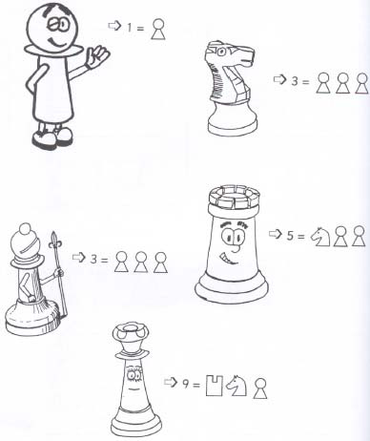

**Faz um círculo no prato mais pesado de cada balança …**

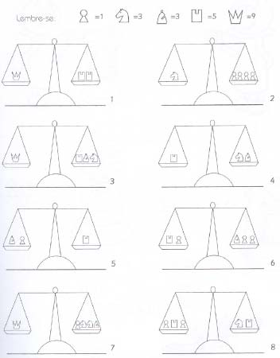

**Pinta a figura!**

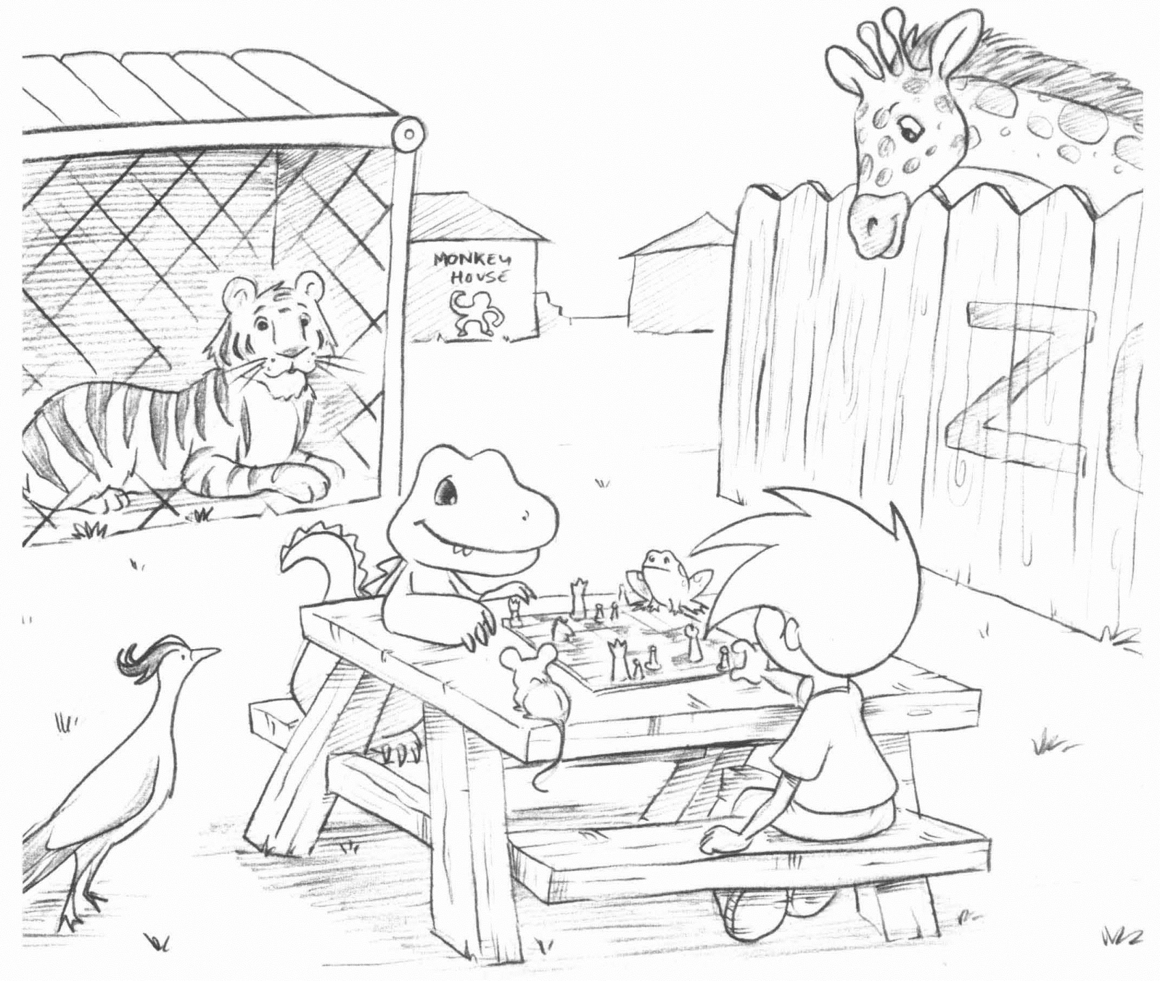

**Exercícios:**

**Que peças Brancas estão a ser atacadas?**

**Assinala-as com um círculo!**

|  |  |  |  |  |  |  |  |  |  |  |  |  |  |  |  |  |  |  |  |  |  |  |  |  |  |  |  |  |  |  |  |  |  |  |  |  |  |  |  |  |  |  |  |  |  |  |  |  |  |  |  |  |  |  |  |  |  |  |  |  |  |  |  |  |  |  |  |  |  |  |  |  |  |  |  |  |  |  |  |  |  |  |  |  |  |  |  |  |  |  |  |  |  |  |  |  |  |  |  |  |  |  |  |  |  |  |  |  |  |  |  |  |  |  |  |  |  |  |  |  |  |  |  |  |  |  |  |  |  |  |  |  |  |  |  |  |  |  |  |  |  |  |  |  |  |  |  |  |  |  |  |  |  |  |  |  |  |  |  |  |  |  |  |  |  |  |  |  |  |  |  |  |  |  |  |  |  |  |  |  |  |  |  |  |  |  |  |  |  |  |  |  |  |  |  |  |  |  |  |  |  |  |  |  |  |  |  |  |  |  |  |  |  |  |  |  |  |  |  |  |  |  |  |  |  |  |  |  |  |  |  |  |  |  |  |  |  |  |  |  |  |  |  |  |  |
| --- | --- | --- | --- | --- | --- | --- | --- | --- | --- | --- | --- | --- | --- | --- | --- | --- | --- | --- | --- | --- | --- | --- | --- | --- | --- | --- | --- | --- | --- | --- | --- | --- | --- | --- | --- | --- | --- | --- | --- | --- | --- | --- | --- | --- | --- | --- | --- | --- | --- | --- | --- | --- | --- | --- | --- | --- | --- | --- | --- | --- | --- | --- | --- | --- | --- | --- | --- | --- | --- | --- | --- | --- | --- | --- | --- | --- | --- | --- | --- | --- | --- | --- | --- | --- | --- | --- | --- | --- | --- | --- | --- | --- | --- | --- | --- | --- | --- | --- | --- | --- | --- | --- | --- | --- | --- | --- | --- | --- | --- | --- | --- | --- | --- | --- | --- | --- | --- | --- | --- | --- | --- | --- | --- | --- | --- | --- | --- | --- | --- | --- | --- | --- | --- | --- | --- | --- | --- | --- | --- | --- | --- | --- | --- | --- | --- | --- | --- | --- | --- | --- | --- | --- | --- | --- | --- | --- | --- | --- | --- | --- | --- | --- | --- | --- | --- | --- | --- | --- | --- | --- | --- | --- | --- | --- | --- | --- | --- | --- | --- | --- | --- | --- | --- | --- | --- | --- | --- | --- | --- | --- | --- | --- | --- | --- | --- | --- | --- | --- | --- | --- | --- | --- | --- | --- | --- | --- | --- | --- | --- | --- | --- | --- | --- | --- | --- | --- | --- | --- | --- | --- | --- | --- | --- | --- | --- | --- | --- | --- | --- | --- | --- | --- | --- | --- | --- | --- | --- | --- | --- | --- | --- | --- | --- | --- | --- |
| |  |  |  |  |  |  |  |  |  | | --- | --- | --- | --- | --- | --- | --- | --- | --- | | 8 | R |  |  |  |  |  |  |  | | 7 |  |  |  |  |  |  |  |  | | 6 | Q |  |  |  |  |  | P |  | | 5 |  |  |  |  |  |  |  |  | | 4 |  | n |  |  | l |  |  |  | | 3 |  |  |  | p |  |  |  |  | | 2 | P |  | L |  |  |  |  |  | | 1 |  |  |  |  |  |  |  | N | |  | a | b | c | d | e | f | g | h | | |  |  |  |  |  |  |  |  |  | | --- | --- | --- | --- | --- | --- | --- | --- | --- | | 8 |  |  |  |  |  |  |  |  | | 7 |  |  | p |  |  |  |  |  | | 6 |  | P |  |  |  |  |  |  | | 5 | N |  |  |  | r |  |  | L | | 4 |  |  | P |  |  |  | n |  | | 3 |  |  |  |  | n |  |  |  | | 2 |  |  | R |  |  |  | P |  | | 1 |  |  |  | N |  | N |  |  | |  | a | b | c | d | e | f | g | h | | |  |  |  |  |  |  |  |  |  | | --- | --- | --- | --- | --- | --- | --- | --- | --- | | 8 |  |  |  |  |  |  |  |  | | 7 |  |  |  |  | P |  |  |  | | 6 |  |  | p |  |  |  |  |  | | 5 |  | P |  | P |  |  | l | P | | 4 |  |  |  |  |  |  |  |  | | 3 |  |  |  |  |  |  | n |  | | 2 |  |  |  |  | P |  |  |  | | 1 |  |  | Q |  |  |  |  |  | |  | a | b | c | d | e | f | g | h | |
| |  |  |  |  |  |  |  |  |  | | --- | --- | --- | --- | --- | --- | --- | --- | --- | | 8 |  |  |  |  | R |  |  |  | | 7 |  | L | p | N | p | p | p |  | | 6 |  |  |  |  |  | n |  |  | | 5 |  | q |  |  |  |  |  |  | | 4 |  |  |  | P |  |  | Q |  | | 3 |  |  |  |  | P |  |  |  | | 2 |  |  |  |  | l |  |  |  | | 1 |  |  |  |  | r |  |  |  | |  | a | b | c | d | e | f | g | h | | |  |  |  |  |  |  |  |  |  | | --- | --- | --- | --- | --- | --- | --- | --- | --- | | 8 | Q |  |  |  |  |  |  |  | | 7 |  |  |  |  |  |  |  | r | | 6 |  |  |  | R |  | P |  |  | | 5 |  |  | p |  |  |  | N |  | | 4 |  |  |  |  | n |  |  |  | | 3 |  |  | P |  |  |  | P |  | | 2 |  |  |  | P |  | p |  | R | | 1 | q |  |  |  |  |  |  |  | |  | a | b | c | d | e | f | g | h | | |  |  |  |  |  |  |  |  |  | | --- | --- | --- | --- | --- | --- | --- | --- | --- | | 8 |  | r |  |  |  |  |  |  | | 7 |  |  | l |  |  | l |  |  | | 6 |  |  | n |  |  | n |  |  | | 5 |  |  |  |  |  |  |  |  | | 4 |  |  |  | P | P |  |  |  | | 3 |  |  | p |  |  | p |  |  | | 2 | P | P | P |  |  | P | P | P | | 1 |  |  |  |  |  |  |  |  | |  | a | b | c | d | e | f | g | h | |
| |  |  |  |  |  |  |  |  |  | | --- | --- | --- | --- | --- | --- | --- | --- | --- | | 8 | l |  |  |  |  |  |  |  | | 7 | l | P | p |  |  | p | p |  | | 6 |  |  | P |  | n |  |  |  | | 5 |  |  |  | p | P |  | Q |  | | 4 |  |  | n | P | p |  |  |  | | 3 |  |  | P |  |  |  | n | p | | 2 |  | L |  |  |  | P |  |  | | 1 |  |  |  |  |  |  |  | L | |  | a | b | c | d | e | f | g | h | | |  |  |  |  |  |  |  |  |  | | --- | --- | --- | --- | --- | --- | --- | --- | --- | | 8 | r |  | L |  |  |  | Q |  | | 7 |  |  |  |  |  | p |  |  | | 6 |  |  |  |  |  |  |  | n | | 5 | p |  |  |  |  | P |  |  | | 4 |  | p |  |  |  | p | L |  | | 3 |  |  | P |  | N |  | P | P | | 2 | R |  |  |  |  |  |  | q | | 1 |  |  |  |  |  |  |  |  | |  | a | b | c | d | e | f | g | h | | |  |  |  |  |  |  |  |  |  | | --- | --- | --- | --- | --- | --- | --- | --- | --- | | 8 | r | n |  | q | k | l | n | r | | 7 |  | p | p |  |  | p | p | p | | 6 | p |  |  | p |  |  |  |  | | 5 |  |  |  |  | N |  |  |  | | 4 |  |  | L |  | P |  | l |  | | 3 |  |  | N |  |  |  |  |  | | 2 | P | P | P |  |  | P | P | P | | 1 | R |  | L | Q | K |  |  | R | |  | a | b | c | d | e | f | g | h | |

**Exercícios:**

**Que peças Negras estão a ser atacadas?**

**Assinala-as com um círculo!**

|  |  |  |  |  |  |  |  |  |  |  |  |  |  |  |  |  |  |  |  |  |  |  |  |  |  |  |  |  |  |  |  |  |  |  |  |  |  |  |  |  |  |  |  |  |  |  |  |  |  |  |  |  |  |  |  |  |  |  |  |  |  |  |  |  |  |  |  |  |  |  |  |  |  |  |  |  |  |  |  |  |  |  |  |  |  |  |  |  |  |  |  |  |  |  |  |  |  |  |  |  |  |  |  |  |  |  |  |  |  |  |  |  |  |  |  |  |  |  |  |  |  |  |  |  |  |  |  |  |  |  |  |  |  |  |  |  |  |  |  |  |  |  |  |  |  |  |  |  |  |  |  |  |  |  |  |  |  |  |  |  |  |  |  |  |  |  |  |  |  |  |  |  |  |  |  |  |  |  |  |  |  |  |  |  |  |  |  |  |  |  |  |  |  |  |  |  |  |  |  |  |  |  |  |  |  |  |  |  |  |  |  |  |  |  |  |  |  |  |  |  |  |  |  |  |  |  |  |  |  |  |  |  |  |  |  |  |  |  |  |  |  |  |  |  |  |
| --- | --- | --- | --- | --- | --- | --- | --- | --- | --- | --- | --- | --- | --- | --- | --- | --- | --- | --- | --- | --- | --- | --- | --- | --- | --- | --- | --- | --- | --- | --- | --- | --- | --- | --- | --- | --- | --- | --- | --- | --- | --- | --- | --- | --- | --- | --- | --- | --- | --- | --- | --- | --- | --- | --- | --- | --- | --- | --- | --- | --- | --- | --- | --- | --- | --- | --- | --- | --- | --- | --- | --- | --- | --- | --- | --- | --- | --- | --- | --- | --- | --- | --- | --- | --- | --- | --- | --- | --- | --- | --- | --- | --- | --- | --- | --- | --- | --- | --- | --- | --- | --- | --- | --- | --- | --- | --- | --- | --- | --- | --- | --- | --- | --- | --- | --- | --- | --- | --- | --- | --- | --- | --- | --- | --- | --- | --- | --- | --- | --- | --- | --- | --- | --- | --- | --- | --- | --- | --- | --- | --- | --- | --- | --- | --- | --- | --- | --- | --- | --- | --- | --- | --- | --- | --- | --- | --- | --- | --- | --- | --- | --- | --- | --- | --- | --- | --- | --- | --- | --- | --- | --- | --- | --- | --- | --- | --- | --- | --- | --- | --- | --- | --- | --- | --- | --- | --- | --- | --- | --- | --- | --- | --- | --- | --- | --- | --- | --- | --- | --- | --- | --- | --- | --- | --- | --- | --- | --- | --- | --- | --- | --- | --- | --- | --- | --- | --- | --- | --- | --- | --- | --- | --- | --- | --- | --- | --- | --- | --- | --- | --- | --- | --- | --- | --- | --- | --- | --- | --- | --- | --- | --- | --- | --- | --- | --- |
| |  |  |  |  |  |  |  |  |  | | --- | --- | --- | --- | --- | --- | --- | --- | --- | | 8 |  |  |  |  |  |  |  |  | | 7 |  |  |  |  |  |  |  |  | | 6 |  |  |  |  |  |  |  |  | | 5 | p | p | p | p | p | p | p | p | | 4 |  | P | P | P | P | P | P |  | | 3 |  |  |  |  |  |  |  |  | | 2 |  |  |  |  |  |  |  |  | | 1 |  |  |  |  |  |  |  |  | |  | a | b | c | d | e | f | g | h | | |  |  |  |  |  |  |  |  |  | | --- | --- | --- | --- | --- | --- | --- | --- | --- | | 8 |  |  |  |  |  |  |  | r | | 7 |  |  |  |  | p |  |  |  | | 6 |  |  |  |  |  | p | N |  | | 5 |  |  |  |  | P | p |  |  | | 4 | q |  | l |  |  | p | p | P | | 3 |  |  |  | p |  |  |  |  | | 2 |  | N |  |  |  |  |  |  | | 1 |  |  |  | R |  |  |  |  | |  | a | b | c | d | e | f | g | h | | |  |  |  |  |  |  |  |  |  | | --- | --- | --- | --- | --- | --- | --- | --- | --- | | 8 |  |  |  |  |  |  |  |  | | 7 |  |  |  |  |  |  |  |  | | 6 |  |  | r |  |  |  |  | L | | 5 |  |  |  | P |  |  |  |  | | 4 |  |  |  |  | P | p |  |  | | 3 |  |  |  |  |  | P | p |  | | 2 |  |  | P |  | N |  | P | P | | 1 |  |  | r |  |  |  | l |  | |  | a | b | c | d | e | f | g | h | |
| |  |  |  |  |  |  |  |  |  | | --- | --- | --- | --- | --- | --- | --- | --- | --- | | 8 |  |  |  |  |  |  |  |  | | 7 |  |  |  | n |  |  | p |  | | 6 |  | q |  |  |  |  |  |  | | 5 |  |  |  |  |  |  |  | p | | 4 |  |  |  | L |  |  | L |  | | 3 |  |  |  |  |  |  |  |  | | 2 |  | n |  |  |  |  |  |  | | 1 |  |  |  |  |  |  | l |  | |  | a | b | c | d | e | f | g | h | | |  |  |  |  |  |  |  |  |  | | --- | --- | --- | --- | --- | --- | --- | --- | --- | | 8 |  |  |  |  |  |  |  |  | | 7 |  |  |  | P | p |  | p |  | | 6 |  |  | p |  |  |  | P | p | | 5 |  |  |  |  | N | N |  | P | | 4 |  |  | p | P |  |  | P | p | | 3 |  |  |  | p | P | P |  | P | | 2 |  |  |  |  |  |  |  |  | | 1 |  |  |  |  |  |  |  |  | |  | a | b | c | d | e | f | g | h | | |  |  |  |  |  |  |  |  |  | | --- | --- | --- | --- | --- | --- | --- | --- | --- | | 8 |  |  |  |  |  |  |  |  | | 7 | p | p | p | p | p |  | p | p | | 6 |  |  |  |  |  | p |  |  | | 5 | N |  |  |  |  |  | N |  | | 4 |  |  |  | L |  |  |  | P | | 3 |  |  |  |  |  | P | P |  | | 2 | P | P |  | P | P |  |  |  | | 1 |  |  |  |  |  |  |  |  | |  | a | b | c | d | e | f | g | h | |
| |  |  |  |  |  |  |  |  |  | | --- | --- | --- | --- | --- | --- | --- | --- | --- | | 8 |  |  |  |  |  |  | N |  | | 7 |  |  |  |  |  |  |  |  | | 6 |  | p |  | p |  | p |  | p | | 5 |  | P | p | P |  | P | p | P | | 4 |  |  | N |  | p |  | P |  | | 3 |  |  |  | p |  | P |  |  | | 2 |  |  | P |  |  |  |  |  | | 1 |  |  |  |  |  |  |  |  | |  | a | b | c | d | e | f | g | h | | |  |  |  |  |  |  |  |  |  | | --- | --- | --- | --- | --- | --- | --- | --- | --- | | 8 |  |  |  |  |  |  |  |  | | 7 |  |  |  |  |  |  |  |  | | 6 |  |  |  |  |  |  |  |  | | 5 |  |  |  | p |  | p |  |  | | 4 |  |  |  |  | P |  |  |  | | 3 |  |  | p |  |  |  |  | p | | 2 |  | P |  |  |  |  | P |  | | 1 |  |  |  |  |  |  |  |  | |  | a | b | c | d | e | f | g | h | | |  |  |  |  |  |  |  |  |  | | --- | --- | --- | --- | --- | --- | --- | --- | --- | | 8 | r |  | l | q | k | l | n | r | | 7 | p | p | p | n | p | p | p |  | | 6 |  |  |  |  | N |  |  | p | | 5 |  |  |  |  |  |  |  |  | | 4 |  |  |  |  | p |  |  |  | | 3 | P |  |  |  |  |  |  |  | | 2 |  | P | P | P |  | P | P | P | | 1 | R | N | L | Q | K | L |  | R | |  | a | b | c | d | e | f | g | h | |

