Nome: _________________________________________ Data: _________________
Reis da 2ª Dinastia “A Dinastia de Avis”

1. _________________________________________________________
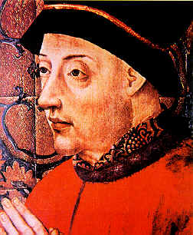
____________________________________________________________________________________________________________________________________________________________________________________________________________________________

2. ___________________________________________________
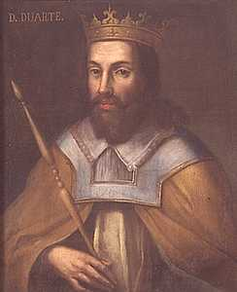
____________________________________________________________________________________________________________________________________________________________________________________________________________________________

3. ___________________________________________________
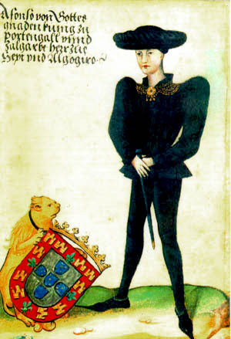
____________________________________________________________________________________________________________________________________________________________________________________________________________________________

4. ___________________________________________________
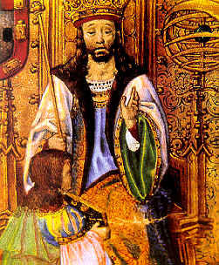
____________________________________________________________________________________________________________________________________________________________________________________________________________________________

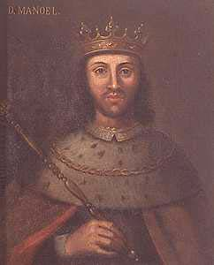
5.___________________________________________________
____________________________________________________________________________________________________________________________________________________________________________________________________________________________

6. ___________________________________________________
____________________________________________________________________________________________________________________________________________________________________________________________________________________________
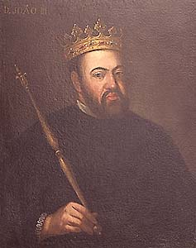

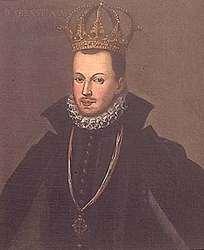
7.___________________________________________________
____________________________________________________________________________________________________________________________________________________________________________________________________________________________

8.___________________________________________________
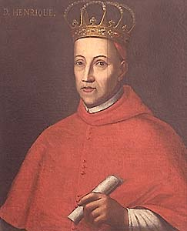
____________________________________________________________________________________________________________________________________________________________________________________________________________________________

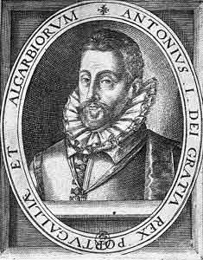
9. ___________________________________________________
____________________________________________________________________________________________________________________________________________________________________________________________________________________________

Cronologia dos Reis de Portugal
Reis da 2ª Dinastia-Avis
1385 - 1433
D. João I "O de Boa Memória"
1433 - 1438
D. Duarte I "O Eloquente"
1438 - 1481
D. Afonso V "O Africano"
1481 - 1495
D. João II "O Príncipe Perfeito"
1495 - 1521
D. Manuel I "O Venturoso"
1521 - 1557
D. João III "O Piedoso"
1557 - 1578
D. Sebastião I "O Desejado"
1578 - 1580
D. Henrique I "O Casto"
1580 - 1580
D. António I "O Determinado"

