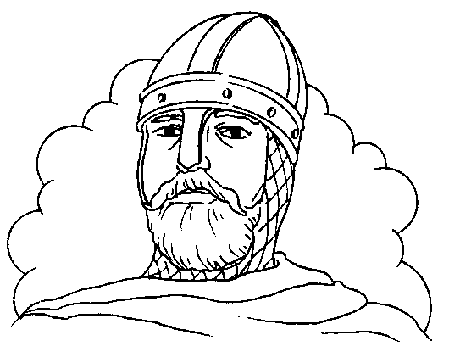

________________________________________________

________________________________________________

__________________________________________________________________________________________________________________________________________________________________________________________________________________________________________________________________________________________________________________________________________________________________________________________________________________________________________________________________________________________________________________________________________________________________________________________________________________________________________________________________________________________________________________________________________________________________________________________________________________________________________________________________________________________________________________________________________________________________________________________________________________________________________________________________________________________________________________________________________________________________________________________________________________________________________________________________________________________________________________________________________________________________________________________________________________________________________________________________________________________________________________________________________________________________________________________**Trabalho realizado por:__________________________________ 4.ºAno**

__________________________________________________________________________

