Reis da 1ª Dinastia “Afonsina”
1. __________________________________________________________
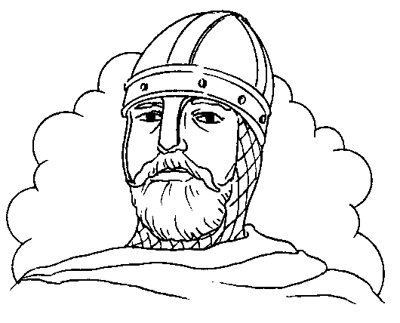
____________________________________________________________________________________________________________________________________________________________________________________________________________________________

2. ___________________________________________________
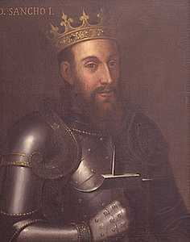
____________________________________________________________________________________________________________________________________________________________________________________________________________________________

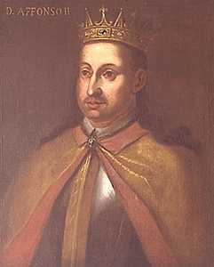
3. ___________________________________________________
____________________________________________________________________________________________________________________________________________________________________________________________________________________________

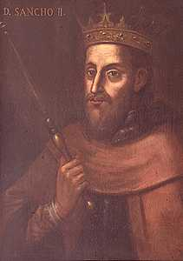
4. ___________________________________________________
____________________________________________________________________________________________________________________________________________________________________________________________________________________________

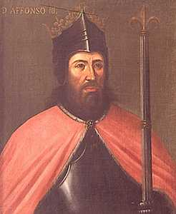
5.___________________________________________________
____________________________________________________________________________________________________________________________________________________________________________________________________________________________

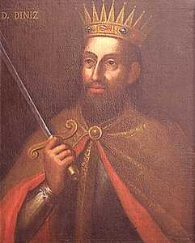
6. ___________________________________________________
____________________________________________________________________________________________________________________________________________________________________________________________________________________________

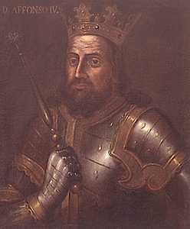
7.___________________________________________________
____________________________________________________________________________________________________________________________________________________________________________________________________________________________

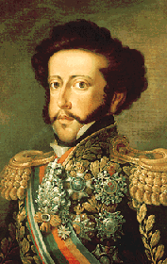
8.___________________________________________________
____________________________________________________________________________________________________________________________________________________________________________________________________________________________

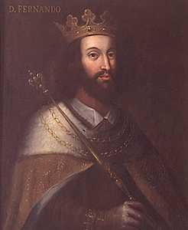
9. ___________________________________________________
____________________________________________________________________________________________________________________________________________________________________________________________________________________________

Cronologia dos Reis de Portugal
Primeira Dinastia - Afonsina
1143 - 1185
D. Afonso Henriques "O Conquistador
1185 - 1211
D. Sancho I "O Povoador
1211 - 1223
D. Afonso II "O Gordo"

1223 - 1248
D. Sancho II "O Capelo"
1248 - 1279
D. Afonso III "O Bolonhês
1279 - 1325
D. Dinis I "O Lavrador"
1325 - 1357
D. Afonso IV "O Bravo"
1357 - 1367

D. Pedro I "O Justiceiro"

1367 - 1383
D. Fernando I "O Formoso"

