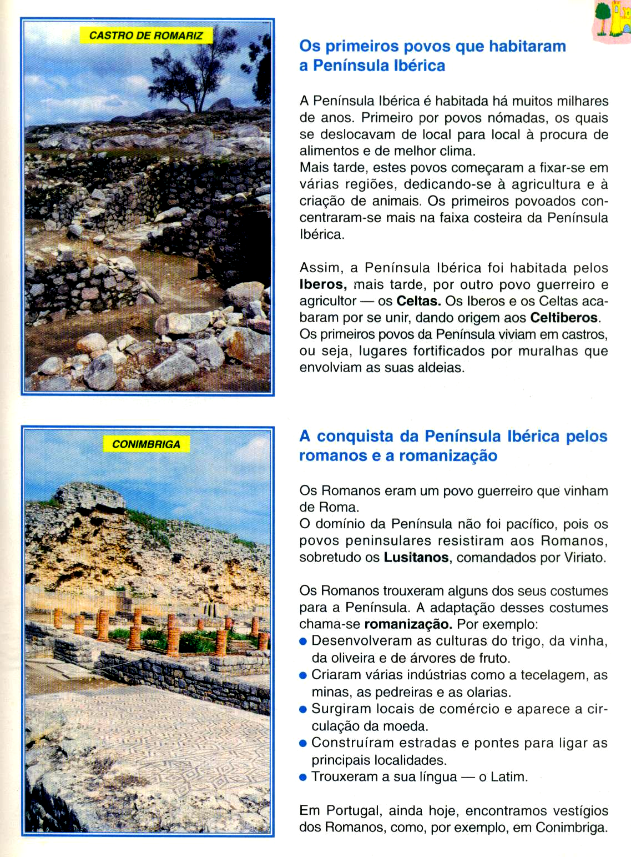
Nome: _______________________________________________
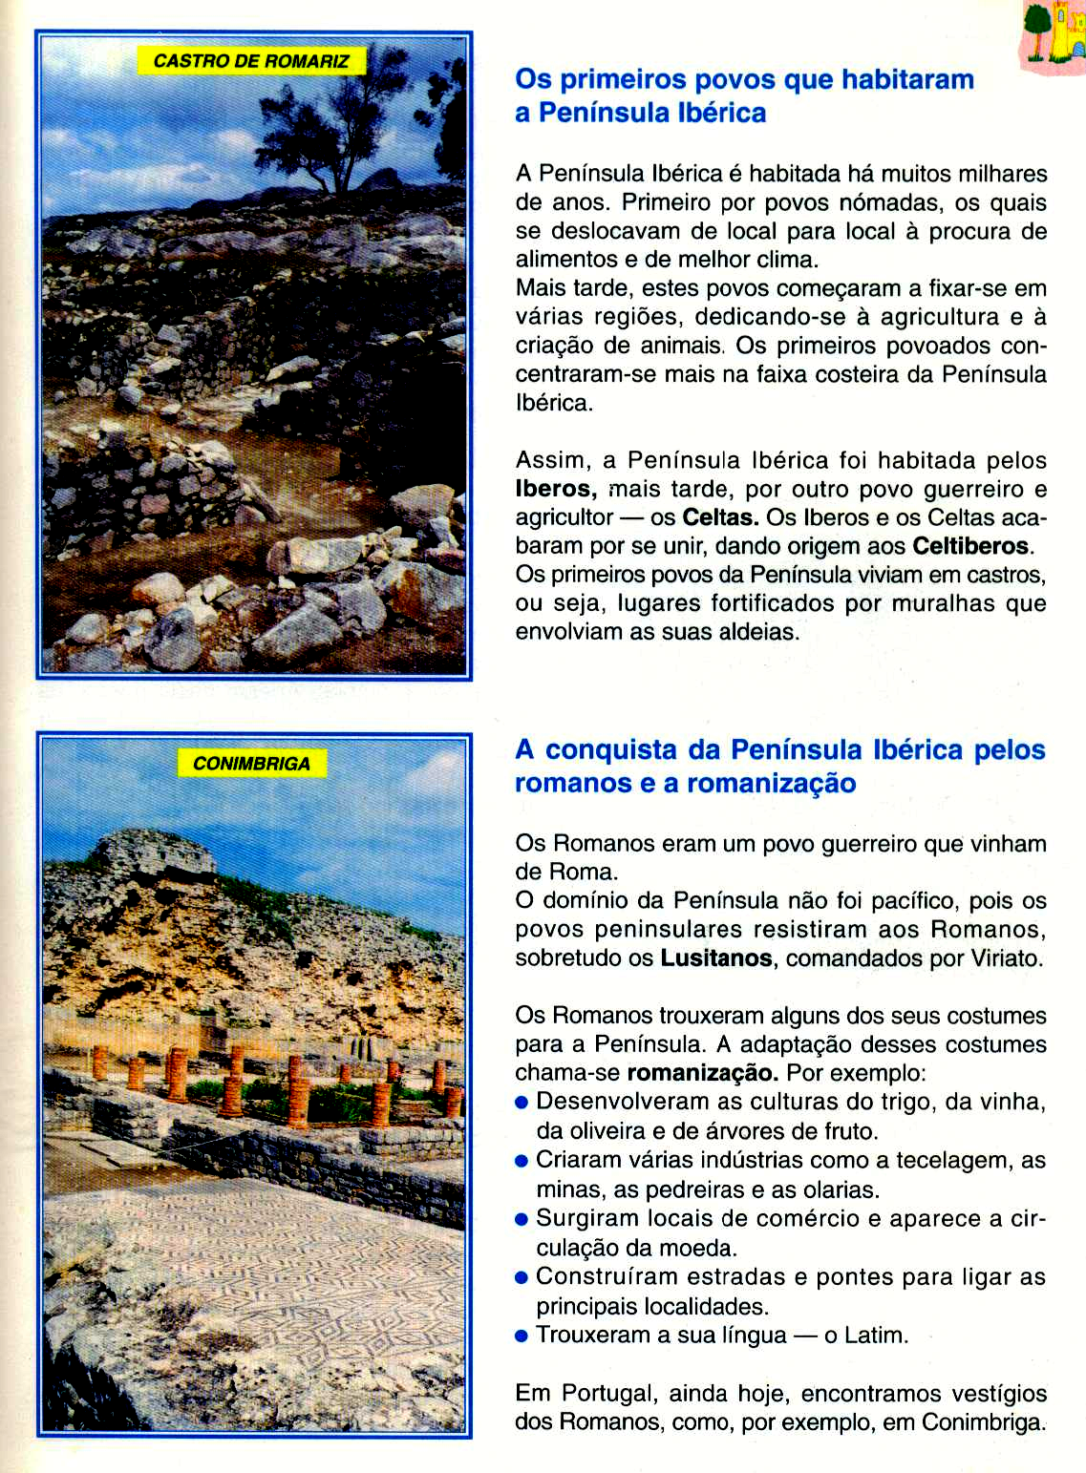
Data: _______________________
Nome dos primeiros povos a habitar a Península Ibérica:
_______________________________________________________________________________________________________________________________________
Onde viviam?
_______________________________________________________________________________________________________________________________________
Que povo veio a seguir?
_______________________________________________________________________________________________________________________________________
O que trouxeram?
____________________________________________________________________________________________________________________________________________________________________________________________________________________________________________________________________________________________________________________________________

