**“Bilhete de Identidade” de Portugal**

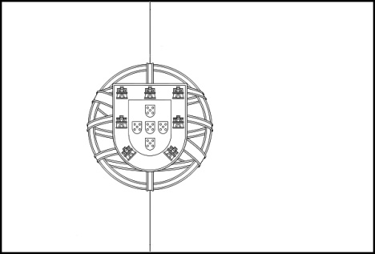

Nome oficial: _____________________________________________

Sistema político: ___________________________________________

Símbolos nacionais: ________________________________________

Língua oficial: _____________________________________________

Divisão territorial: _________________________________________

Capital: __________________________________________________

Área: ____________________________________________________

População: _______________________________________________

Religião maioritária: ________________________________________

Moeda: __________________________________________________

Clima: ___________________________________________________

**“Bilhete de Identidade” de Portugal**

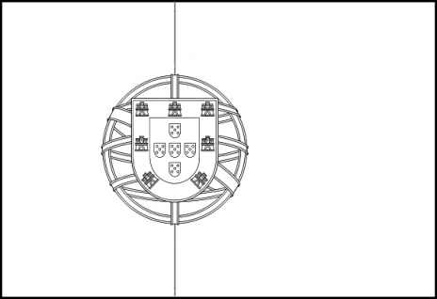

Nome oficial: _____________________________________________

Sistema político: ___________________________________________

Símbolos nacionais: ________________________________________

Língua oficial: _____________________________________________

Divisão territorial: _________________________________________

Capital: __________________________________________________

Área: ____________________________________________________

População: _______________________________________________

Religião maioritária: ________________________________________

Moeda: __________________________________________________

Clima: ___________________________________________________