Continua a história.
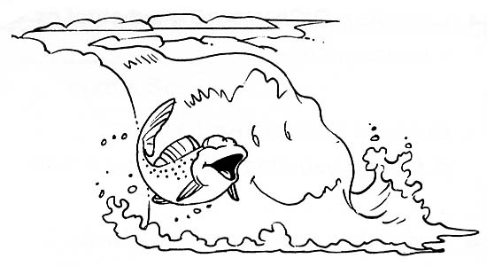

Era uma vez um peixe que vivia ___________________________
________________________________________________________________________________________________________________________________________________________________________________________________________________________________________________________________________________________________________________________________________________________________________________________________________________________________________________________________________________________________________________________________________________________________________________________________________________________________________________________________________________________________________________________________________________________________________________________________________________________________________________________________________________________________________________________________________________________________________________________________________________________________________________________________________________________________________________________________________________________________________________________________________________________________________________

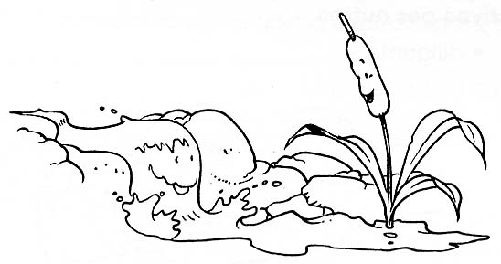
Continua a história.

A água do rio corria por entre pedras e seixos quando vê ...
________________________________________________________________________________________________________________________________________________________________________________________________________________________________________________________________________________________________________________________________________________________________________________________________________________________________________________________________________________________________________________________________________________________________________________________________________________________________________________________________________________________________________________________________________________________________________________________________________________________________________________________________________________________________________________________________________________________________________________________________________________________________________________________________________________________________________________________________________________________________________________________________________________________________________________

