______________________________________________________
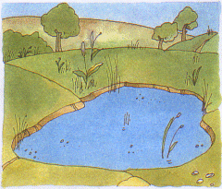
____________________________________________________________________________________________________________________________________________________________________________________________________________________________________________________________________________________________________________________________________________
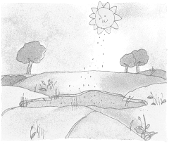
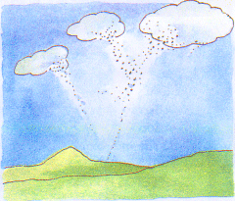
________________________________________________________________________________________________________________________________________________________________________________________________________________________________________________________________________________________________

________________________________________________________________________________________________________________________________________________________________________________________________________________________________________________________________________________________________
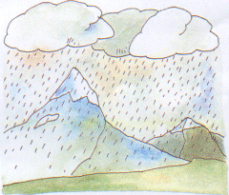
________________________________________________________________________________________________________________________________________________________________________________________________________________________________________________________________________________________________________________________________________________
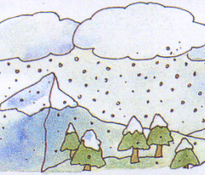
____________________________________________________________________________________________________________________________________________________________________________________________________________________________________________________________________________________________________________________________________________

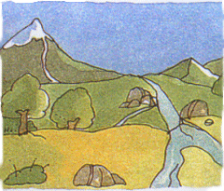
________________________________________________________________________________________________________________________________________________________________________________________________________________________________________________________________________________________________
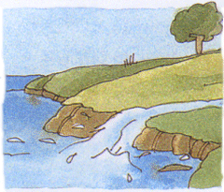
________________________________________________________________________________________________________________________________________________________________________________________________________________________________________________________________________________________________

___________________________
Ano: ______ Turma: _______

