Classe dos Milhares |  |  | Classe das Unidades
CM | DM | UM | C | D | U

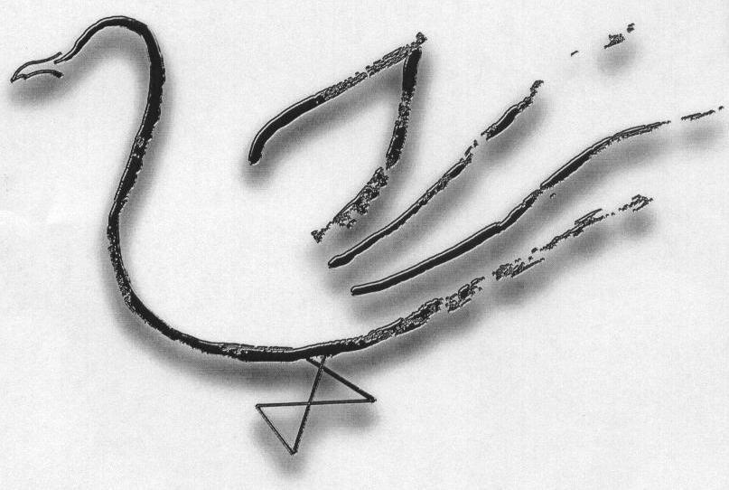
Agrupamento de Escolas Terras de Larus
EB1/JI Quinta de Santo António

Nome: ____________________________________________________________ Data: ____ / ____ / _______
1 - Decompõe:

12 453 = __________+__________+__________+__________+__________+__________
24 671 = __________+__________+__________+__________+__________+__________
37 819 = __________+__________+__________+__________+__________+__________
55 608 = __________+__________+__________+__________+__________+__________
68 915 = __________+__________+__________+__________+__________+__________
90 115 = __________+__________+__________+__________+__________+__________

2 – Escreve a leitura dos números por classes e ordens:

27 569 | - Classes: _____________________________________________________________ _____________________________________________________________________
 | - Ordens: ______________________________________________________________ _____________________________________________________________________
45 567 | - Classes: _____________________________________________________________ _____________________________________________________________________
 | - Ordens: ______________________________________________________________ _____________________________________________________________________
72 003 | - Classes: _____________________________________________________________ _____________________________________________________________________
 | - Ordens: ______________________________________________________________ _____________________________________________________________________
84 607 | - Classes: _____________________________________________________________ _____________________________________________________________________
 | - Ordens: ______________________________________________________________ _____________________________________________________________________

