data:
ficha de matemática
- 4º ano -
EB1 Nº1 de Aires
avaliação:
nome:

Ajuda o Márcio a decompor os seguintes números:
2 314,75
__________________________________________________________________________________________________________________________________________________________________

28 761,234
__________________________________________________________________________________________________________________________________________________________________

931 452,5
__________________________________________________________________________________________________________________________________________________________________

7 645 389
__________________________________________________________________________________________________________________________________________________________________

Escreve por ordens:
_____________________________________________________________________________________________________________________________________________________________________________________
45 678,324
_____________________________________________________________________________________________________________________________________________________________________________________
7 848,34
987 234,56
_____________________________________________________________________________________________________________________________________________________________________________________
1 234 654
_____________________________________________________________________________________________________________________________________________________________________________________

Escreve por ordem crescente
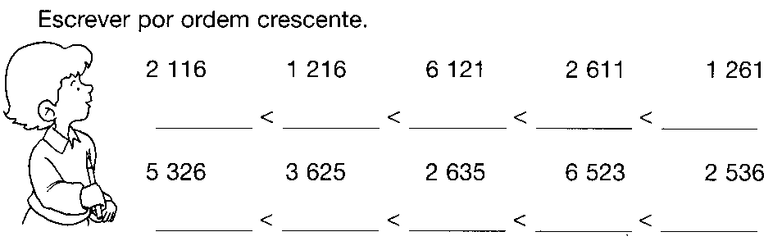

Completa com >, < ou =

1000 |  | 10 dezenas |  | 2 676 |  | 2 766
10 000 |  | 100 centenas |  | 1 000 unidades |  | 1 000
100 000 |  | 1 000 milhares |  | 2 dúzias |  | 25
236 984 |  | 236 948 |  | 3 quarteirões |  | 25
6 582 |  | 7 milhares |  | 10 décimas |  | 1

Efectua as operações:
258 : 35 = _____ | 182 : 12 = _____ | 368 : 23 = _____ | 403 : 31 = _____
429 : 34 = _____ | 634 : 41 = _____ | 672 : 42 = _____ | 1286 : 51 = ____

Lê com atenção os problemas e resolve-os.
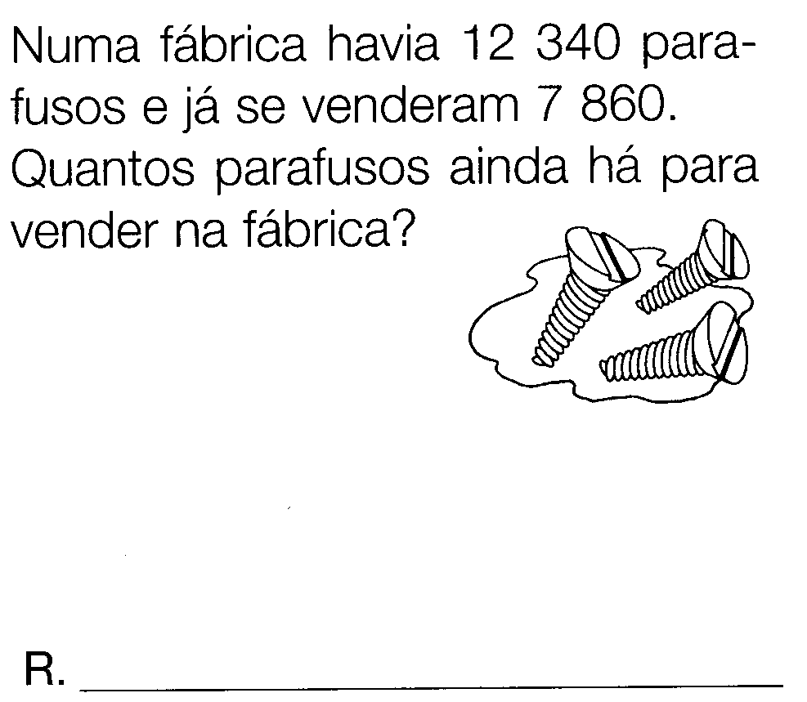 | 