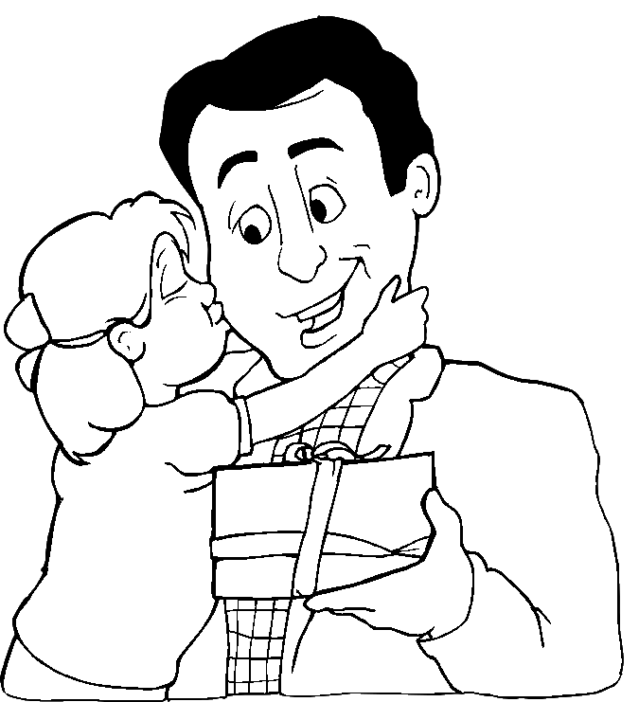
Avenal, 19 de Março de 2003

Querido Pai:

________________________________________________________________________________________________________________________________________________________________________________________________________________________________________________________________________________________________________________________________________________________________________________________________________________________________________________________________________________________________________________________

Com muitos beijinhos

_____________________________
______________________________

