
Nome:________________________________Data:__/___/___

A partir do título de uma história e das personagens que nela participam, imagina e escreve o que aconteceu…
- Título da história: Donos e Bichos
- Personagens; macaco, cão, dono do macaco e dono do cão.

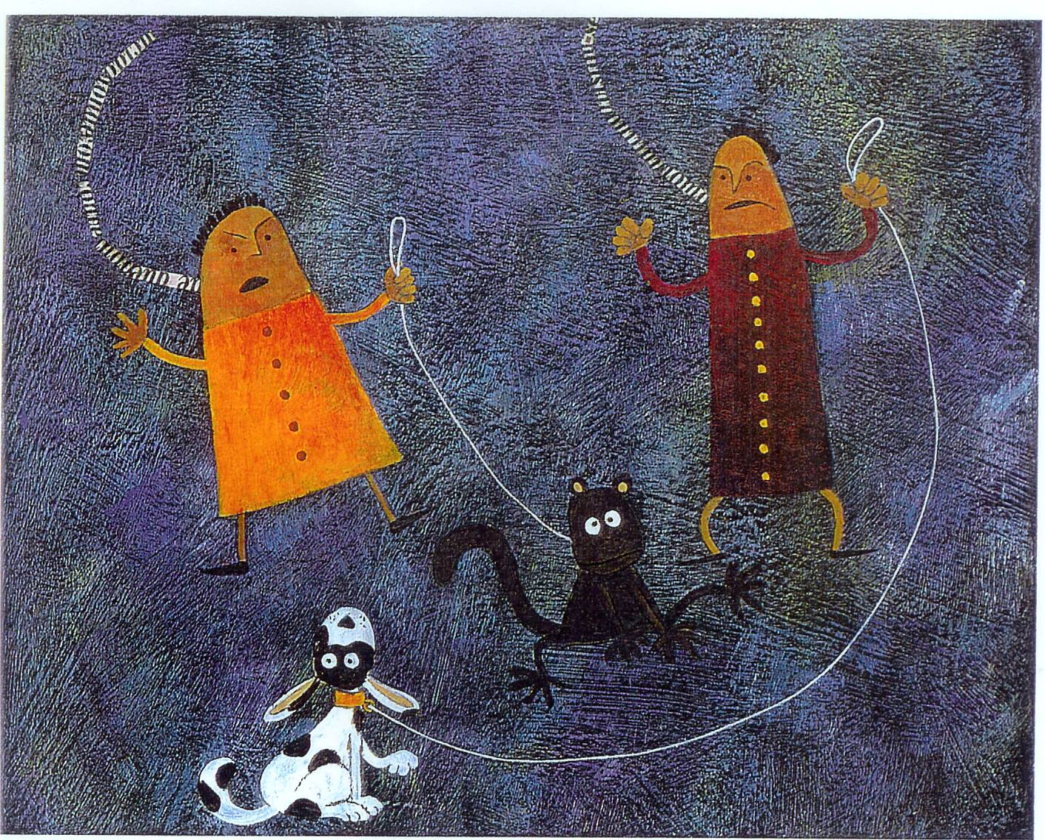

Para escreveres a tua história, procura seguir as pistas que se indicam:
- Que acontecia sempre que os donos dos bichos se visitavam?
- Onde estavam nesse dia?
- Que aconteceu entre os dois animais?
- Que fizeram os donos?
- Como acabou a história?

____________________________________
_____________________________________________________________________________________________________________________________________________________________________________________________________________________________________________________________________________________________________________________________________________________________________________________________________________________________________________________________________________________________________________________________________________________________________________________________________________________________________________________________________________________________________________________________________________________________________________________________________________________________________________________________________________________________________________________________________________________________________________________________________________________________________________________________________________________________________________________________________________________________________________________________________________________________________________________________________________________________________________________________________________________________________________________________________________________________________________________________________________________________________________________________________________________________________________________________________________________________________________________________________________________________________________________________________________________________________________________________________________________________________________________________________________________________________________________________________________________________________________________________________________________________________________________________________________________________________________________________________________________________________________________________________________________________________________________________________________________________

