Nome: ___________________________________________
Data: ____________________________________________
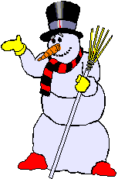
Produção Escrita

Faz uma composição sobre o Inverno, não utilizando nenhuma das palavras que estão dentro do rectângulo.
Frio Neve Branco
Boneco Cachecol Lareira
Chuva Casaco Nuvens

____________________

___________________________________________________________________________________________________________________________________________________________________________________________________
___________________________________________________________________________________________________________________________________________________________________________________________________
_________________________________________________________________
__________________________________________________________________________________________________________________________________
_________________________________________________________________
__________________________________________________________________________________________________________________________________
_________________________________________________________________
__________________________________________________________________________________________________________________________________
_________________________________________________________________
__________________________________________________________________________________________________________________________________
_________________________________________________________________
__________________________________________________________________________________________________________________________________
_________________________________________________________________
__________________________________________________________________________________________________________________________________
_________________________________________________________________
_________________________________________________________________

