Nome:________________________________________________________
Data:_________________________________________________________

Escreve um bonito diálogo entre uma andorinha e uma folha de Outono.

Olá!
Eu sou uma andorinha.


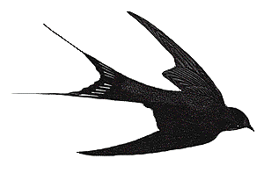
E eu sou uma folha
de Outono

________________________________________________________________________________________________________________________________________________________________________________________________________________________________________________________________________________________________________________________________________________________________________________________________________________________________________________________________________________________________________________________________________________________________________________________________________________________________________________________________________________________________________________________________________________________________________________________________________________

