AGRUPAMENTO VERTICAL DE ESCOLAS TERRAS DE LARUS
EB1/JI Quinta de Santo António

Nome: ____________________________________________ Data: ______________________
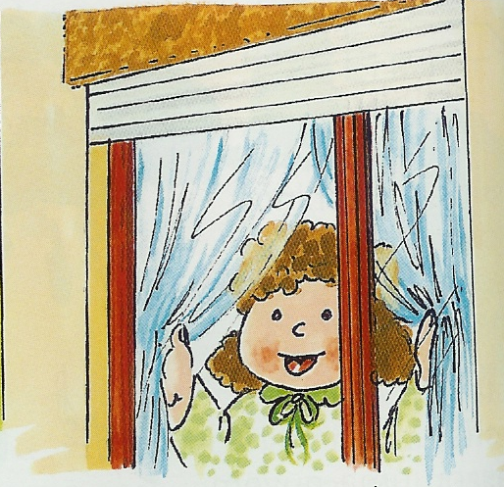

Melhoramento de Texto

Quem? ______________________
Quando? ____________________
Onde estava?_________________
____________________________
O que fez? ___________________
____________________________
Porquê? _____________________
________________________________________________________

______________________________________
______________________________________________________________________
__________________________________________________________________________________________________________________________________________________________________________________________________________________________________________________________________________________________________________________________________________________________________________________________________________________________________________________________________________________________________________________________________________________________________________________________________________________________________________________________________________________________________________________________________________________________________________________________________________________________________________________________________________________________________________________________________________________________________________________________________________________________________________________________________________________________

