|  |  |  |
| --- | --- | --- |
|  |  |  |
|  | FICHA N.° **5 |** Texto narrativo |  |

1. Observa as imagens seguintes com atenção.

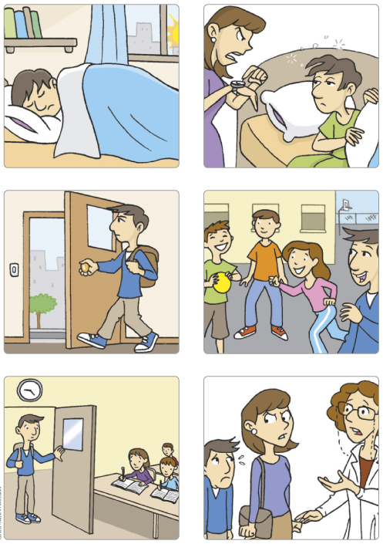

1. Escreve uma história a partir das imagens. Organiza o teu texto e dá-lhe um título.

**Antes de começares a escrever, tem em atenção as seguintes indicações:**

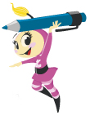• escreve o texto de acordo com o que te é pedido;

• escreve, pelo menos, 90 palavras;

• faz um rascunho do texto, a lápis, numa folha branca.

**Depois de escreveres o rascunho do teu texto:**

• revê com cuidado e corrige o que for necessário;

• copia o texto para aqui, em letra legível, a caneta de tinta azul ou preta.

Título _______________________________

________________________________________________________________________________________________________________________________________________________________________________________________________________________________________________________________________________________________________________________________________________________________________________________________________________________________________________________________________________________________________________________________________________________________________________________________________________________________________________________________________________________________________________________________________________________________________________________________________________________________________________________________________________________________________________________________________________________________________________________________________________________________________________

____________________________________________________________________________________

____________________________________________________________________________________

|  |  |  |
| --- | --- | --- |
|  |  |  |
|  | Banda desenhada |  |