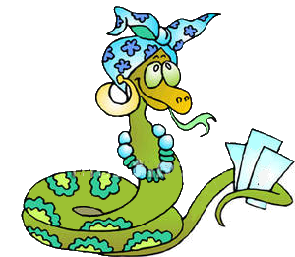
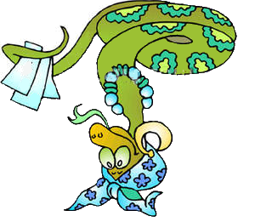
Grau a grau sobe ou desce o degrau
Grupo __________

Adjectivo | Grau | Frase | Pontos | Extras | Total
 | _______________________  _______________________ | _____________________________________________________  _____________________________________________________
 | _______________________  _______________________ | _____________________________________________________  _____________________________________________________
 | _______________________  _______________________ | _____________________________________________________  _____________________________________________________
 | _______________________  _______________________ | _____________________________________________________  _____________________________________________________
 | _______________________  _______________________ | _____________________________________________________  _____________________________________________________
 | _______________________  _______________________ | _____________________________________________________  _____________________________________________________
 | _______________________  _______________________ | _____________________________________________________  _____________________________________________________
 | _______________________  _______________________ | _____________________________________________________  _____________________________________________________
 | _______________________  _______________________ | _____________________________________________________  _____________________________________________________
 | _______________________  _______________________ | _____________________________________________________  _____________________________________________________
 | _______________________  _______________________ | _____________________________________________________  _____________________________________________________

