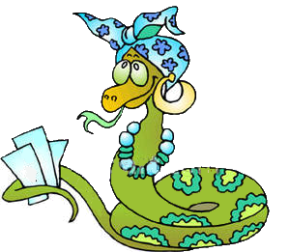
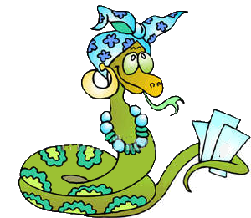
Grau a grau sobe ou desce o degrau

Adjectivo | Grau | Frase | Pontos | Penalização | Total
 | _______________________  _______________________ | ______________________________________________  ______________________________________________
 | _______________________  _______________________ | ______________________________________________  ______________________________________________
 | _______________________  _______________________ | ______________________________________________  ______________________________________________
 | _______________________  _______________________ | ______________________________________________  ______________________________________________
 | _______________________  _______________________ | ______________________________________________  ______________________________________________
 | _______________________  _______________________ | ______________________________________________  ______________________________________________
 | _______________________  _______________________ | ______________________________________________  ______________________________________________
 | _______________________  _______________________ | ______________________________________________  ______________________________________________
 | _______________________  _______________________ | ______________________________________________  ______________________________________________
 | _______________________  _______________________ | ______________________________________________  ______________________________________________

