Nome: _____________________________________________
Data: ______________________________________________
➢Lê e copia
la __________________________________________________
le __________________________________________________
li __________________________________________________
lo __________________________________________________
lu __________________________________________________
➢Lê, copia e faz a divisão silábica pintando um por cada sílaba
 | 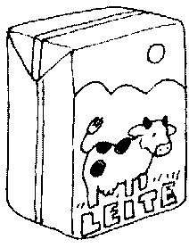 | 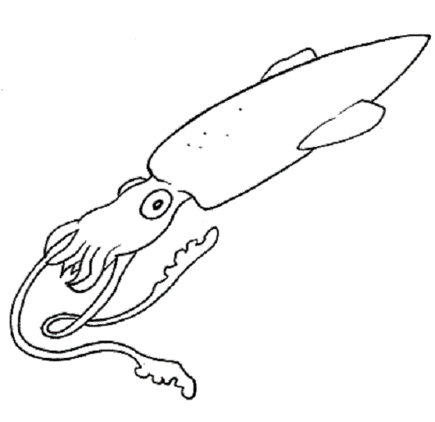 | 
lata | leite | lula | lupa
___________ | ___________ | ____________ | ___________

