Nome: ______________________________________________

Data: _____________________________

1-Ordena as sílabas para formar as palavras.

|  |  |  |
| --- | --- | --- |
| pa | li | tu |

|  |  |  |
| --- | --- | --- |
| da | da | de |

|  |  |  |
| --- | --- | --- |
| pe | ta | te |

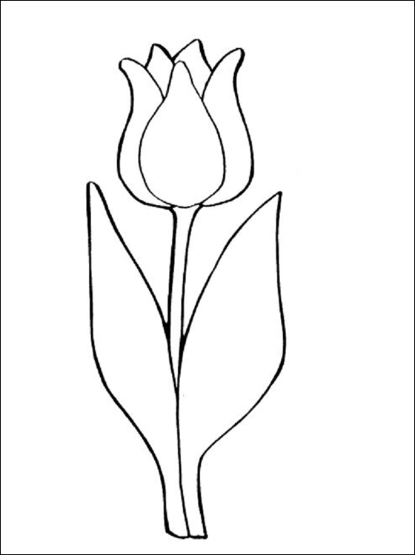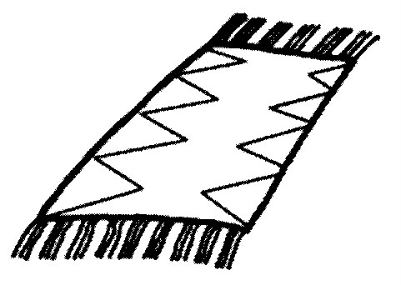

______________ _____________ _______________

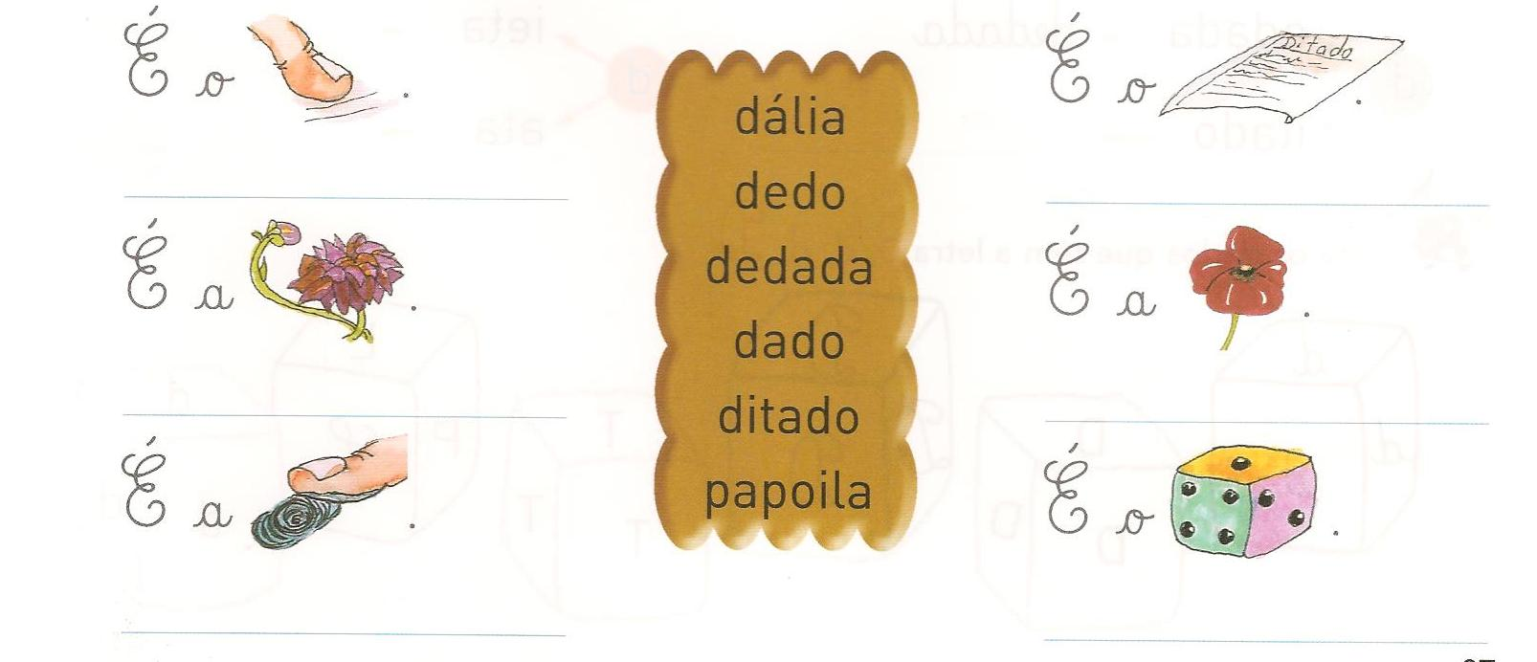2- Completa com as palavras do quadro.