
Eb1 de Igreja – Fornelos

Ficha de Língua Portuguesa – 1º ano

Data: __________________________________________
Nome : ___________________________________________

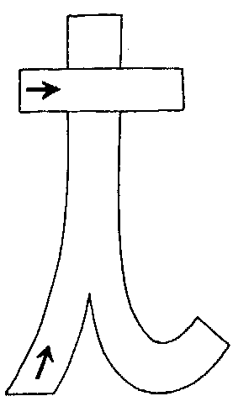

Completa
______________________________________________________________________________________________________________

______________________________________________________________________________________________________________

______________________________________________________________________________________________________________

______________________________________________________________________________________________________________

______________________________________________________________________________________________________________

Nome: _______________________________ Data: ____________

Pinta as imagens que têm o som “t” no nome

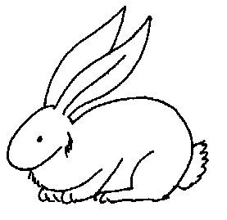 |  |  | 
 |  | 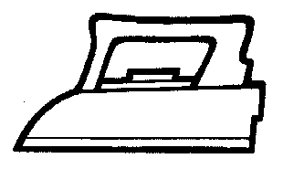 | 
Legenda as imagens

 |  |  | 
________ _________ ________ __________

Lê, copia e ilustra

O pai tapou a pipa.
______________________________________________

A tia põe o tapete.
_____________________________________________

