Nome ____________________________________________________________________

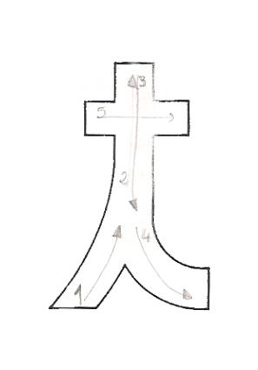

Data _____________________________________________________________________

t __________ __________ __________ __________

t __________ __________ __________ __________

t __________ __________ __________ __________

ta __________ __________ __________ __________

ta __________ __________ __________ __________

te __________ __________ __________ __________

te __________ __________ __________ __________

ti __________ __________ __________ __________

ti __________ __________ __________ __________

to __________ __________ __________ __________

to __________ __________ __________ __________

tu __________ __________ __________ __________

tu __________ __________ __________ __________

**Lê as palavras e circunda os t.**

|  |  |  |  |
| --- | --- | --- | --- |
|  |  |  |  |
| tia | pato | pote | apito |