**Português**

**Nome: \_\_\_\_\_\_\_\_\_\_\_\_\_\_\_\_\_\_\_\_\_\_\_\_\_\_ Data: \_\_\_\_\_\_\_\_\_\_\_**

🖙**Lê e completa as frases.**

j0151967[1]j0343921[1]

|  |
| --- |
| pai  pipa  pá  pau  pé  teia  pião  tapete |

É a e a .

\_\_\_\_\_\_\_\_\_\_\_\_\_\_\_\_\_\_\_\_\_\_\_\_\_\_\_\_\_\_\_\_\_\_\_\_\_\_\_\_\_\_\_

hm00383_[1]j0358749[1]

É o e o .

\_\_\_\_\_\_\_\_\_\_\_\_\_\_\_\_\_\_\_\_\_\_\_\_\_\_\_\_\_\_\_\_\_\_\_\_\_\_\_\_\_\_\_

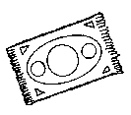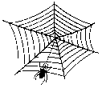

É o e a .

\_\_\_\_\_\_\_\_\_\_\_\_\_\_\_\_\_\_\_\_\_\_\_\_\_\_\_\_\_\_\_\_\_\_\_\_\_\_\_\_\_\_\_\_

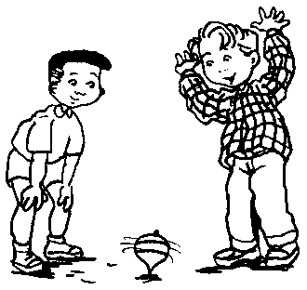j0199937[1]

É o e o .

\_\_\_\_\_\_\_\_\_\_\_\_\_\_\_\_\_\_\_\_\_\_\_\_\_\_\_\_\_\_\_\_\_\_\_\_\_\_\_\_\_\_\_\_

🖙Lê e liga as palavras aos desenhos:

|  |  |  |  |  |  |  |  |  |  |
| --- | --- | --- | --- | --- | --- | --- | --- | --- | --- |
| passarinho | • |  | • pé |  | pá |  | • |  | • pipa |
| automóvelpé | • |  | • popó |  |  | teia  pipa | • |  | • pá |
|  | • |  | • piu-piu |  |  |  | • |  | • teia |
| pão (2) | • |  | • pau |  |  | jogo do pião  tapete (2) | • |  | • tapete |
| pau | • |  | • pão |  |  |  | • |  | • pião |

##### 🖙Fátimapato Escreve:

|  |  |  |  |  |  |  |  |  |
| --- | --- | --- | --- | --- | --- | --- | --- | --- |
|  |  |  |  | pote |  | apito |  | pote  apito  pato  tia |
| \_\_\_\_\_\_\_ |  | \_\_\_\_\_\_\_ |  | \_\_\_\_\_\_\_\_ |  | \_\_\_\_\_\_\_\_\_\_ |  |