Nome: _______________________________________________________
Data: _________________________________

LETRA P – Palavras com p
1- Lê, copia e ilustra:

pá | pé | pó | pau | pia | pão | pipi
popó | papa | papá | pipa | papo | poupa | pai
popó | Pepe | Piupiu | Pepa | pião | pipo

Nome: _______________________________________________________
Data: _________________________________

1 – Copia:
pa ____________________________________________________________________
pe ____________________________________________________________________
pi ____________________________________________________________________
po ____________________________________________________________________
pu ____________________________________________________________________

2 – Copia:
Pa ____________________________________________________________________
Pe ____________________________________________________________________
Pi ____________________________________________________________________
Po ____________________________________________________________________
Pu ____________________________________________________________________

3 – Legenda:
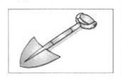


______________ __________________
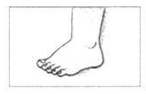
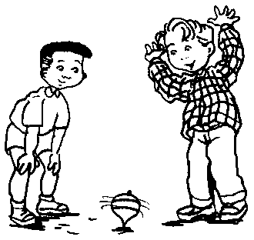

_______________ ___________________
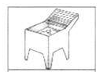
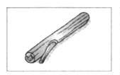

_________________ ___________________
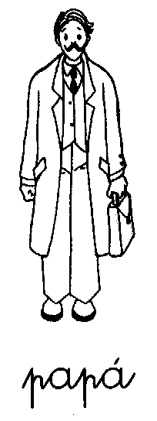

_________
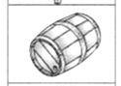
_____________ ou _________________
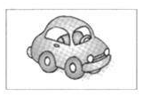

_________
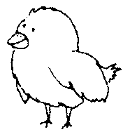
_____________ ou ______________ ________ ou
___________

