Nome _____________________________________________________

Data ______________________________________________________

**1. Completa e copia.**

P ____________________________________________

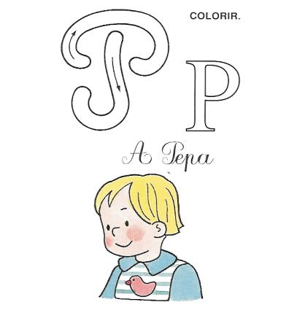

P ____________________________________________

P ____________________________________________

P ____________________________________________

Pa _______________________________________________

Pe ________________________________________________

Pi ________________________________________________________

Po ________________________________________________________

Pu ________________________________________________________

**2. Completa os nomes com p ou P.**

|  |  |  |
| --- | --- | --- |
|  |  |  |
| ___aulo | ___aula | ___ote |