##### Nome: \_\_\_\_\_\_\_\_\_\_\_\_\_\_\_\_\_\_\_\_\_\_\_\_\_\_\_\_\_\_\_\_\_\_\_\_\_\_\_\_\_\_\_\_\_\_\_\_\_\_\_\_

Data: \_\_\_\_\_\_\_\_\_\_\_\_\_\_\_\_\_\_\_\_\_\_\_\_\_\_\_\_\_\_\_\_\_\_\_\_\_\_\_\_\_\_\_\_\_\_\_\_\_\_\_\_\_

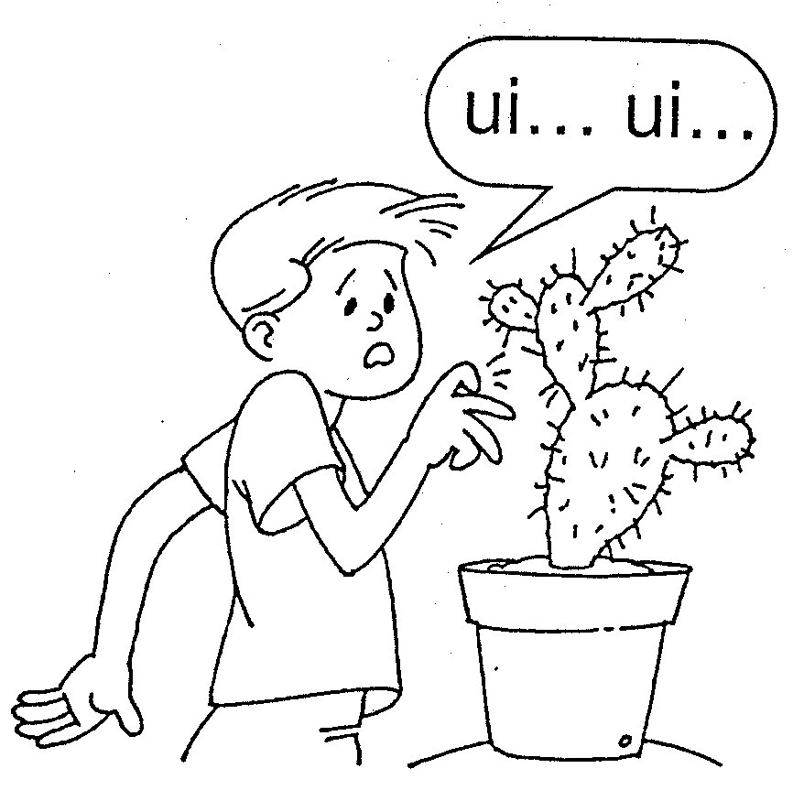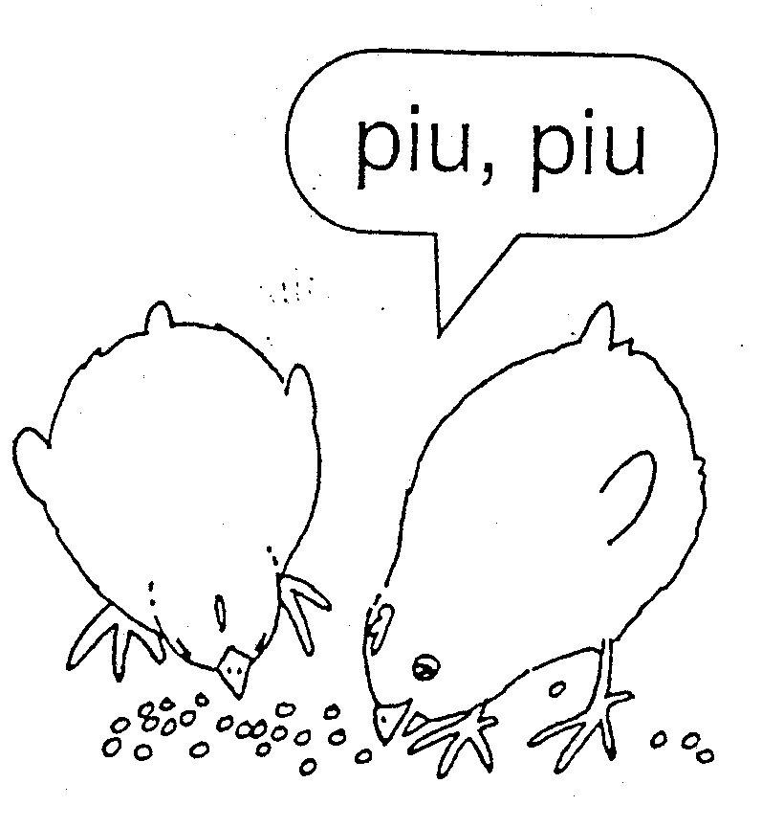

1. Completa:

**iu**\_\_\_\_\_\_\_\_\_\_\_\_\_\_\_\_\_\_\_\_\_\_\_\_\_\_\_\_\_\_\_\_\_\_\_\_\_\_\_\_\_\_\_\_\_\_\_\_\_\_\_\_\_\_

**Iu**\_\_\_\_\_\_\_\_\_\_\_\_\_\_\_\_\_\_\_\_\_\_\_\_\_\_\_\_\_\_\_\_\_\_\_\_\_\_\_\_\_\_\_\_\_\_\_

**ui**\_\_\_\_\_\_\_\_\_\_\_\_\_\_\_\_\_\_\_\_\_\_\_\_\_\_\_\_\_\_\_\_\_\_\_\_\_\_\_\_\_\_\_\_\_\_\_\_\_\_\_\_\_\_

**Ui**\_\_\_\_\_\_\_\_\_\_\_\_\_\_\_\_\_\_\_\_\_\_\_\_\_\_\_\_\_\_\_\_\_\_\_\_\_\_\_\_\_\_\_\_\_\_\_

1. Sublinha as palavras com **iu**  ou **ui**.

|  |
| --- |
| fugiu um Rui muito riu bola piu-piu  Luísa subiu Ana cuidado viu Luís caiu |

##### Nome: \_\_\_\_\_\_\_\_\_\_\_\_\_\_\_\_\_\_\_\_\_\_\_\_\_\_\_\_\_\_\_\_\_\_\_\_\_\_\_\_\_\_\_\_\_\_\_\_\_\_\_\_

Data: \_\_\_\_\_\_\_\_\_\_\_\_\_\_\_\_\_\_\_\_\_\_\_\_\_\_\_\_\_\_\_\_\_\_\_\_\_\_\_\_\_\_\_\_\_\_\_\_\_\_\_\_\_

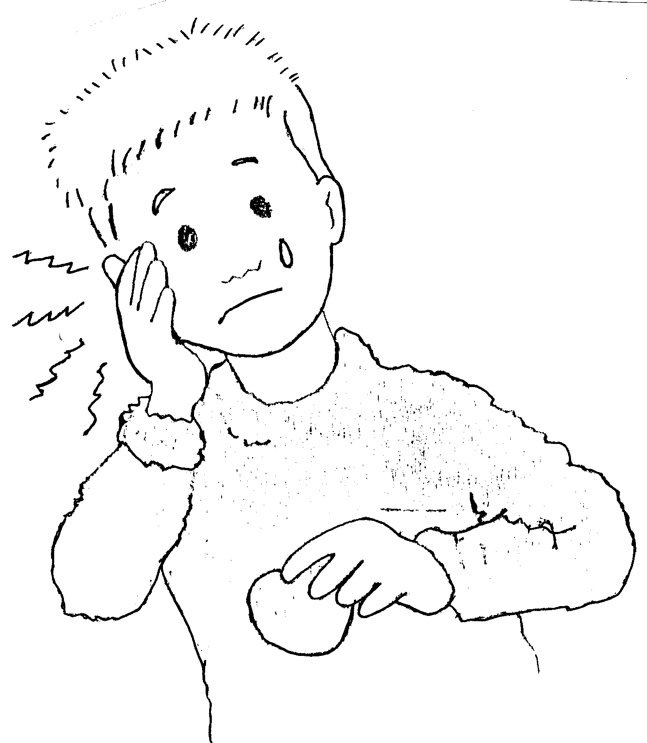

1. 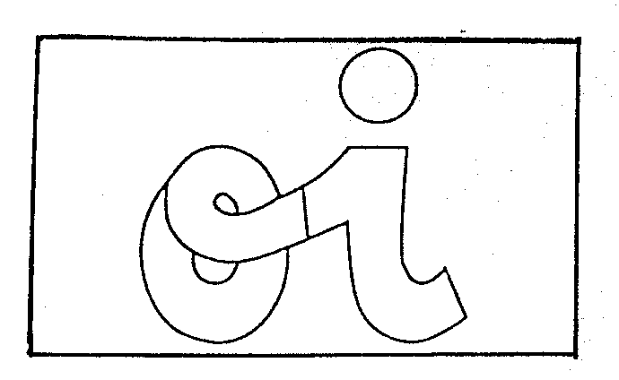Pinta de duas cores.

dói ...

O dente d\_\_

1. Copia.

oi \_\_\_\_\_\_\_\_\_\_\_\_\_\_\_\_\_\_\_\_\_\_\_\_\_\_\_\_\_\_\_\_\_\_\_\_\_\_\_\_\_\_\_\_\_\_\_\_\_\_\_\_\_\_\_\_

oi\_\_\_\_\_\_\_\_\_\_\_\_\_\_\_\_\_\_\_\_\_\_\_\_\_\_\_\_\_\_\_\_\_\_\_\_\_\_\_\_\_\_\_\_\_\_\_\_\_\_\_\_\_\_\_\_\_\_\_ Oi\_\_\_\_\_\_\_\_\_\_\_\_\_\_\_\_\_\_\_\_\_\_\_\_\_\_\_\_\_\_\_\_\_\_\_\_\_\_\_\_\_\_\_\_\_\_\_\_\_\_\_\_\_\_\_\_\_

Oi \_\_\_\_\_\_\_\_\_\_\_\_\_\_\_\_\_\_\_\_\_\_\_\_\_\_\_\_\_\_\_\_\_\_\_\_\_\_\_\_\_\_\_\_\_\_\_\_\_\_\_\_\_\_\_

1. Rodeia o ditongo oi.

baloiço loiro foi noitinha rói

noite dezoito coitada

1. ..\..\Programas\Microsoft Office\Clipart\standard\stddir4\PE02059_.wmfCompleta as palavras seguintes com oi.

..\..\Programas\Microsoft Office\Clipart\Pub60Cor\NA00494_.wmf

..\..\Programas\Microsoft Office\Clipart\standard\stddir4\SY00484_.wmf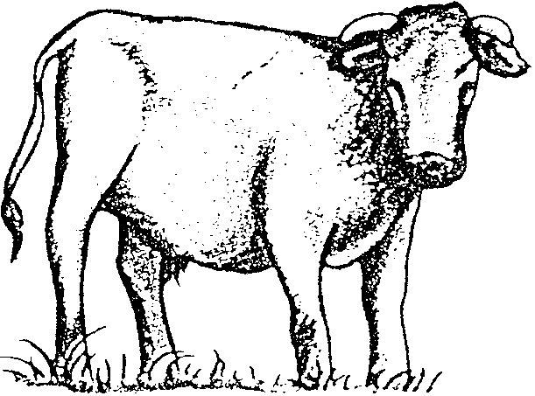

\_\_ to b \_\_ bal \_\_ ço n \_\_ te

##### Nome: \_\_\_\_\_\_\_\_\_\_\_\_\_\_\_\_\_\_\_\_\_\_\_\_\_\_\_\_\_\_\_\_\_\_\_\_\_\_\_\_\_\_\_\_\_\_\_\_\_\_\_

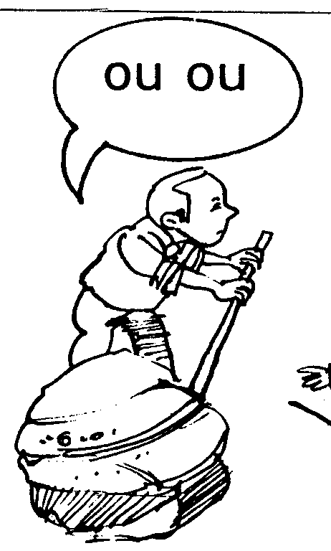Data: \_\_\_\_\_\_\_\_\_\_\_\_\_\_\_\_\_\_\_\_\_\_\_\_\_\_\_\_\_\_\_\_\_\_\_\_\_\_\_\_\_\_\_\_\_\_\_\_\_\_\_\_\_

* 1. 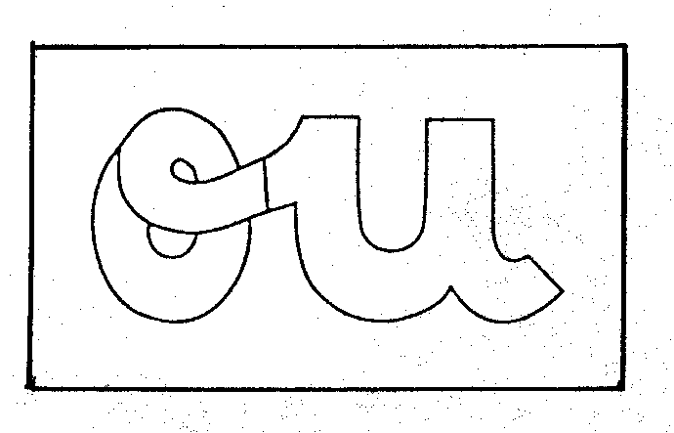Pinta de duas cores.

* 1. Copia e completa.

ou \_\_\_\_\_\_\_\_\_\_\_\_\_\_\_\_\_\_\_\_\_\_\_\_\_\_\_\_\_\_\_\_\_\_\_\_\_\_\_\_\_\_\_\_\_\_\_\_\_\_\_\_\_\_\_

ou \_\_\_\_\_\_\_\_\_\_\_\_\_\_\_\_\_\_\_\_\_\_\_\_\_\_\_\_\_\_\_\_\_\_\_\_\_\_\_\_\_\_\_\_\_\_\_\_\_\_\_\_\_\_\_

Ou \_\_\_\_\_\_\_\_\_\_\_\_\_\_\_\_\_\_\_\_\_\_\_\_\_\_\_\_\_\_\_\_\_\_\_\_\_\_\_\_\_\_\_\_\_\_\_\_\_\_\_\_\_\_\_

Ou \_\_\_\_\_\_\_\_\_\_\_\_\_\_\_\_\_\_\_\_\_\_\_\_\_\_\_\_\_\_\_\_\_\_\_\_\_\_\_\_\_\_\_\_\_\_\_\_\_\_\_\_\_\_\_

1. Nas palavras, circundo o ditongo ou.

fechou vassoura Outono tesoura

terminou pintou roupa

1. ..\..\Programas\Microsoft Office\Clipart\standard\stddir3\IN00701_.wmf..\..\Programas\Microsoft Office\Clipart\standard\stddir3\IN01124_.WMF..\..\Programas\Microsoft Office\Clipart\standard\stddir3\FD00705_.wmf..\..\Programas\Microsoft Office\Clipart\smbusbas\BS00773_.wmfCompleta as palavras seguintes com ou.

tes \_\_ ra vass\_\_ra \_\_ tono cen \_\_ ras

##### Nome: \_\_\_\_\_\_\_\_\_\_\_\_\_\_\_\_\_\_\_\_\_\_\_\_\_\_\_\_\_\_\_\_\_\_\_\_\_\_\_\_\_\_\_\_\_\_\_\_\_\_\_\_

Data: \_\_\_\_\_\_\_\_\_\_\_\_\_\_\_\_\_\_\_\_\_\_\_\_\_\_\_\_\_\_\_\_\_\_\_\_\_\_\_\_\_\_\_\_\_\_\_\_\_\_\_\_\_

1. 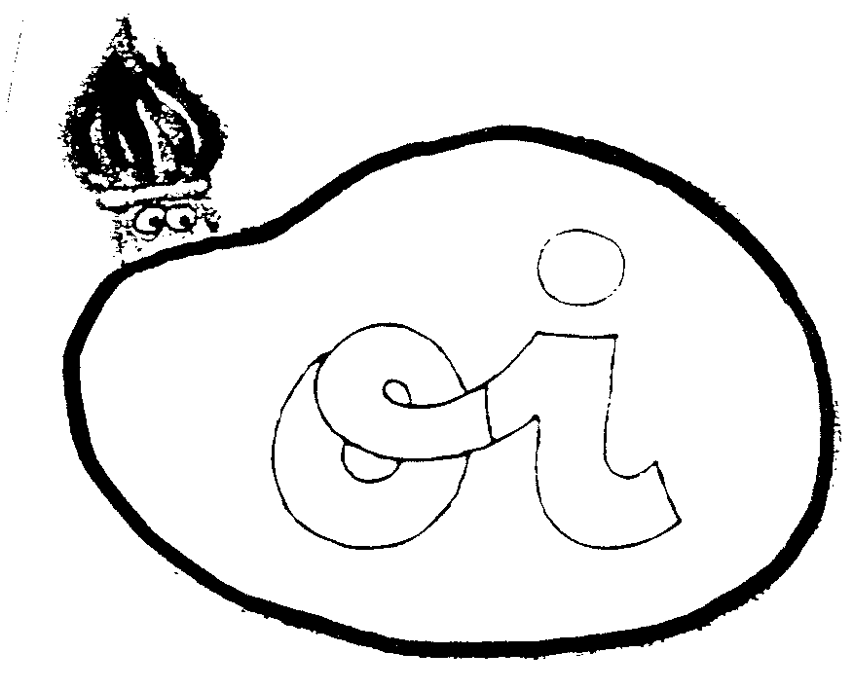Pinta com duas cores.
2. Escrevo os ditongos.

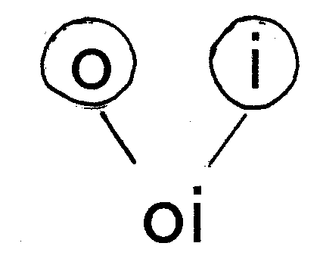oi \_\_\_\_\_\_\_\_\_\_\_\_\_\_\_\_\_\_\_\_\_\_\_\_\_\_\_\_\_\_\_\_\_\_\_

1. 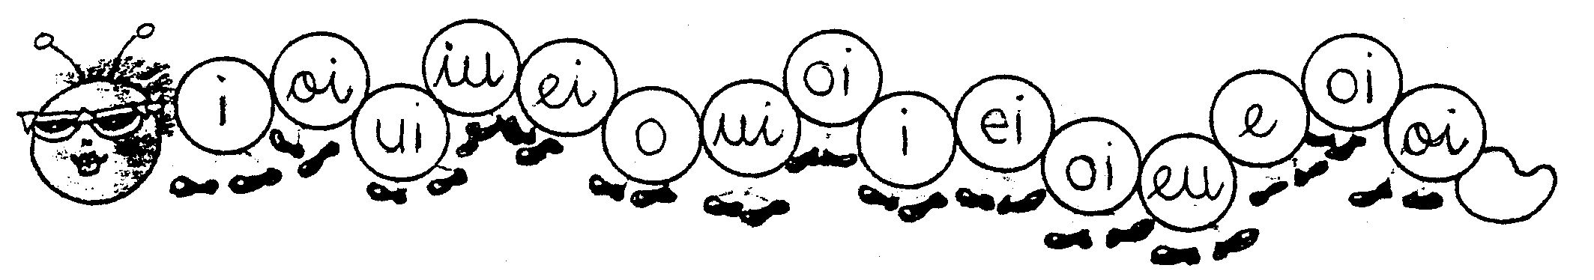Pinto apenas os círculos que têm o ditongo **oi.**
2. Pinta com duas cores.
3. Escrevo os ditongos .

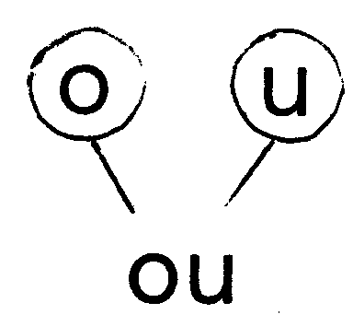

ou \_\_\_\_\_\_\_\_\_\_\_\_\_\_\_\_\_\_\_\_\_\_\_\_\_\_

##### Nome: \_\_\_\_\_\_\_\_\_\_\_\_\_\_\_\_\_\_\_\_\_\_\_\_\_\_\_\_\_\_\_\_\_\_\_\_\_\_\_\_\_\_\_\_\_\_\_\_\_\_\_\_

###### Data: \_\_\_\_\_\_\_\_\_\_\_\_\_\_\_\_\_\_\_\_\_\_\_\_\_\_\_\_\_\_\_\_\_\_\_\_\_\_\_\_\_\_\_\_\_\_\_\_\_\_\_\_\_

1. 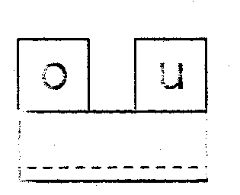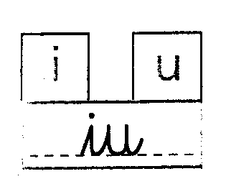Identifico os ditongos e completo.

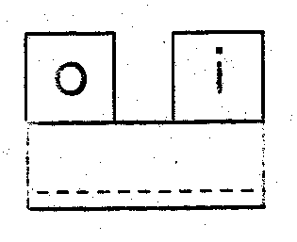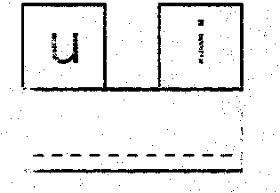

1. Rodeio e copio os ditongos da frase.

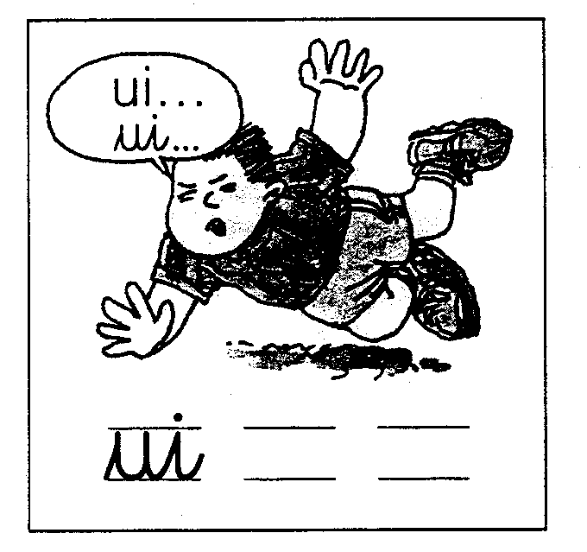

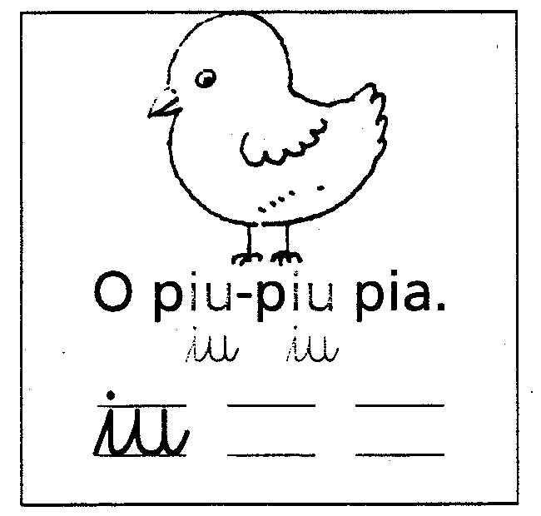

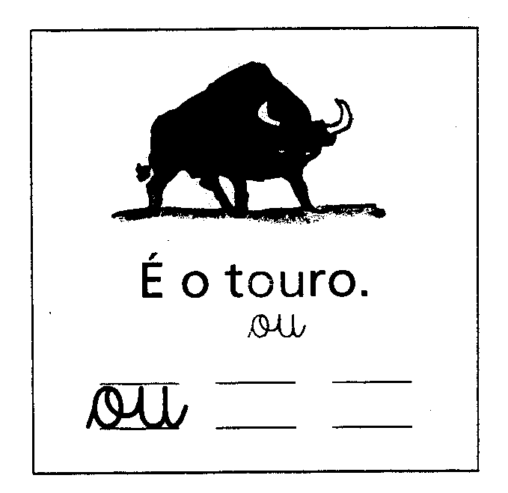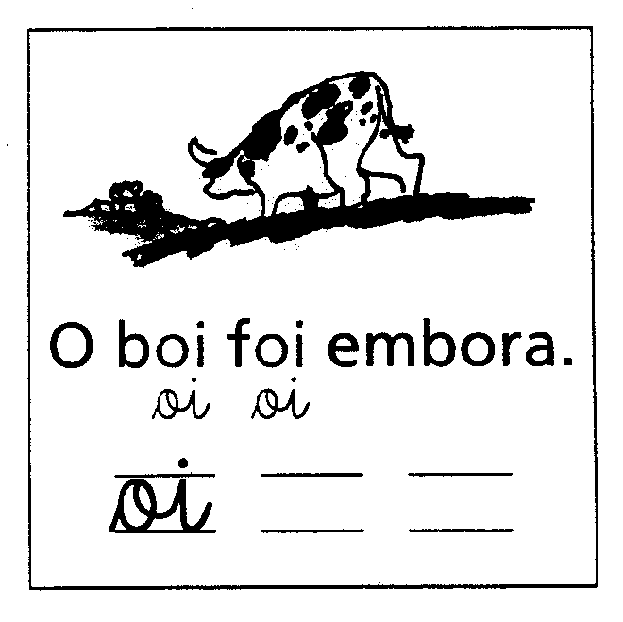

1. Relaciono os ditongos como no exemplo.

|  |  |  |  |
| --- | --- | --- | --- |
|  | ui |  | ou |
| Iu |  | Oi |  |

##### Nome: \_\_\_\_\_\_\_\_\_\_\_\_\_\_\_\_\_\_\_\_\_\_\_\_\_\_\_\_\_\_\_\_\_\_\_\_\_\_\_\_\_\_\_\_\_\_\_\_\_\_\_

**Data:** \_\_\_\_\_\_\_\_\_\_\_\_\_\_\_\_\_\_\_\_\_\_\_\_\_\_\_\_\_\_\_\_\_\_\_\_\_\_\_\_\_\_\_\_\_\_\_\_\_\_\_\_\_

1. 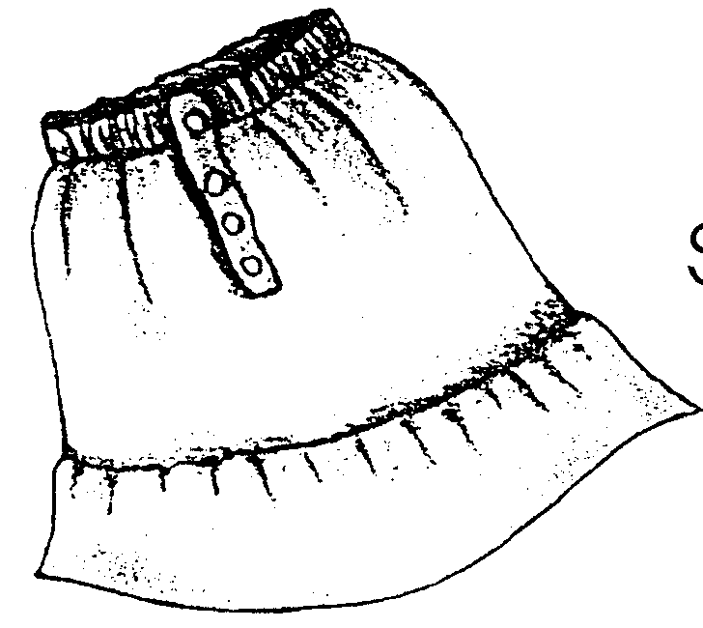Pinta de duas cores.

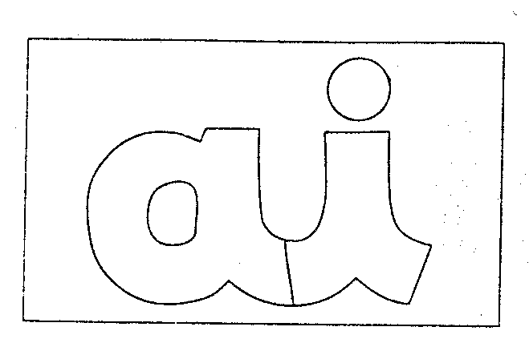

s**ai**a

1. Completa.

Ai \_\_\_\_\_\_\_\_\_\_\_\_\_\_\_\_\_\_\_\_\_\_\_\_\_\_\_\_\_\_\_\_\_\_\_\_\_\_\_\_\_\_\_\_\_\_\_\_\_\_\_\_\_

Ai \_\_\_\_\_\_\_\_\_\_\_\_\_\_\_\_\_\_\_\_\_\_\_\_\_\_\_\_\_\_\_\_\_\_\_\_\_\_\_\_\_\_\_\_\_\_\_\_\_\_\_\_\_\_

ai \_\_\_\_\_\_\_\_\_\_\_\_\_\_\_\_\_\_\_\_\_\_\_\_\_\_\_\_\_\_\_\_\_\_\_\_\_\_\_\_\_\_\_\_\_\_\_\_\_\_\_\_\_\_

ai \_\_\_\_\_\_\_\_\_\_\_\_\_\_\_\_\_\_\_\_\_\_\_\_\_\_\_\_\_\_\_\_\_\_\_\_\_\_\_\_\_\_\_\_\_\_\_\_\_\_\_\_\_\_

1. ..\..\Programas\Microsoft Office\Clipart\standard\stddir1\BD06473_.WMFCompleta as palavras com o ditongo **ai**. ..\..\Programas\Microsoft Office\Clipart\standard\stddir3\IN00341_.wmf

x \_\_\_le g \_\_\_ ola s \_\_\_a c \_\_\_xa

1. ..\..\Programas\Microsoft Office\Clipart\standard\stddir1\AN01314_.wmf..\..\Programas\Microsoft Office\Clipart\smbusbas\PE07410_.WMF..\..\Programas\Microsoft Office\Clipart\Pub60Cor\SO00382_.wmfPinta os desenhos que tenham a letra **ai**.

..\..\Programas\Microsoft Office\Clipart\standard\stddir1\BD06473_.WMF..\..\Programas\Microsoft Office\Clipart\standard\stddir1\BD06074_.WMF

##### Nome: \_\_\_\_\_\_\_\_\_\_\_\_\_\_\_\_\_\_\_\_\_\_\_\_\_\_\_\_\_\_\_\_\_\_\_\_\_\_\_\_\_\_\_\_\_\_\_\_\_\_\_

**Data:** \_\_\_\_\_\_\_\_\_\_\_\_\_\_\_\_\_\_\_\_\_\_\_\_\_\_\_\_\_\_\_\_\_\_\_\_\_\_\_\_\_\_\_\_\_\_\_\_\_\_\_\_\_

1. Pinta de duas cores.

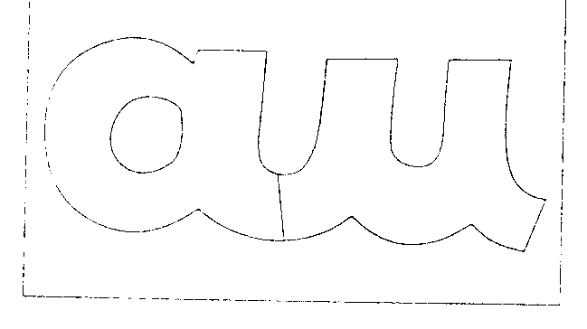

**pau**

1. Completa.

au \_\_\_\_\_\_\_\_\_\_\_\_\_\_\_\_\_\_\_\_\_\_\_\_\_\_\_\_\_\_\_\_\_\_\_\_\_\_\_\_\_\_\_\_\_\_\_\_\_\_\_\_\_

au \_\_\_\_\_\_\_\_\_\_\_\_\_\_\_\_\_\_\_\_\_\_\_\_\_\_\_\_\_\_\_\_\_\_\_\_\_\_\_\_\_\_\_\_\_\_\_\_\_\_\_\_\_\_

Au \_\_\_\_\_\_\_\_\_\_\_\_\_\_\_\_\_\_\_\_\_\_\_\_\_\_\_\_\_\_\_\_\_\_\_\_\_\_\_\_\_\_\_\_\_\_\_\_\_\_\_\_\_\_

Au \_\_\_\_\_\_\_\_\_\_\_\_\_\_\_\_\_\_\_\_\_\_\_\_\_\_\_\_\_\_\_\_\_\_\_\_\_\_\_\_\_\_\_\_\_\_\_\_\_\_\_\_\_\_\_

1. Rodeia nas palavras os ditongos **au.**

cauda mau automóvel

auto-estrada pauta

Paulo saudade automático

1. ..\..\Programas\Microsoft Office\Clipart\corpbas\j0079085.wmf..\..\Programas\Microsoft Office\Clipart\standard\stddir2\EN00375_.wmf..\..\Programas\Microsoft Office\Clipart\standard\stddir1\BD06188_.WMFDiz o que vez e completa as palavras com **au.**

\_\_\_ tocarro \_\_\_tomóvel

p\_\_ta

##### Nome: \_\_\_\_\_\_\_\_\_\_\_\_\_\_\_\_\_\_\_\_\_\_\_\_\_\_\_\_\_\_\_\_\_\_\_\_\_\_\_\_\_\_\_\_\_\_\_\_\_\_\_

**Data:** \_\_\_\_\_\_\_\_\_\_\_\_\_\_\_\_\_\_\_\_\_\_\_\_\_\_\_\_\_\_\_\_\_\_\_\_\_\_\_\_\_\_\_\_\_\_\_\_\_\_\_\_\_

1. Completa.

a i a u

ai au

1. Completa e pinta.

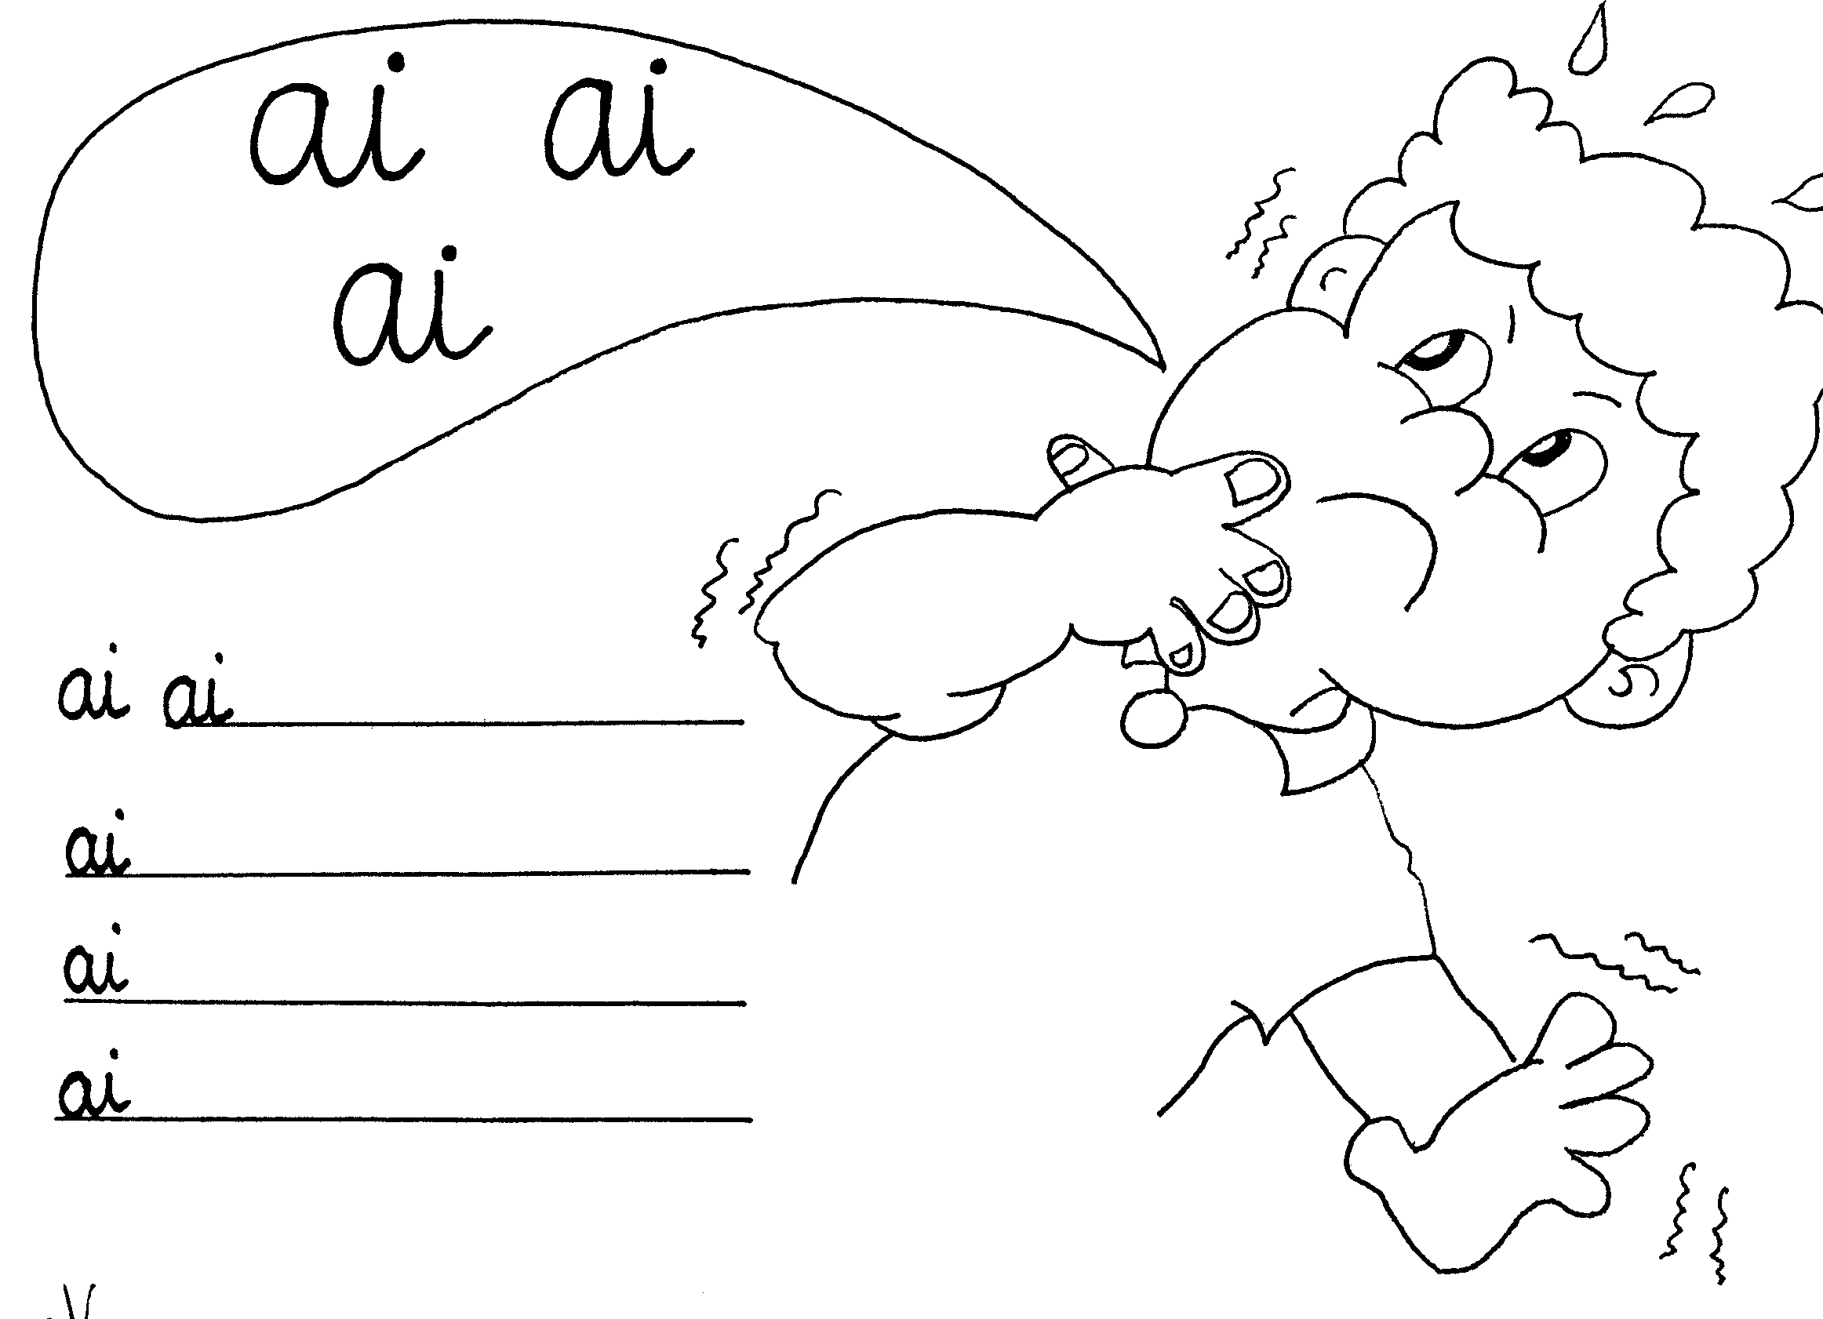

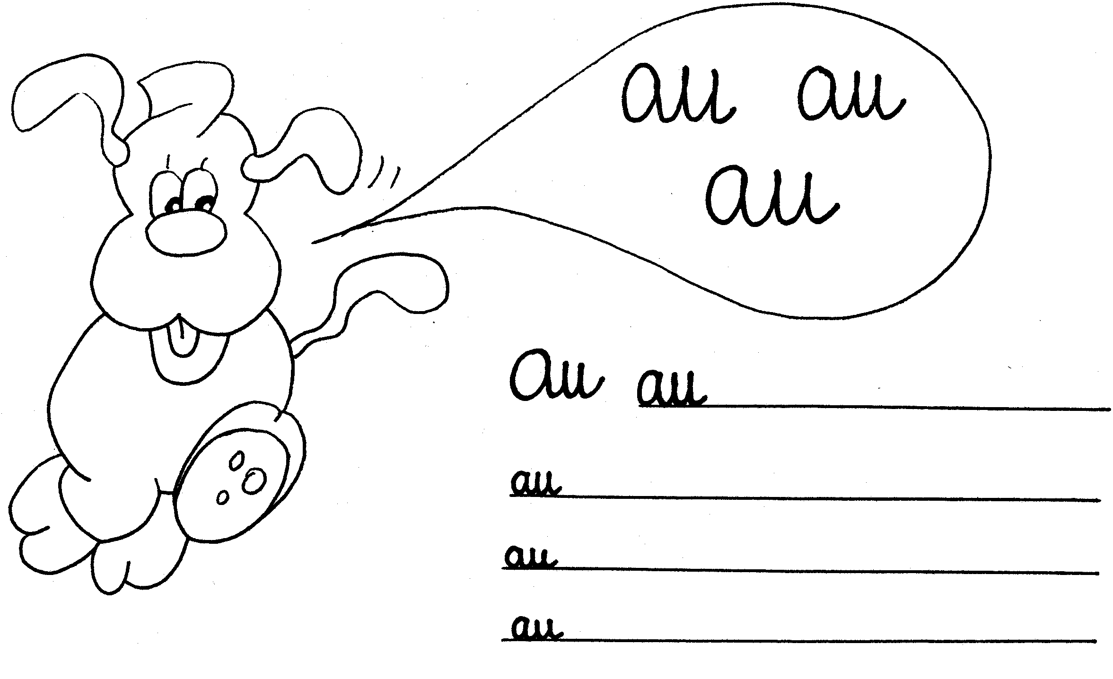

##### Nome: \_\_\_\_\_\_\_\_\_\_\_\_\_\_\_\_\_\_\_\_\_\_\_\_\_\_\_\_\_\_\_\_\_\_\_\_\_\_\_\_\_\_\_\_\_\_\_\_\_\_\_\_

**Data:** \_\_\_\_\_\_\_\_\_\_\_\_\_\_\_\_\_\_\_\_\_\_\_\_\_\_\_\_\_\_\_\_\_\_\_\_\_\_\_\_\_\_\_\_\_\_\_\_\_\_\_\_\_

1. Pinta e copia.

**ã o**

\_\_\_\_\_\_

ão\_\_\_\_\_\_\_\_\_\_\_\_\_\_\_\_\_\_\_\_\_\_\_\_\_\_\_\_\_\_\_\_\_\_\_\_\_\_\_\_\_\_\_\_\_\_\_\_\_\_\_\_\_

ão\_\_\_\_\_\_\_\_\_\_\_\_\_\_\_\_\_\_\_\_\_\_\_\_\_\_\_\_\_\_\_\_\_\_\_\_\_\_\_\_\_\_\_\_\_\_\_\_\_\_\_\_\_

1. Completa as palavras com **ão.**

..\..\Programas\Microsoft Office\Clipart\standard\stddir1\AN02372_.wmf..\..\Programas\Microsoft Office\Clipart\standard\stddir1\AN01651_.wmf..\..\Programas\Microsoft Office\Clipart\standard\stddir1\AN01310_.wmf..\..\Programas\Ficheiros comuns\Microsoft Shared\Clipart\CagCat50\AN01124_.wmf

le\_\_\_ tubar\_\_\_ c\_\_\_ pav\_\_\_

..\..\Programas\Microsoft Office\Clipart\standard\stddir1\BD05702_.WMF..\..\Programas\Microsoft Office\Clipart\corpbas\j0079254.wmf..\..\Programas\Ficheiros comuns\Microsoft Shared\Clipart\CagCat50\BD08911_.WMF

..\..\Programas\Microsoft Office\Clipart\standard\stddir3\FD01006_.wmf

p\_\_\_ lim\_\_\_ nataç\_\_\_ avi\_\_\_

1. Rodeia nas palavras o ditongo **ão**

anão sabão são

irmão João camião

##### Nome: \_\_\_\_\_\_\_\_\_\_\_\_\_\_\_\_\_\_\_\_\_\_\_\_\_\_\_\_\_\_\_\_\_\_\_\_\_\_\_\_\_\_\_\_\_\_\_\_\_\_\_\_

**Data:** \_\_\_\_\_\_\_\_\_\_\_\_\_\_\_\_\_\_\_\_\_\_\_\_\_\_\_\_\_\_\_\_\_\_\_\_\_\_\_\_\_\_\_\_\_\_\_\_\_\_\_\_\_

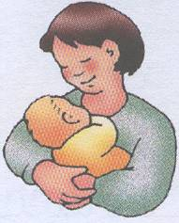

1. Completa e pinta.

ãe\_\_\_\_\_\_\_\_\_\_\_\_\_\_\_\_\_\_\_\_\_\_\_\_\_\_\_\_\_\_\_\_\_\_\_

m**ãe**

1. Sublinha
2. nas palavras o ditongo **ãe.**

Guimarães cães capitães

1. ..\..\Programas\Microsoft Office\Clipart\standard\stddir1\AN02359_.wmfCompleta e pinta.

ia \_\_\_\_\_\_\_\_\_\_\_\_\_\_\_\_\_\_\_\_\_\_\_\_\_\_\_\_\_\_\_\_\_\_

Ia\_\_\_\_\_\_\_\_\_\_\_\_\_\_\_\_\_\_\_\_\_\_\_\_\_\_\_\_\_\_\_\_\_\_\_

m**ia**

1. Rodeia nas palavras o ditongo **ia.**

comia sabia fazia

##### Nome: \_\_\_\_\_\_\_\_\_\_\_\_\_\_\_\_\_\_\_\_\_\_\_\_\_\_\_\_\_\_\_\_\_\_\_\_\_\_\_\_\_\_\_\_\_\_\_\_\_\_\_\_

**Data:** \_\_\_\_\_\_\_\_\_\_\_\_\_\_\_\_\_\_\_\_\_\_\_\_\_\_\_\_\_\_\_\_\_\_\_\_\_\_\_\_\_\_\_\_\_\_\_\_\_\_\_\_\_

* 1. Pinta os desenhos que correspondem a palavras que têm o ditongo **ai** .

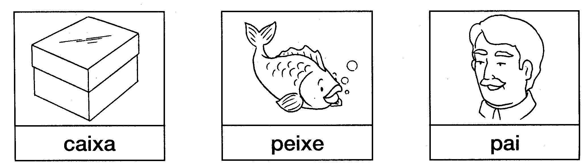

\_\_\_\_\_\_\_\_\_\_\_\_\_\_\_\_\_\_\_\_\_\_\_\_\_\_\_\_\_\_\_\_\_\_\_\_\_\_\_\_\_\_\_\_\_\_\_\_\_\_\_\_\_\_\_\_

* 1. Pinta os desenhos que têm o ditongo **au** .

..\..\Programas\Microsoft Office\Clipart\smbusbas\BS00773_.wmf..\..\Programas\Microsoft Office\Clipart\standard\stddir4\SY00484_.wmf..\..\Programas\Microsoft Office\Clipart\corpbas\j0079085.wmf

1. 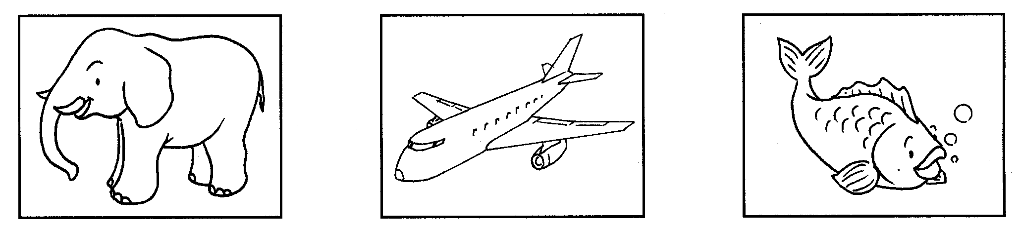Pinta os desenhos que têm o ditongo **ão** .

##### Nome: \_\_\_\_\_\_\_\_\_\_\_\_\_\_\_\_\_\_\_\_\_\_\_\_\_\_\_\_\_\_\_\_\_\_\_\_\_\_\_\_\_\_\_\_\_\_\_\_\_\_\_\_

**Data:** \_\_\_\_\_\_\_\_\_\_\_\_\_\_\_\_\_\_\_\_\_\_\_\_\_\_\_\_\_\_\_\_\_\_\_\_\_\_\_\_\_\_\_\_\_\_\_\_\_\_\_\_\_

1. Pinto com duas cores.

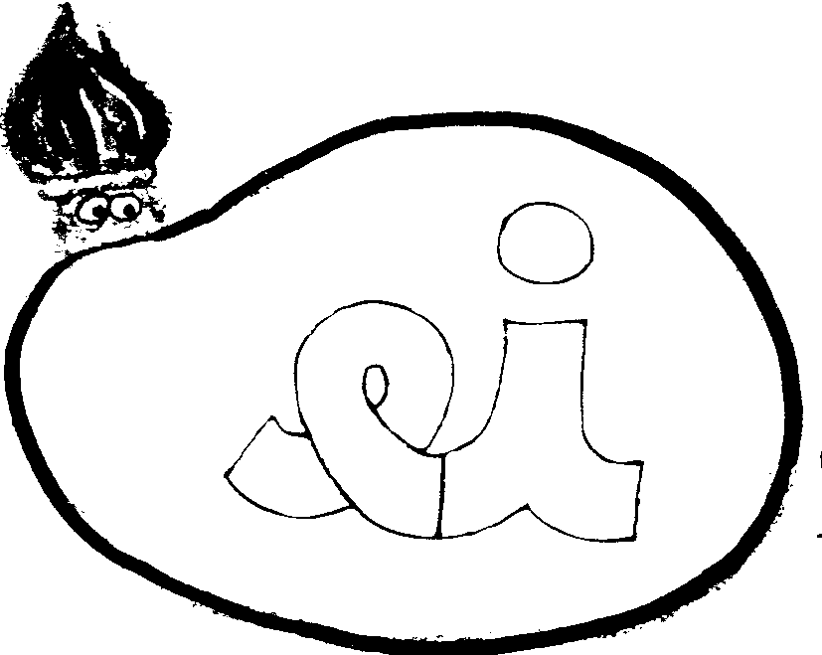

1. Pinto apenas os círculos que têm o ditongo **ei**.

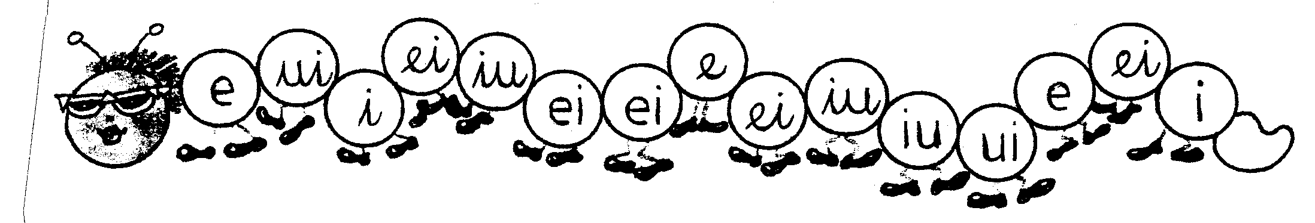

1. 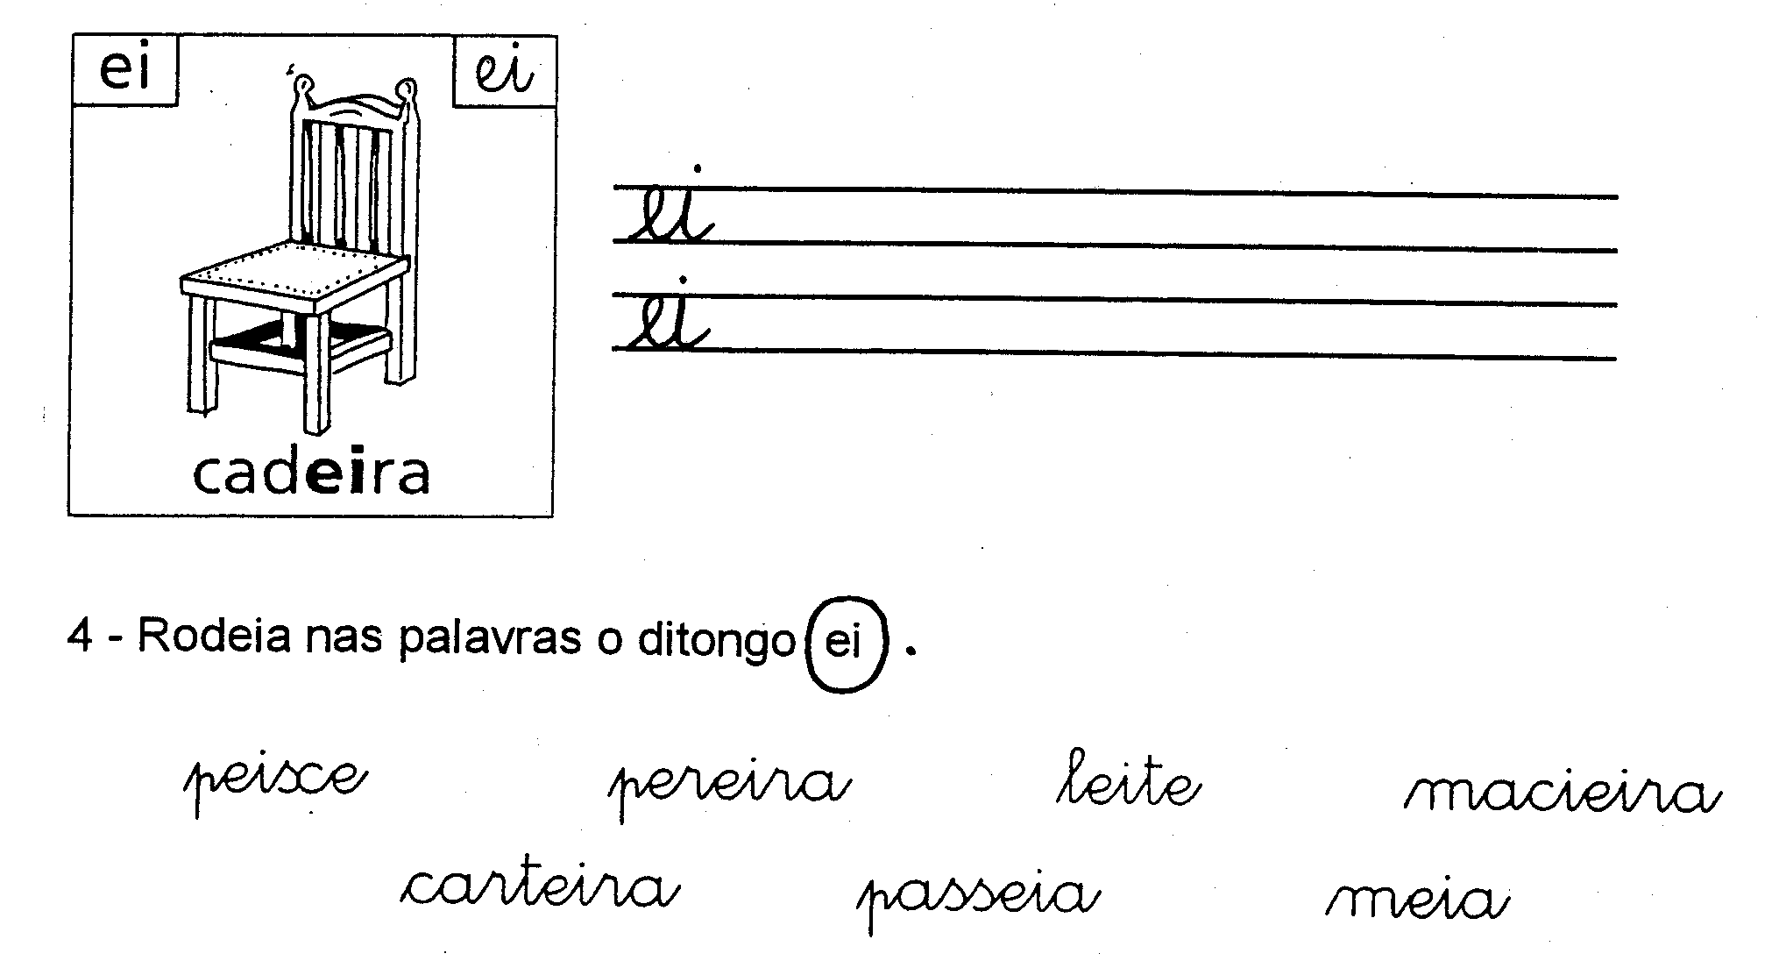Escrevo conforme o exemplo.

##### Nome: \_\_\_\_\_\_\_\_\_\_\_\_\_\_\_\_\_\_\_\_\_\_\_\_\_\_\_\_\_\_\_\_\_\_\_\_\_\_\_\_\_\_\_\_\_\_\_\_\_\_\_\_

**Data:** \_\_\_\_\_\_\_\_\_\_\_\_\_\_\_\_\_\_\_\_\_\_\_\_\_\_\_\_\_\_\_\_\_\_\_\_\_\_\_\_\_\_\_\_\_\_\_\_\_\_\_\_\_

1. Pinto com duas cores.

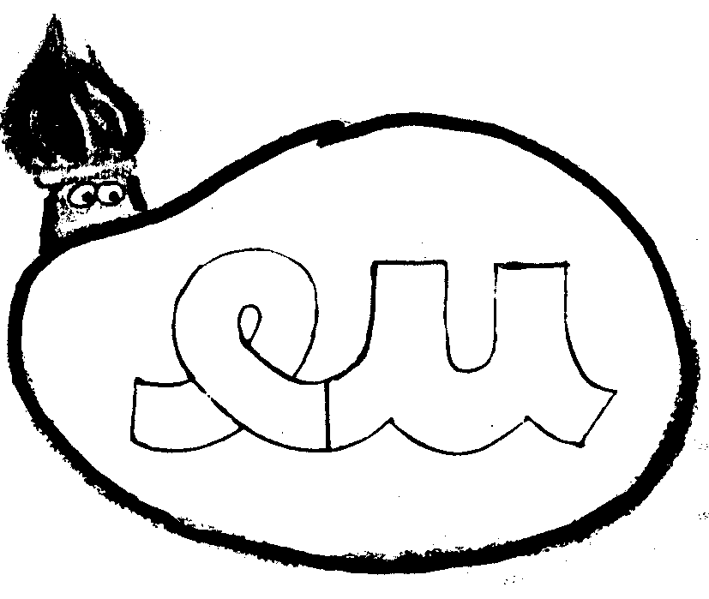

1. Escrevo o ditongo.

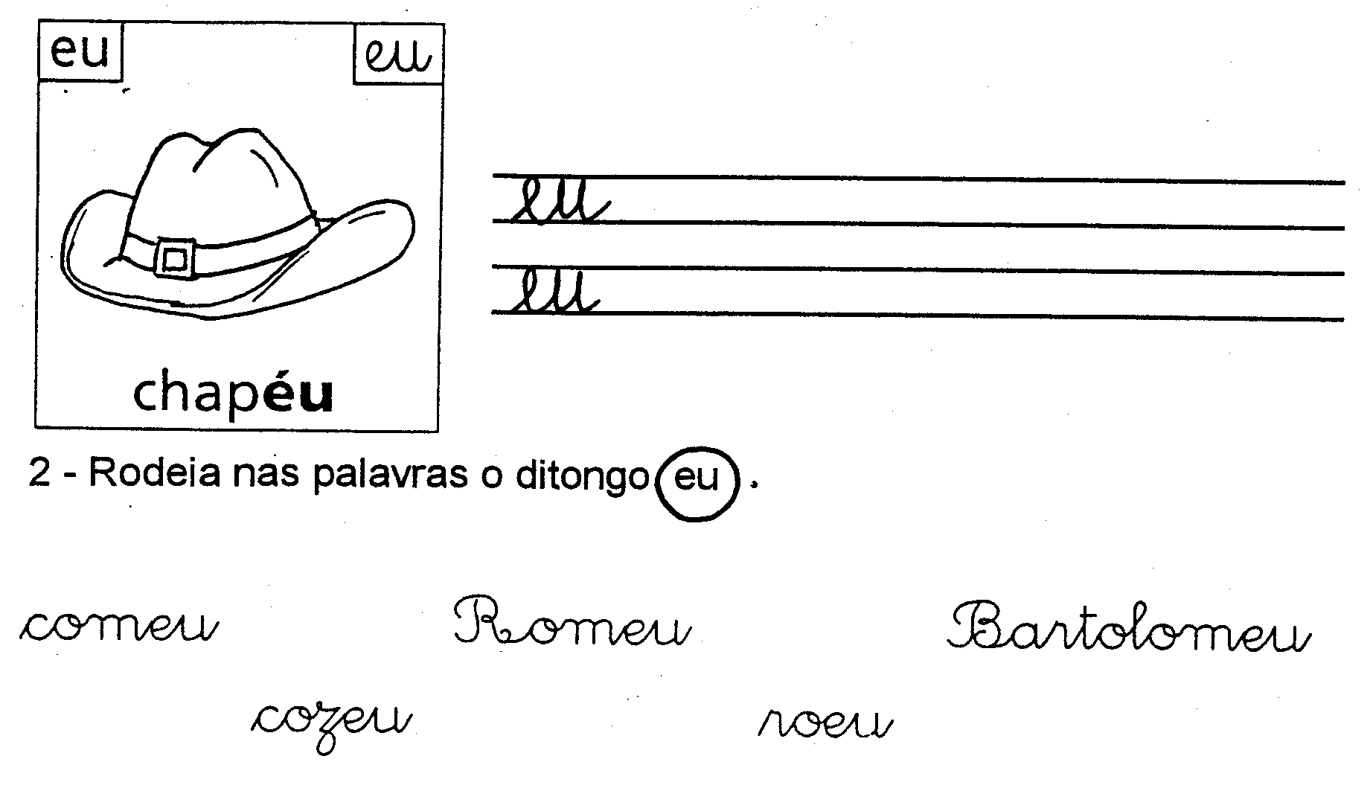

1. Pinto apenas os círculos que têm o ditongo **eu**.
2. Escrevo conforme o exemplo e faço o desenho da frase.

##### Nome: \_\_\_\_\_\_\_\_\_\_\_\_\_\_\_\_\_\_\_\_\_\_\_\_\_\_\_\_\_\_\_\_\_\_\_\_\_\_\_\_\_\_\_\_\_\_\_\_\_\_\_\_

**Data:** \_\_\_\_\_\_\_\_\_\_\_\_\_\_\_\_\_\_\_\_\_\_\_\_\_\_\_\_\_\_\_\_\_\_\_\_\_\_\_\_\_\_\_\_\_\_\_\_\_\_\_\_\_

1. Faz a correspondência.

**Iu**

**Ui**

**Oi**

**Ou**

**Ai**

**Au**

**Ão**

**iu**

**ui**

**oi**

**ou**

**ai**

**au**

**ão**

1. Completa.

**iu - \_\_\_\_\_ Iu - \_\_\_\_\_**

**ui - \_\_\_\_\_ Ui - \_\_\_\_\_**

**oi - \_\_\_\_\_ Oi - \_\_\_\_\_**

**ou - \_\_\_\_\_ Ou - \_\_\_\_\_**

**ai - \_\_\_\_\_ Ai - \_\_\_\_\_**

**au - \_\_\_\_\_ Au - \_\_\_\_\_**

**ão - \_\_\_\_\_ Ão - \_\_\_\_\_**