As vogais, juntas, formam palavrinhas. Descobre esta!
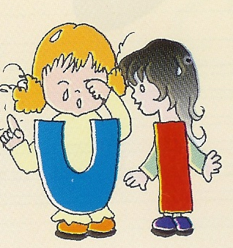
Pinta as letras das cores respectivas.
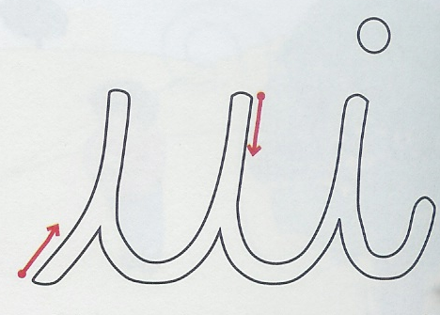

ESCOLA N.º 6 DE PENICHE

Língua Portuguesa
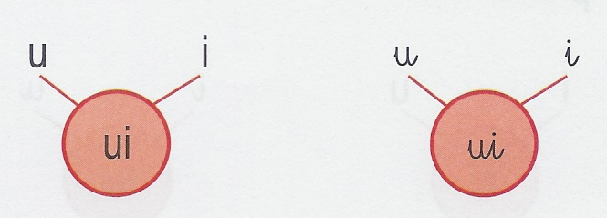
__________________________________________________________________________________________________________________________________________________

__________________________________________________________________________________________________________________________________________________

__________________________________________________________________________________________________________________________________________________

___________________________________________________________________________________________________________________________________________________
Lê e copia seguindo os exemplos.

