**E.B.1/J.I. Tapada das Mercês**

**1.ºAB – Prof.ª Sara Fortes**

**Ditongos: ai – Ai / au – Au - (revisões de outros ditongos dados)**

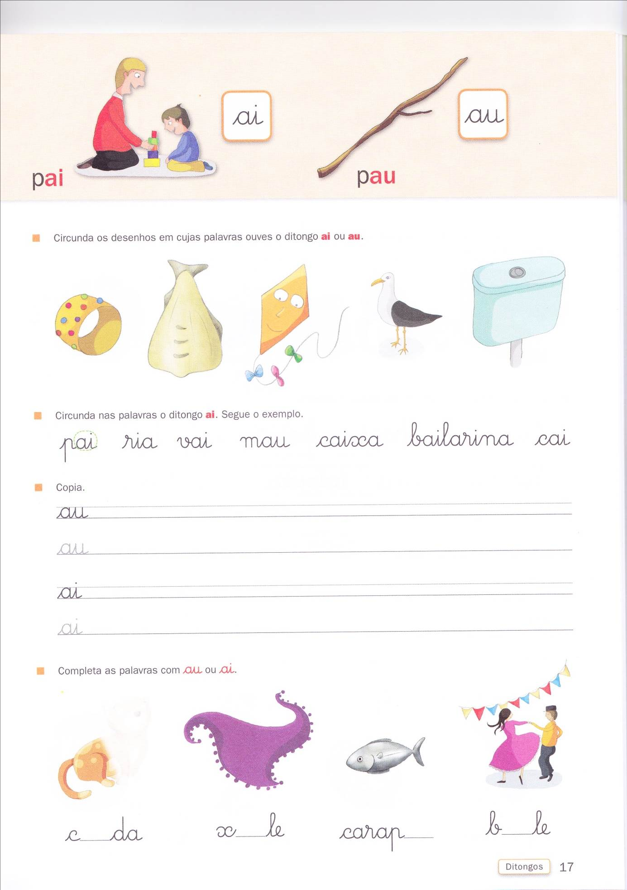**Nome: _____________________________________________ Data: ____/_____/______ N.º______**

**- Completa** as palavras com os **ditongos** referidos:

|  |  |  |  |
| --- | --- | --- | --- |
| **iu** | **ui** | **ai** | **au** |
| p___ - p___  v____ | c____dado  R___ | g____vota  c____  p____  c____xa  s____  b____larina | c____da  p____  m____  _____la  P____lo |

|  |  |
| --- | --- |
| **oi** | **ou** |
| n____va  n____te  b___  f____ce | _____riço  _____ro  r____pa  l____ro |