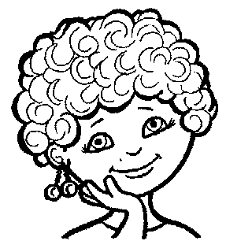

L L L L L L L L L
L L L L L L L L L
L_____________________________
L_____________________________
La____________________________
Le____________________________
Li___________________________
Lo____________________________
Lu___________________________

L L L L L L L L L
L L L L L L L L L
L_____________________________
L_____________________________
La____________________________
Le____________________________
Li___________________________
Lo____________________________
Lu___________________________

S S S S S S S S S S S S S
S S S S S S S S S S S S S
S_________________________________
S__________________________________
Sa_________________________________
Se__________________________________
Si__________________________________
So__________________________________
Su_________________________________
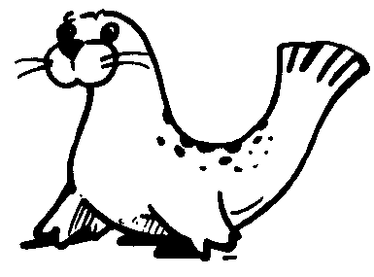

f f f f f f f f f f f f
f f f f f f f f f f f f
f_________________________________
f__________________________________
fa_________________________________
fe__________________________________
fi__________________________________
fo__________________________________
fu_________________________________
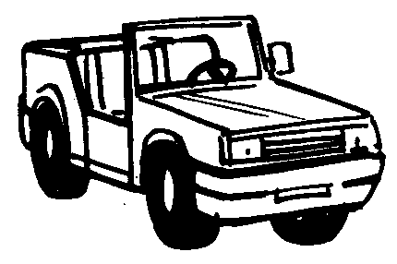

j j j j j j j j j j j j j
j j j j j j j j j j j j j
j_________________________________
j__________________________________
ja_________________________________
je__________________________________
ji__________________________________
jo__________________________________
ju_________________________________
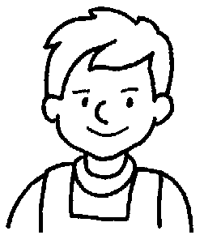

J J J J J J J J J J J
J J J J J J J J J J J
J__________________________________
J__________________________________
Já_________________________________
Je__________________________________
Ji__________________________________
Jo__________________________________
Ju_________________________________

Divide as palavras em sílabas.
Pato- ___ ___ pipa- ___ ___
Pateta- ___ ___ pote- ___ ___
Papaia- ___ ___ ___ ___

Divide as palavras em sílabas.
Pato- ___ ___ pipa- ___ ___
Pateta- ___ ___ pote- ___ ___
Papaia- ___ ___ ___ ___

Divide as palavras em sílabas.
Pato- ___ ___ pipa- ___ ___
Pateta- ___ ___ pote- ___ ___
Papaia- ___ ___ ___ ___

Divide as palavras em sílabas.
Pato- ___ ___ pipa- ___ ___
Pateta- ___ ___ pote- ___ ___
Papaia- ___ ___ ___ ___

Divide as palavras em sílabas.
sofá- ___ ___ saco- ___ ___
caneta- ___ ___ ___ javali- ___ ___ ___
Papaia- ___ ___ ___ ___ capa- ___ ___

Divide as palavras em sílabas.
sofá- ___ ___ saco- ___ ___
caneta- ___ ___ ___ javali- ___ ___ ___
Papaia- ___ ___ ___ ___ capa- ___ ___
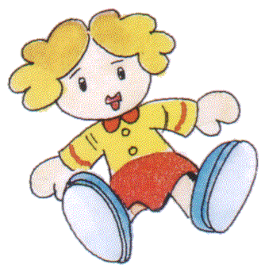

F F F F F F F F F F
F F F F F F F F F F
F_________________________________
F__________________________________
Fa_________________________________
Fe__________________________________
Fi__________________________________
Fo__________________________________
Fu_________________________________
z z z z z z z z z z z z z z z
Z Z Z Z Z Z Z Z Z Z
z_________________________________
Z________________________________
za_________________________________
Za________________________________
ze__________________________________
Ze________________________________
zi_________________________________
Zi________________________________
zo_________________________________
Zo _______________________________
zu________________________________
Zu________________________________

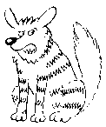

h h h h h h h h h h h h h h h h
h h h h h h h h h h h h h h h h
h__________________________________
h__________________________________
ha_________________________________
he__________________________________
hi__________________________________
ho__________________________________
hu_________________________________
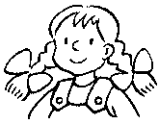

H H H H H H H H H H H
H H H H H H H H H H H
H__________________________________
H__________________________________
Ha_________________________________
He__________________________________
Hi__________________________________
Ho__________________________________
Hu_________________________________
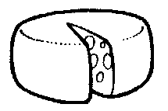

q q q q q q q q q q q q q q q
q q q q q q q q q q q q q q q
q__________________________________
q__________________________________
qua_______________________________
que________________________________
qui________________________________
quo________________________________

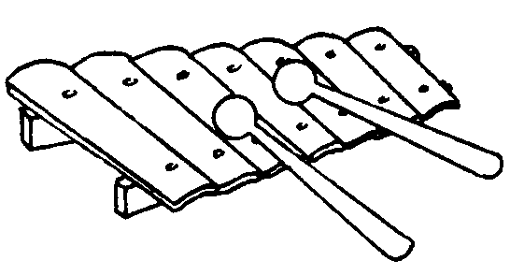

x x x x x x x x x x x x x x
x x x x x x x x x x x x x x
x__________________________________
x__________________________________
xa_________________________________
xe__________________________________
xi__________________________________
xo__________________________________
xu_________________________________
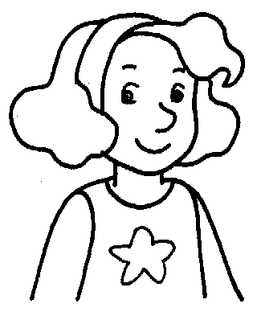

X X X X X X X X X
X X X X X X X X X
X__________________________________
X__________________________________
Xa_________________________________
Xe__________________________________
Xi__________________________________
Xo__________________________________
Xu_________________________________

