Nome:______________________________________________
Data ______/______/______
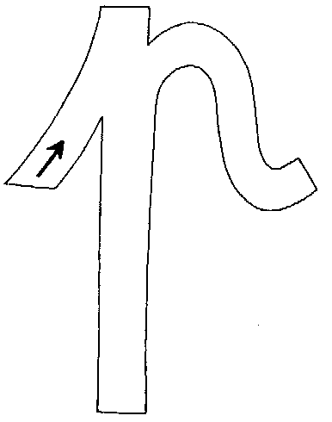
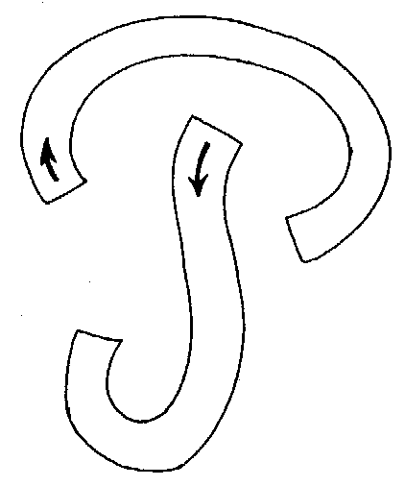
P p

p ______ ______ ______ ______ ______ ______ _______
p ______ ______ ______ ______ ______ ______ _______
P ______ ______ ______ ______ ______ ______ _______
P ______ ______ ______ ______ ______ ______ _______

É a pá.

___________________________

