Nome: ____________________________________________________________


Data: ___/___/____

1. Pinta.

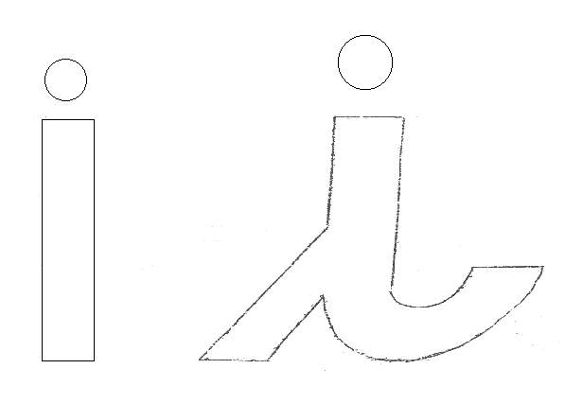
2. Escreve.

i ______ ______ ______ ______ ______ _______
i ______ ______ ______ ______ ______ _______
i ______ ______ ______ ______ ______ _______
i ______ ______ ______ ______ ______ _______

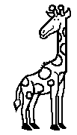
3. Pinta as figuras que tem i no nome.

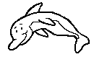


bolo pomba golfinho girafa

