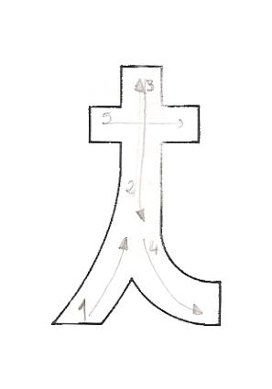
Nome ____________________________________________________________________

Data _____________________________________________________________________

t __________ __________ __________ __________
t __________ __________ __________ __________
t __________ __________ __________ __________
ta __________ __________ __________ __________
ta __________ __________ __________ __________
te __________ __________ __________ __________
te __________ __________ __________ __________
ti __________ __________ __________ __________
ti __________ __________ __________ __________
to __________ __________ __________ __________
to __________ __________ __________ __________
tu __________ __________ __________ __________
tu __________ __________ __________ __________
Lê as palavras e circunda os t.
tia | pato | pote | apito

