Nome _____________________________________________________

Data ______________________________________________________

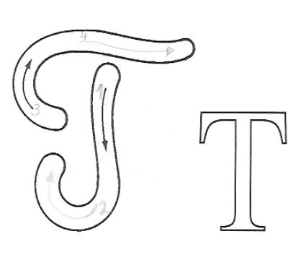
T ________ ________ ________

T ________ ________ ________

T ________ ________ ________

T ________ ________ ________

Ta ________ ________ ________
Te ________ ________ ________ ________

Ti ________ ________ ________ ________

To ________ ________ ________ ________

Tu ________ ________ ________ ________

Liga as palavras.

Tito | apito | tia | teia

