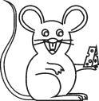

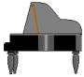
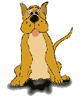

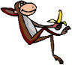
⇨ Escreve as frases:

O Romeu ouve o piano e o violino.
___________________________________________

A Noémia toca .
__________________________________________

O menino ouve o .
___________________________________________

A avó deu a à neta.
___________________________________________

O Diogo viu o .
___________________________________________

⇨ Inventa frases:
cavalo - ___________________________________
médico - ___________________________________
couve - ___________________________________
roda - ___________________________________

⇨ Escreve as frases:

O Romeu ouve o piano e o violino.
___________________________________________

A Noémia toca .
__________________________________________

O menino ouve o .
___________________________________________

A avó deu a à neta.
___________________________________________

O Diogo viu o .
___________________________________________

⇨ Inventa frases:
cavalo - ___________________________________
médico - ___________________________________
couve - ___________________________________
roda - ___________________________________

