FICHA DE TRABALHO
NOME:_________________________________________________
DATA: _____/_____/________
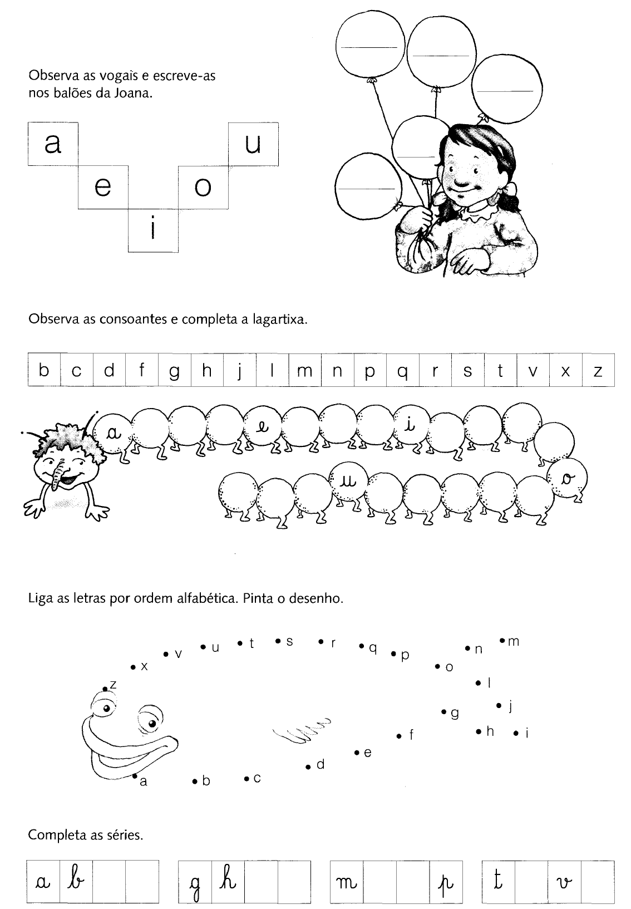

LÍNGUA PORTUGUESA

Data :__________________________________________

Nome :_________________________________________



A , B , C , D , E , F , G , H , I , J , L , M , N , O , P , Q , R , S , T , U , V , X , Z.

______________________________________________________________________

______________________________________________________________________

______________________________________________________________________

______________________________________________________________________

a , b , c , d , e , f , g , h , i , j , l , m , n , o , p , q , r , s , t , u , v , x , z.

______________________________________________________________________

______________________________________________________________________

______________________________________________________________________

______________________________________________________________________


