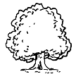 |  |  |  | 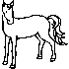 |  | 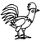 |  |  |  | 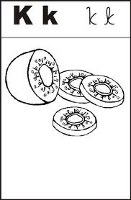 |  |  |  | 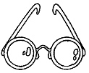 | 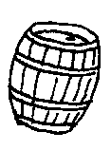 |  | 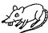 | 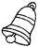 | 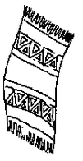 | 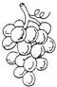 |  | 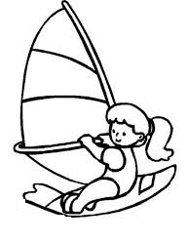 |  | 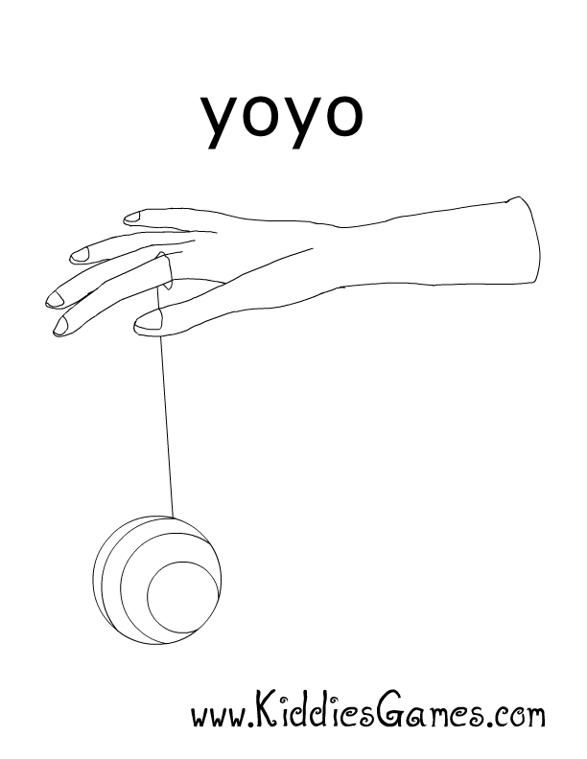
a | b | c | d | e | f | g | h | i | j | k | l | m | n | o | p | q | r | s | t | u | v | w | x | y | z
 |  |  |  |  |  |  |  |  |  |  |  |  |  |  | 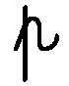 |  |  |  |  |  | 
A | B | C | D | E | F | G | H | I | J | K | L | M | N | O | P | Q | R | S | T | U | V | W | X | Y | Z
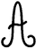 |  |  |  | 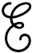 |  |  |  |  |  |  | 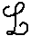 | 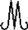 |  |  |  |  | 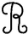 |  |  | 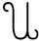 |  |  | 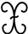 |  | 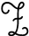

a | b | c | d | e | f | g | h | i | j | k | l | m | n | o | p | q | r | s | t | u | v | w | x | y | z
A | B | C | D | E | F | G | H | I | J | K | L | M | N | O | P | Q | R | S | T | U | V | W | X | Y | Z

