Completa:
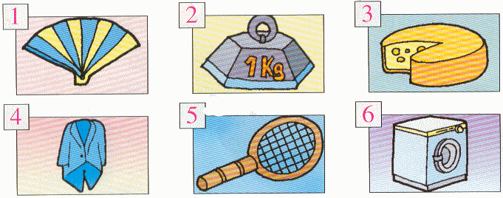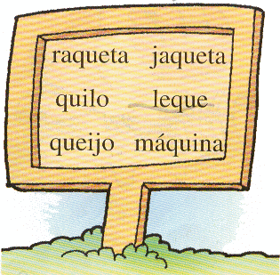

1 - _________________________________  2 - _________________________________ | 3 - _________________________________  4 - _________________________________ | 5 - _________________________________  6 - _________________________________

Lê as frases e copia-as:

A Joana joga com a bola e a raquete ao pé da casa da tia.

_________________________________________________________________________________________________________________________

A tia Joaquina abana-se com o leque.

_________________________________________________________________________________________________________________________

