Nome: Data:

Faz a legenda e inventa algumas frases.

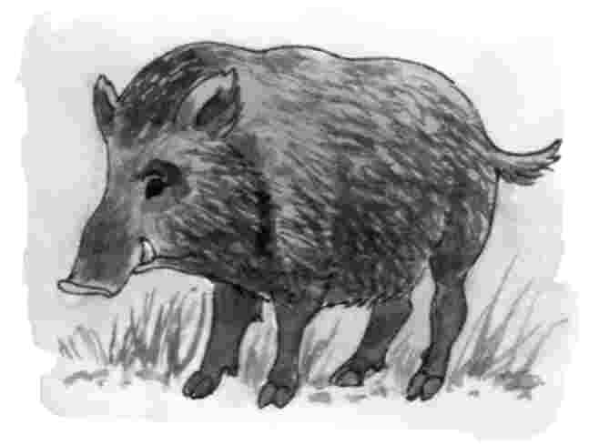
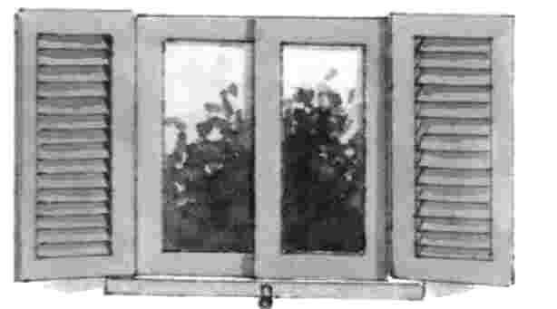
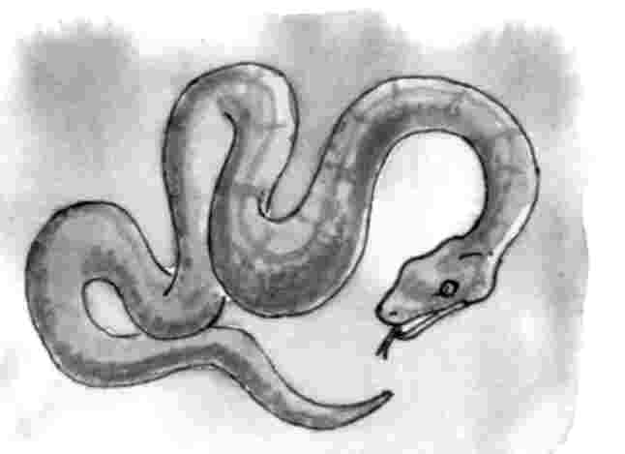

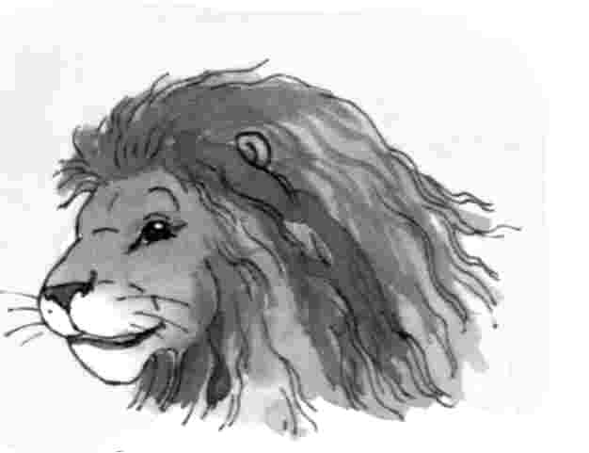
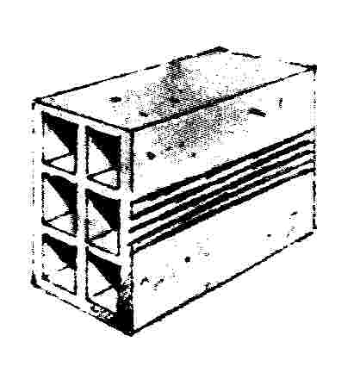
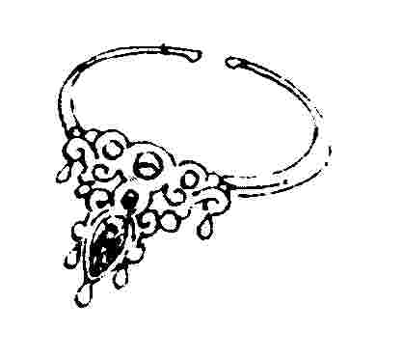

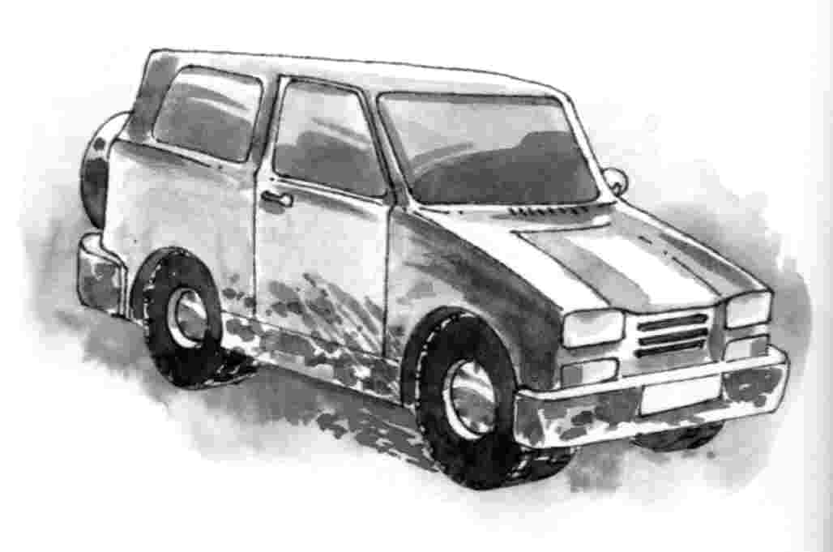

________________________________________________________________________________________________________________________________________________________________________________________________________________________________________________________________________________________________________________________________

Ordena as sílabas para formar palavras.
va
ja
ja
lo
me
Jai
li
la
ja
pe
ji
ba
ju
ne

