Nome: ________________________________________________________Data: _______________

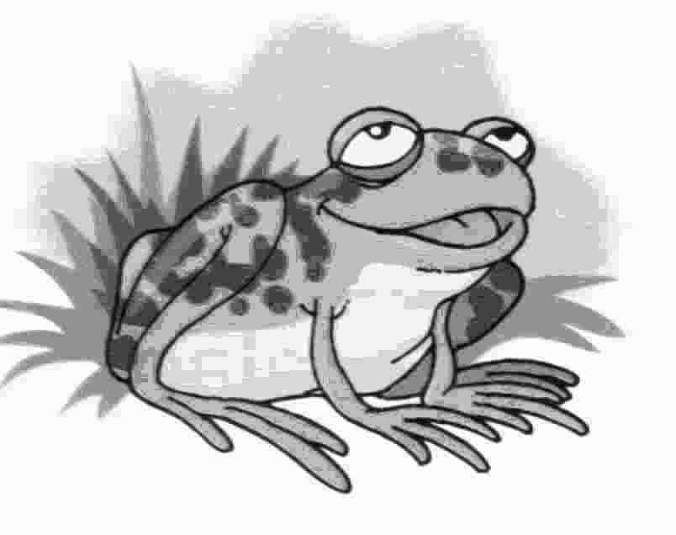

sapo

s _____________________________________________________
sa ____________________________________________________
se ____________________________________________________
si ____________________________________________________
so ____________________________________________________
su ____________________________________________________

Faz a legenda.
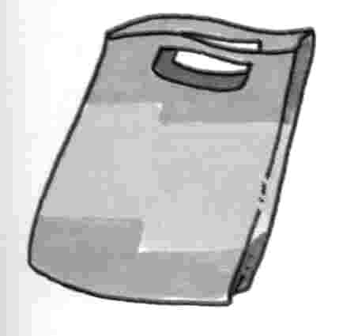
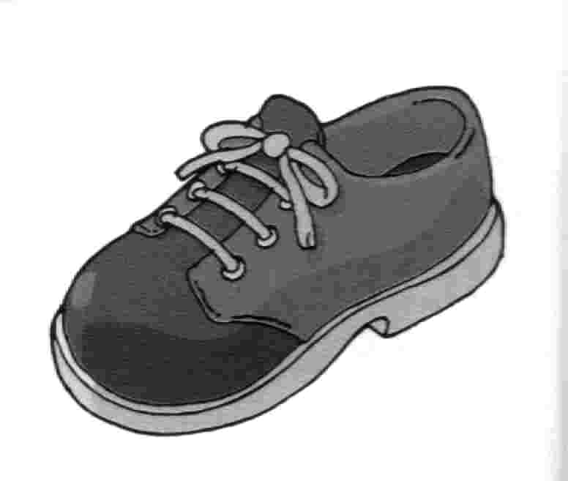
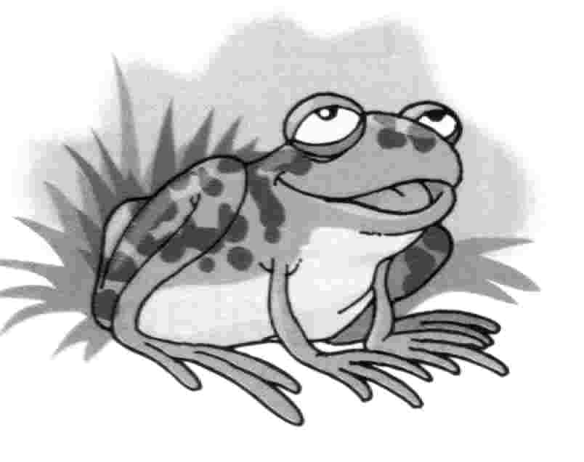
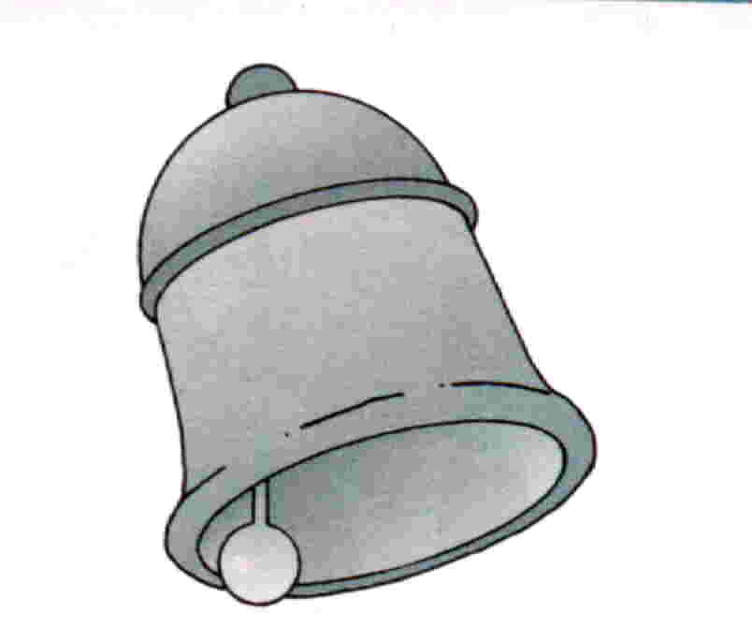
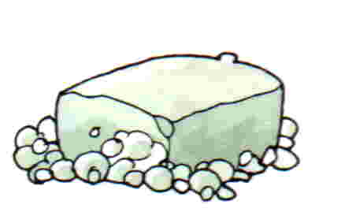

Relaciona as imagens com as frases.
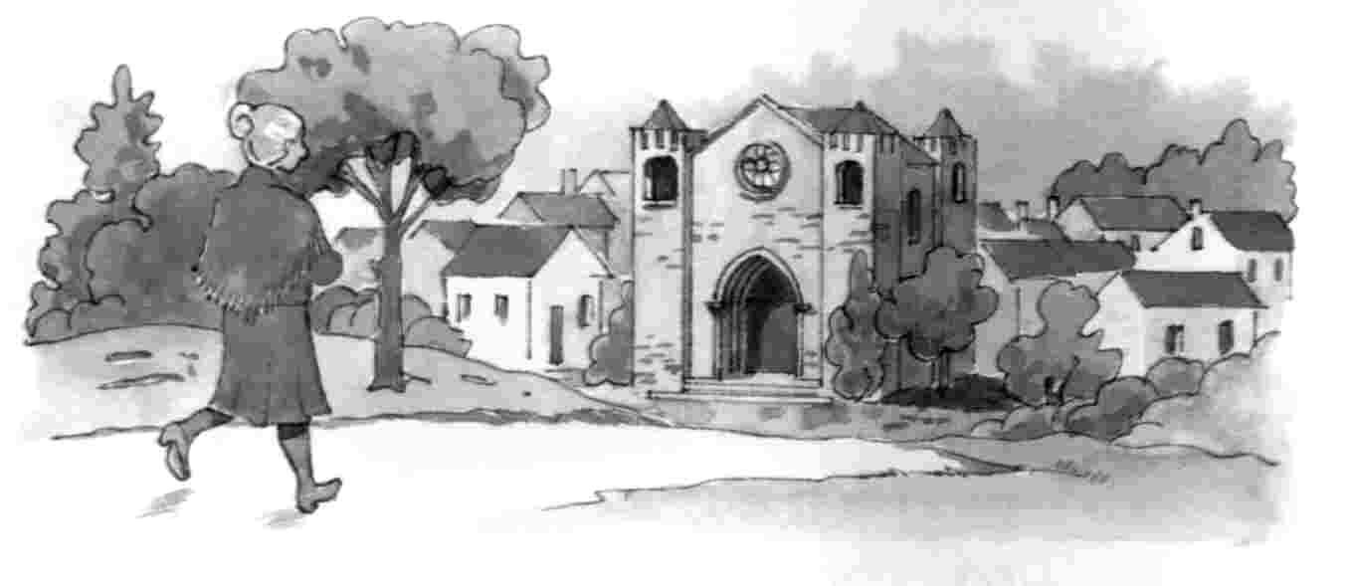

- A Sónia come o pão e a salada. Ela bebe sumo de uva.

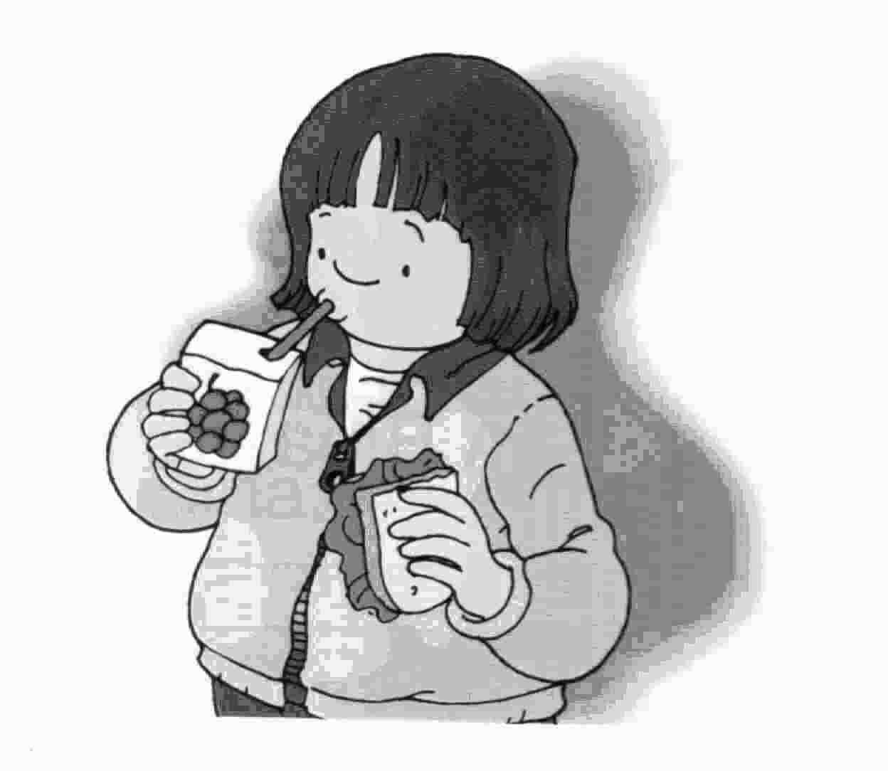

- O Jaime tem muito sono.

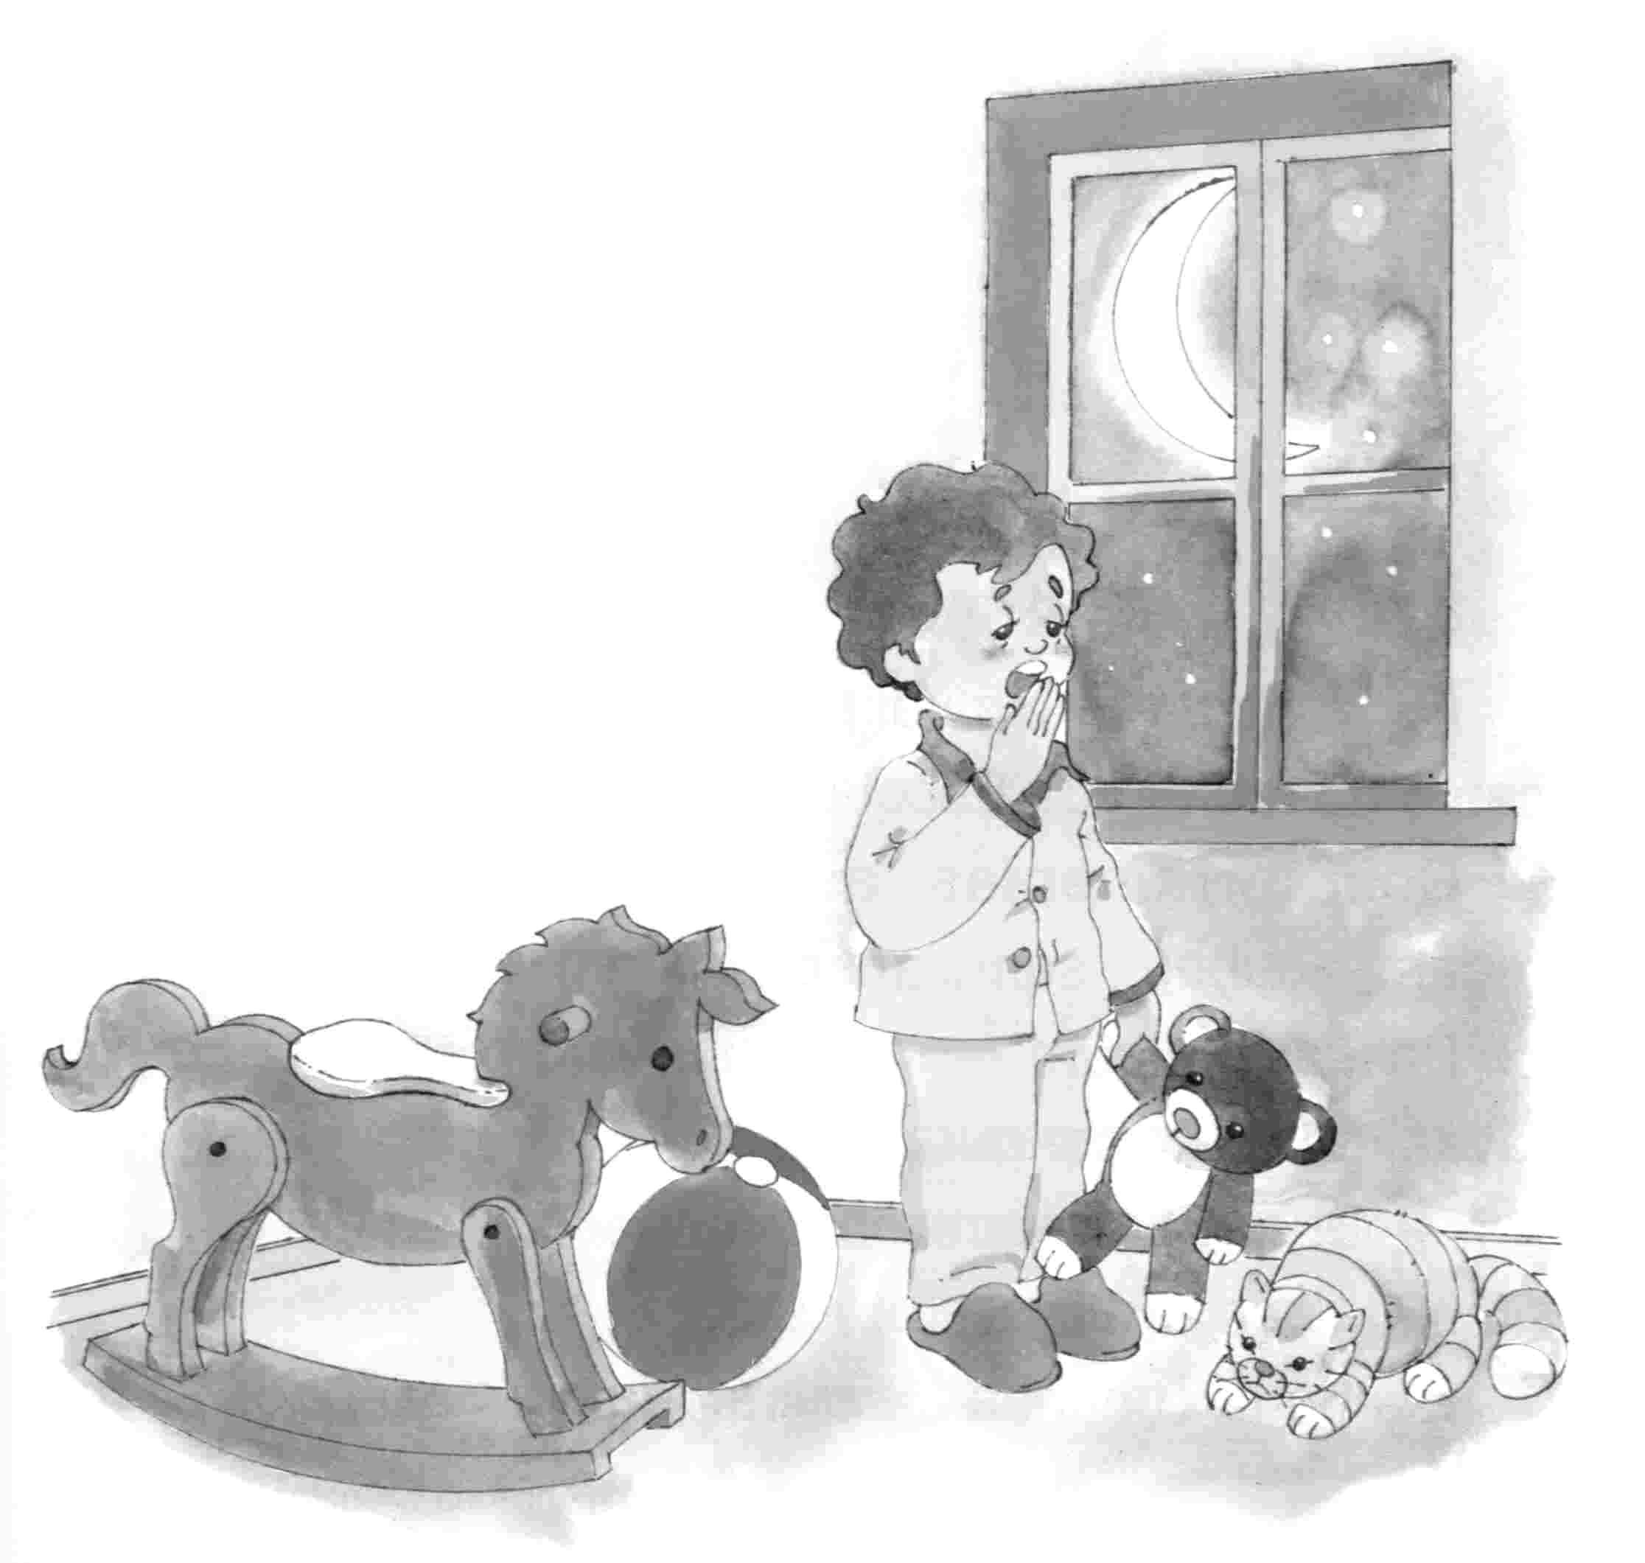

- A avó da Sofia vai à Sé. Ela leva uma saia nova.

Copia as frases anteriores e inventa mais duas frases.

____________________________________________________________________________________________________________________________________________________________________________________________________________________________________________________________________________________________________________________________________________________________________________________________________________________________________________________________________________________________________________

