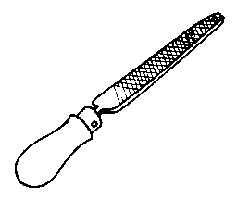 | 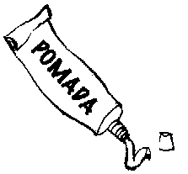 |  |   
      

      
      

      
      

      
      

