Língua Portuguesa
Nome:_______________________________________________
Data:________________________________________________

Lê e copia:
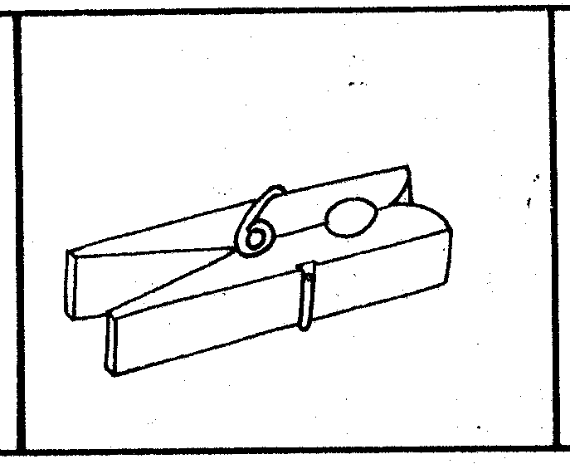
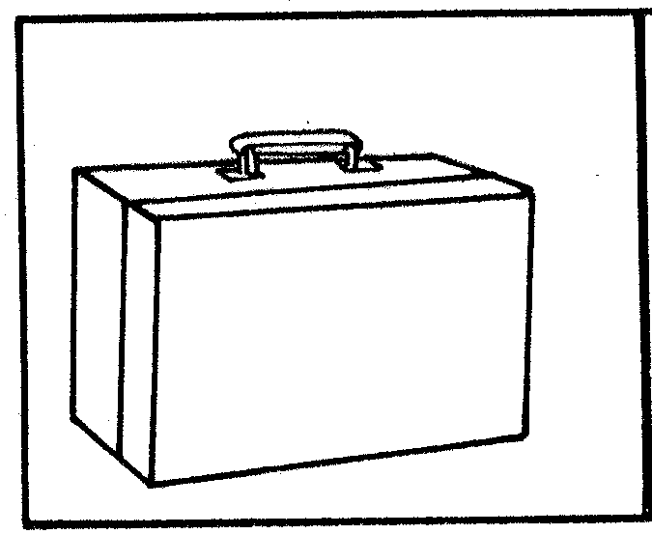
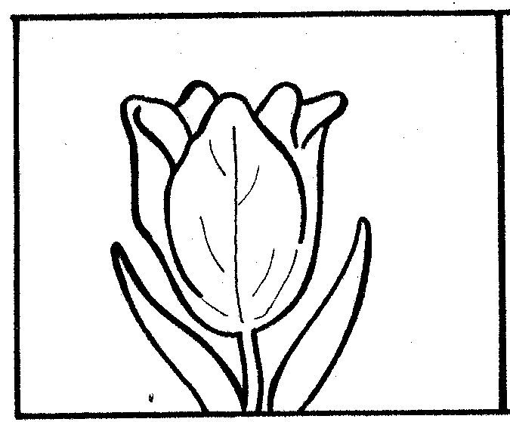

tulipa mola mala
______________ ______________ _____________
______________ ______________ _____________
______________ ______________ _____________
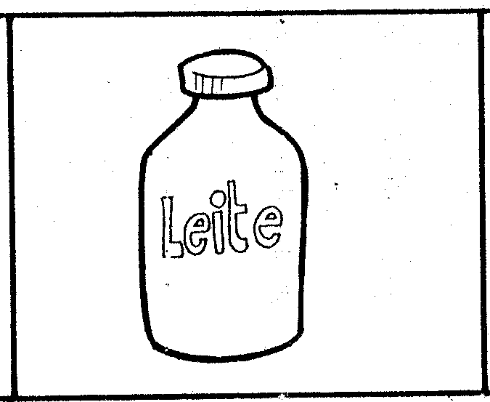

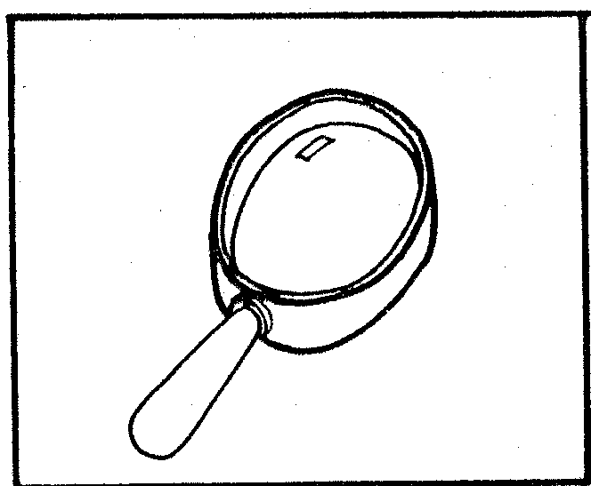
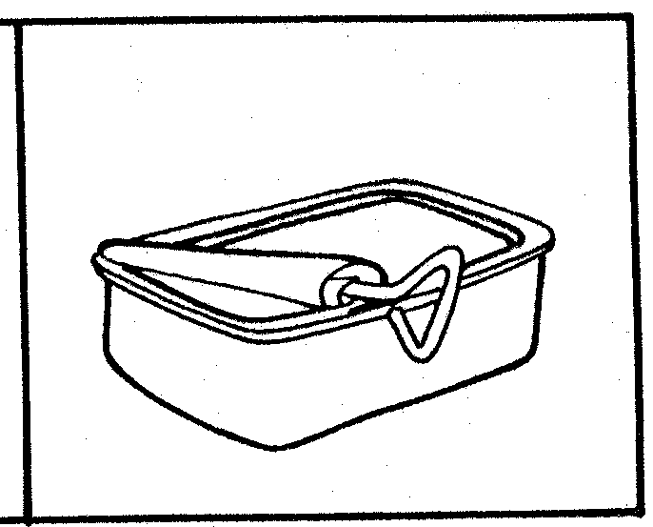

lata leite lupa
______________ ______________ _____________
______________ ______________ _____________
______________ ______________ _____________
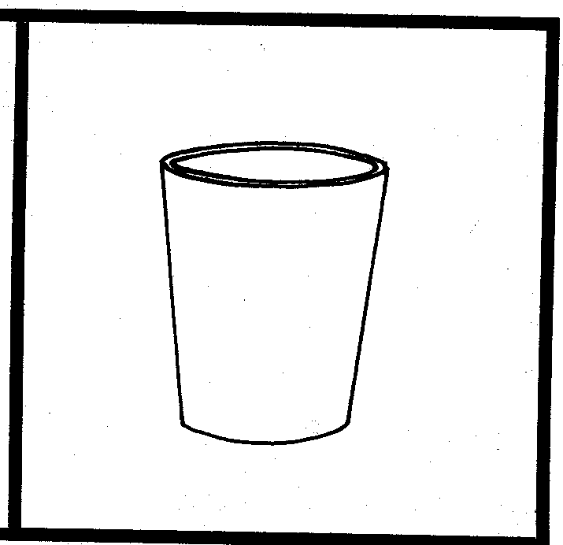
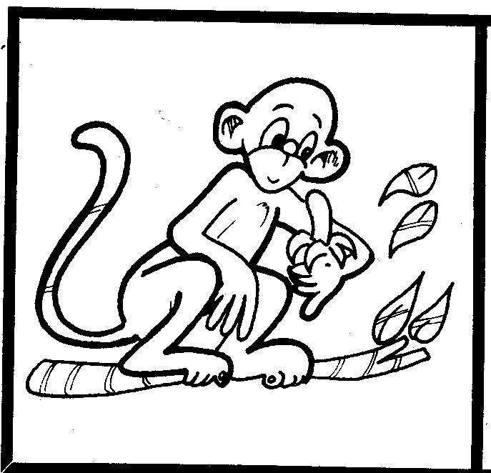
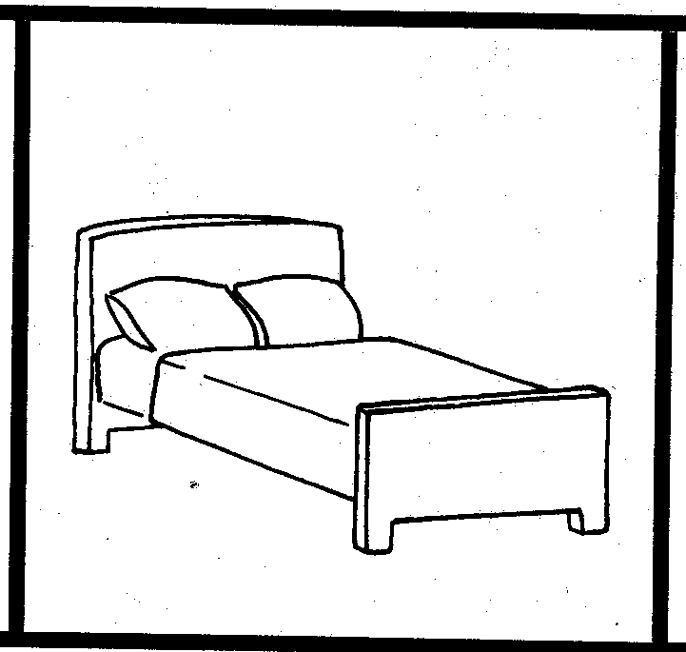

cama copo macaco
______________ ______________ _____________
______________ ______________ _____________
______________ ______________ _____________

Língua Portuguesa
Nome:_______________________________________________
Data:________________________________________________

Recorta as palavras e cola no lugar certo:

tulipa
mola
mala

lata
leite
lupa

cama
copo
macaco

tulipa
mola
mala

lata
leite
lupa

cama
copo
macaco

tulipa
mola
mala

lata
leite
lupa

cama
copo
macaco

higij

