1º Ano
Nome: __________________________________________
Data: ___________________________________________

1 – Pinta o p e completa os grafismos:
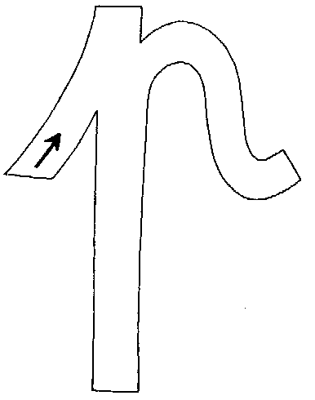 | ________________________________________________________  ________________________________________________________  ________________________________________________________
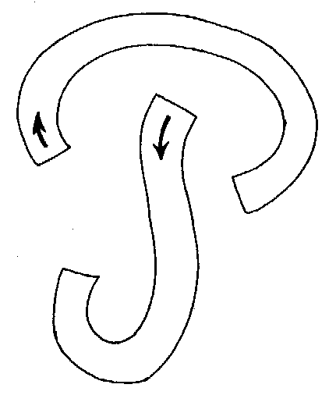 | ________________________________________________________  ________________________________________________________  ________________________________________________________

2 – Legenda as imagens e pinta-as.
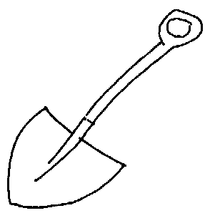 | 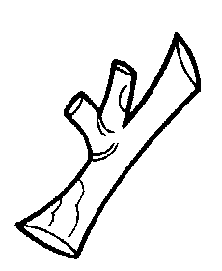 | 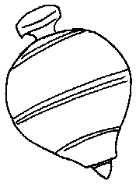 | 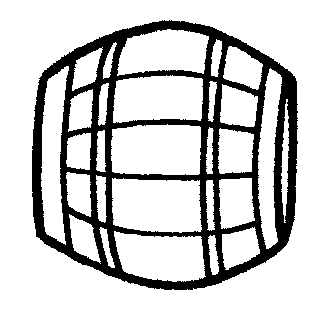
_____________ | ______________ | ______________ | ____________

3 – Pinta o t e o T e completa os grafismos:
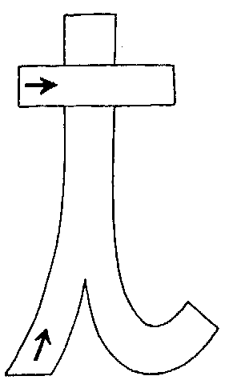 | ________________________________________________________  ________________________________________________________  ________________________________________________________
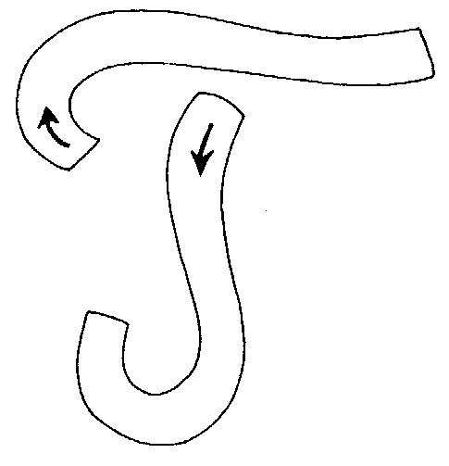 | ________________________________________________________  ________________________________________________________  ________________________________________________________

4 – Legenda as imagens e pinta-as.
 | 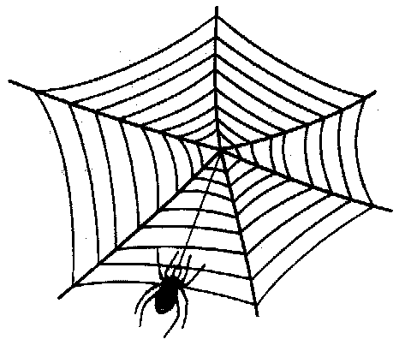 | 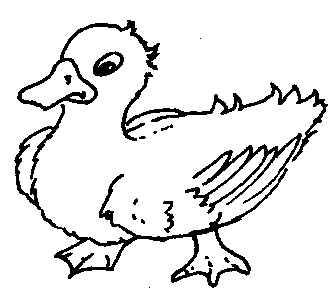 | 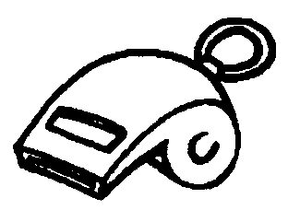
_____________ | ______________ | ______________ | ____________

5 - Pinta o l e o L e completa os grafismos:
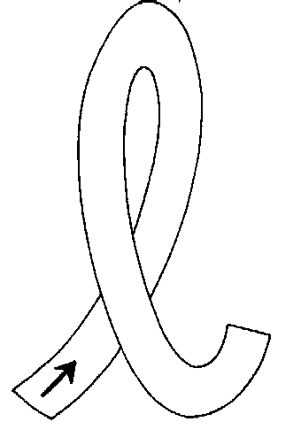 | ________________________________________________________  ________________________________________________________  ________________________________________________________
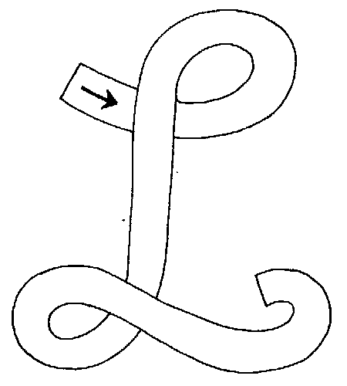 | ________________________________________________________  ________________________________________________________  ________________________________________________________

6 – Legenda as imagens e pinta-as.
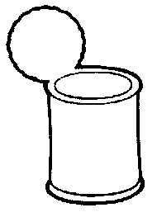 | 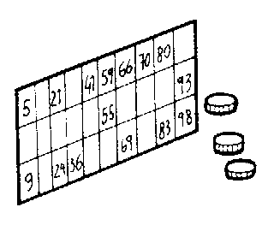 | 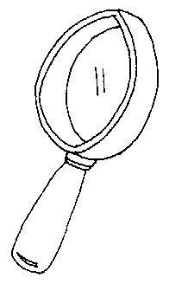 | 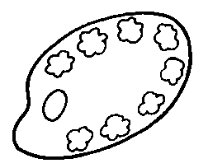
____________ | ______________ | _____________ | ____________

7 - Pinta o d e o D e completa os grafismos:
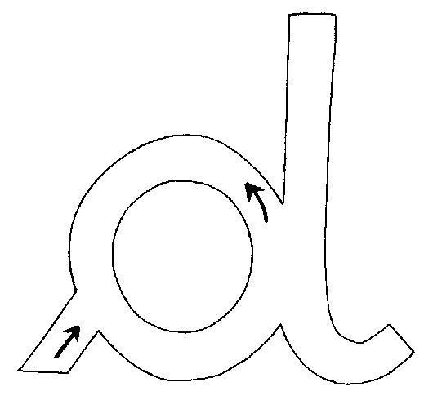 | ________________________________________________________  ________________________________________________________  ________________________________________________________
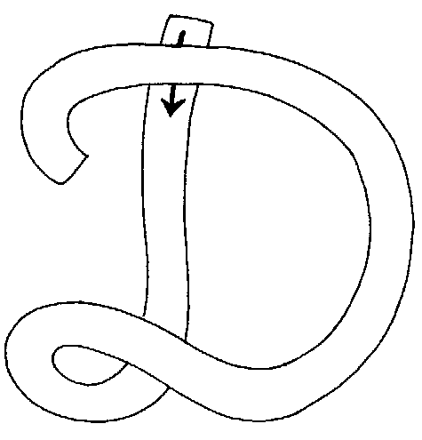 | ________________________________________________________  ________________________________________________________  ________________________________________________________

8 – legenda as imagens ou ilustra.
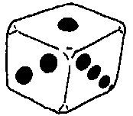 |  | 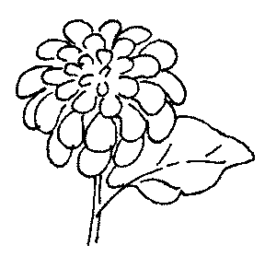
______________ | dedo | ______________ | ditado

9 – Pinta o c e completa os grafismos:
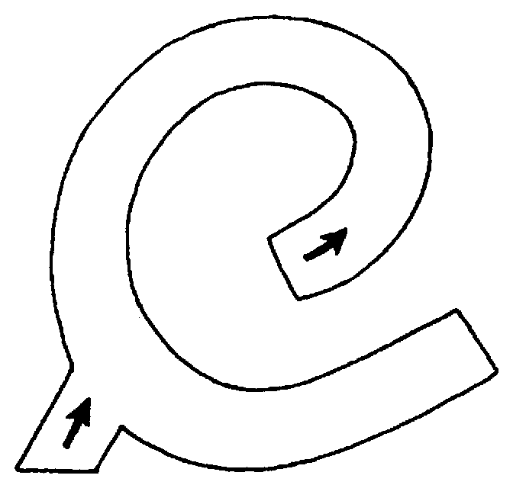 | ________________________________________________________  ________________________________________________________  ________________________________________________________

10 – Copia as frases e ilustra-as.

O dedo da Dalila dói.
____________________________________________
____________________________________________
É o copo da Dalila.
_____________________________________________
_____________________________________________
O capote é do pai da Dalila.
_____________________________________________
_____________________________________________
A capa de lã é da tia do Caio.
_____________________________________________
_____________________________________________

