EB1____________
Língua Portuguesa 1º Ano
Nome: ___________________________________ Data: _________________
1 – Escreve os nomes dos desenhos.
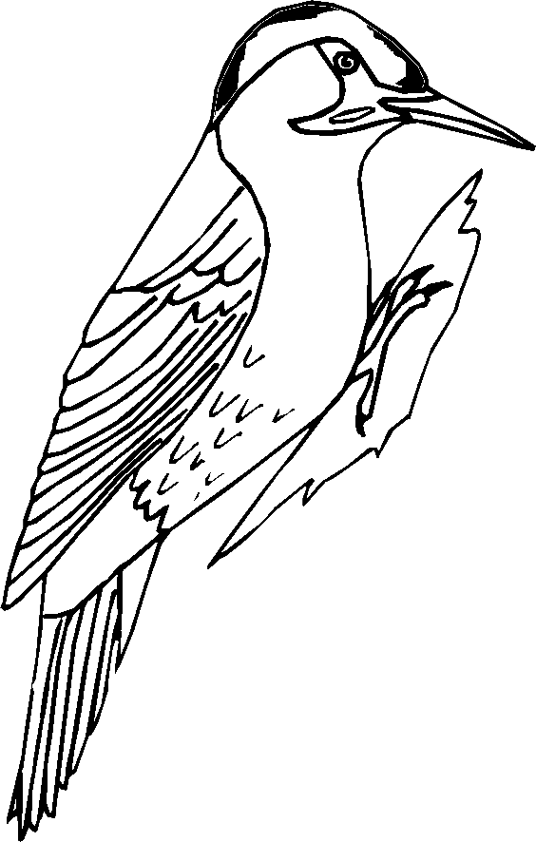

__________ __________ __________ ____________ __________

_________ __________ _________ ____________ ____________

_________ _________ ___________ ____________ __________

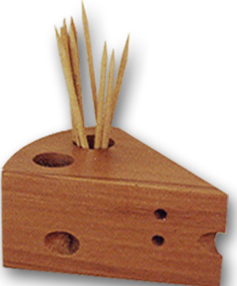

_________ ___________ __________ ____________ ___________

2 – Inventa frases utilizando algumas das palavras anteriores.
________________________________________________________________________________________________________________________________________________________________________________________________________________________________________________________________________________________________________________________________________________________________________________________________
________________________________________________________________
________________________________________________________________
Professora Beatriz Alves

