

Comunicar em língua inglesa

UFCD 6664 Realizar uma exposição sobre organizações internacionais

FORMADORA

Dra. Ana Rua



UFCD

6664

Realizar uma exposição sobre organizações internacionais

Carga horária 50 h

Resultados da Aprendizagem

* Consulta várias fontes de informação.
* Selecciona, organiza e sistematiza a informação recolhida.
* Identifica as instituições internacionais com maior relevância nas diferentes áreas de intervenção.
* Debate, em grupo, as opções de realização do trabalho.
* Apresenta em exposição, sob a forma de cartaz ou de outro suporte, uma instituição internacional.

Conteúdos

* Identificação de instituições internacionais organizadas de acordo com a natureza e âmbito de intervenção.
* Recolha de informação de carácter geral e de carácter selectivo.
* Tratamento da informação.
* Direitos de autor.
* Estruturação e produção de um documento informativo/divulgação/promoção.
* Organização da exposição:
* Reserva do espaço.
* Preparação do espaço.
* Divulgação e promoção do evento.
* Produção de convites.
* Acolhimento dos visitantes.
* Balanço final.

Leitura 1

How to organize your exhibition

When people go to an exhibition about an institution, they want to find credible and simple information about it. You must choose one of the following topics:

* Major environmental problems – air, water, *waste* and noise
* Pollution and public health
* Green technologies: cost and benefit
* New energy sources and their use
* Relation between consumption society and sustainable society
* Environmental preservation friendly behaviour
* *Protocolos e Convenções internacionais no domínio do ambiente e do desenvolvimento sustentável*

Here are some questions that might guide you in your search of information, during the preparation of your materials and even, after the exhibition, checking your visitors' apprehension of the information:

1. What’s the organization?
2. When was the institution created?
3. Who was/were the founder(s) of the institution?
4. Where did the movement start?
5. Where are the headquarters of the institution?
6. What does the institution do? (If possible try to find its mission statement and summarize it).
7. Does it have a worldwide presence? Where?
8. Do/does they/it have a special meaning? Explain.
9. What is/are the symbol(s) of the institution? Do you think its name and logo clearly demonstrate what its aim is?

Find where the organization works in Portugal, and write an email asking for information or documents in Portuguese and English to show to other students/people at the center.

Find a campaign in a video or in an outdoor advertisement and write a short text explaining its objective.

1. How is the campaign called?
2. What is its objective?
3. Who is it directed to?

4. Think about a way of presenting all the information gathered (in digital format - blog / PowerPoint / social networks / …; paper format – poster, leaflet, etc).

5. Now, you need some publicity. You may create leaflets or publicity posters.

If you decide to make leaflets, don’t forget they are informational.

The essential purpose of a publicity poster is the rapid telling of a single simple message using a limited number of elements. Posters are viewed more rapidly than other methods of advertisement. Their message must be strong, simple, and brief.

6. You should also think about a video. Using the information you already have, make a video about your institution.

The video can be either an informational video or a promotional video. If you want you can also use music.

7. You should create an invitation to invite others to view your presentation/work.

A personal touch can be added to your publicity by distributing invitations

*Don’t forget to include reference(s) for your source(s).*

Leitura 2

Fighting for a cause

Source: *Daily Telegraph*, June, 2007



*The Oscar-winning actress, Emma Thompson, yesterday accused Tesco of subjecting its South African fruit pickers to “appalling” pay and conditions.*

Thompson, an ambassador for the anti-poverty campaigners Action Aid, claimed women in the Western Cape were unable to feed their children on wages less than 50p an hour and called on the Government to take action against the supermarket.

Thompson, 48, who toured the Western Cape in February, said: “I have visited these farms and I was shocked at what I saw.”



She said 80 women worked from 7am to 6pm for the equivalent of just 38p.

Her comments came ahead of Tesco’s annual general meeting in London today at which one of the workers is expected to speak for the second year about her plight and that of her colleagues.

Jonathan Church, Tesco’s media director, said: “We have looked at the farm conditions and pay, gone over all the allegations made and not found any evidence to suggest there is a problem.”

1. Complete the table with the required information.

|  |  |
| --- | --- |
| Why? |  |
| Where? |  |
| When? |  |
| How? |  |
| What? |  |
| Who? |  |

1. Search on the internet for other famous people who are ambassadors for important international organizations.

Write about some of those ambassadors, their organizations, the type of work they do, places where they have been to and other information you find relevant. You can also illustrate your work with pictures of those ambassadors, the countries where they played a part, the people they helped.

Leitura 3

What is a NGO?

Source: http://www.ngo.bham.ac.uk/Definingfurther.htm



A

non-governmental organization (NGO) is any non-profit, voluntary citizens' group which is organized on a local, national or international level. Task-oriented and driven by people with a common interest, NGOs perform a variety of service and humanitarian functions, bring citizen concerns to Governments, advocate and monitor policies and encourage political participation through provision of information. Some are organized around specific issues, such as human rights, environment or health. They provide analysis and expertise, serve as early warning mechanisms and help monitor and implement international agreements. Their relationship with offices and agencies of the United Nations system differs depending on their goals, their fieldwork and the mandate of a particular institution.

NGOs are not self-serving in aims and related values. Their aim is to act in the public arena at large, on concerns and issues related to the well being of people, specific groups of people or society as a whole. They are not pursuing the commercial or professional interests of their members.

Though these common characteristics can help describe the notion of the term "NGO", it has to be said that their size can vary considerably. Some NGOs consist of a rather limited number of persons; others may have thousands of members and hundreds of professional staff. In functional terms NGOs can focus on operational and/or advocacy activities. Operational NGOs contribute to the delivery of services (such as in the field of welfare), whereas the primary aim of advocacy NGOs is to influence the policies of public authorities and public opinion in general.

1. Decide if the statements below are true or false:
2. NGOs work for the governments, helping them with humanitarian issues.
3. For the members of a NGO it is very important their own personal interest as well as the public interest.
4. Operational NGOs contribute with their services to the welfare of some underdeveloped areas of the world.
5. There are different types of NGOs depending on their goals, their different issues and their fieldwork.
6. Find words and expressions in the text which mean the same as the following:
7. Optional
8. Member of a city
9. Government management
10. Civil rights that concern the whole mankind
11. Research done outside the laboratory or place of work by scientist, archaeologists, social workers, etc.
12. Dimensions
13. Workers of a company or institution
14. Now watch the documentary [“El sueño de Bianca”](http://www.youtube.com/watch?v=3mN1bl2Dnc8) . Write a short text about this film. State your opinion.

Leitura 4



Seven out of 10 Brits admit to being selfish

Whether it's badmouthing friends to look better or avoiding charity collectors, it seems most of us put ourselves first.

Millions of adults shun work mates to make their own tea in the office, fail to give way to fellow motorists or cook what they want to eat regardless of what their partner would like, research shows.

In fact, seven out of ten people admit they are selfish and, incredibly, one in five will go as far as to say they commit three selfish acts every day.

One in six has never even considered giving up their time to do voluntary work, the study found. And their excuse? They apparently have hectic lifestyles or long working hours - or simply declare 'there's nothing in it for me'.

The study found six out of ten people have bad-mouthed a mate or colleague for their own gains, half have avoided charity collectors and two out of five do not bother contacting relatives. A third say they are selfish when it comes to choosing an evening meal. One in six have passed the buck to a colleague after a mistake at work and the same number have pushed into a queue. Not returning a borrowed item and avoiding rounds in the pub are also common.

Maybe there is hope; however, as three quarters of people recognize they could do more to put other's first.

The survey of 4,000 people was commissioned by Cadet150 to mark National Volunteers Week. A spokesman for the cadet forces movement, which celebrates its 150th anniversary this year, said: 'By helping others you often end up helping yourself too.

'Volunteers have the chance to try out exciting, adventurous activities, they make new friends, acquire new skills and can even pick up valuable vocational qualifications.'

*Source*: http://www.dailymail.co.uk/news/article-1283179/Seven-10-Brits-admit-selfish.html#ixzz0phmnhOJi

1. Connect the vocabulary with right definitions. If necessary, look them up in the text to guess from the context.

|  |  |
| --- | --- |
| 1. to bad-mouth somebody  2. selfishness  3. a queue  4. a survey  5. a volunteer  6. a colleague | a) a person who does a job without getting money  b) a study of people’s opinion, a questionnaire c) to say unpleasant thing about sb  d) a person that you work with  e) a line of people, cars, etc.  f) a characteristic of a person who thinks only about him or herself |

1. Choose the worst act of selfishness and explain your choice to your partner.
2. not contacting relatives
3. avoiding donating to charity
4. bad-mouthing your colleague to gain something
5. borrowing something and not returning it
6. forgetting a friend’s birthday
7. not helping your friends when they ask you to
8. pushing into queue
9. making a meal only for yourself
10. lying to avoid work

1. Now try to put those acts in order beginning with the less serious and finishing with the worst one. Compare with your partner, discuss your choices. Answer the questions.
2. Why are people selfish? Is it wrong? Are you selfish?
3. What acts of selfishness do you commit? What acts of selfishness do you experience from others?
4. Have you ever considered doing voluntary work? Why? /Why not?
5. Why should we help others?

Leitura 5

Green Volunteers

Source: www.godifferently.com/details.asp

*The world guide and information network to voluntary work in nature conservation.*

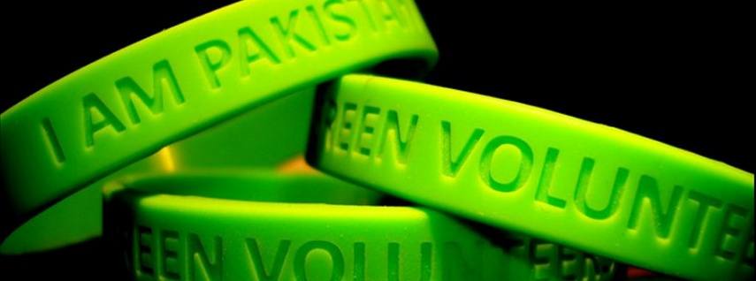

*Choose to spend an interesting vacation, a unique gap year, find research opportunities or contribute to a worthwhile initiative by volunteering in wildlife conservation.*

Green Volunteers is a guide listing hundreds of conservation and wildlife projects throughout the world where often no previous experience is required. Green Volunteers is also an information Network with continuous updates on new projects, access to an email newsletter on conservation volunteering and work opportunities and a forum for exchanging volunteering experiences. It also provides several links to humanitarian volunteering organizations working worldwide.

Both large and small conservation organizations offer volunteers the opportunity to get involved. Some larger organizations offer projects worldwide and may require financial contributions. Others may be smaller and more local and welcome volunteers at little or no financial cost. Green Volunteers puts an emphasis on listing these small organizations working worldwide.

Green Volunteers is recognized for its unique contribution in networking volunteers and nature conservation projects worldwide. From an internship at the World Conservation Union in Geneva to small local project in Bolivia or Greece, Green Volunteers gives you the information you need to get involved.

Green volunteers is one of the few organizations providing an information link between hundreds of small projects in the world, particularly in developing countries, and thousands of prospective volunteers. Green Volunteers has no membership: our only support comes from the sale of the guide. Your contribution, by purchasing the guide, will allow this important communication link to survive.

Get your copy and get involved: it’s fun, rewarding and a lifeline to endangered wildlife throughout the world!

1. Answer these questions on the text.
2. What is “Green Volunteers”? ____________________________________________________________________
3. What do these organizations require? ____________________________________________________________________
4. What is Green Volunteers recognized for? ____________________________________________________________________
5. Complete the sentences according to the information from the text.
6. Green Volunteers is an information ______________________________________ experiences.
7. To work as a Green Volunteer it’s not necessary ___________________________.
8. Some organizations may require ________________________________________.
9. Match the words on the left with their definitions on the right:

|  |  |
| --- | --- |
| 1. Updates | a) buying |
| 2. Worldwide | b) only |
| 3. Unique | c) all over the world |
| 4. Purchasing | d) adding new information or making corrections. |

1. What / who do the underlined words refer to?
2. Where _______________
3. It ___________________
4. Others _______________
5. Its ___________________

1. Complete the sentences with the verbs in brackets in the right tense:
2. If you joined a Green Project, you _______________ (help) wildlife conservation.
3. If she had free time, she _______________ (join) Green Volunteers.
4. If you read the guide attentively, you _________________ (be) well informed about the project.
5. Imagine that you are very interested in one of these organizations/projects. Write a formal letter to this organization asking for all the information about the way you can join a project

Leitura 6

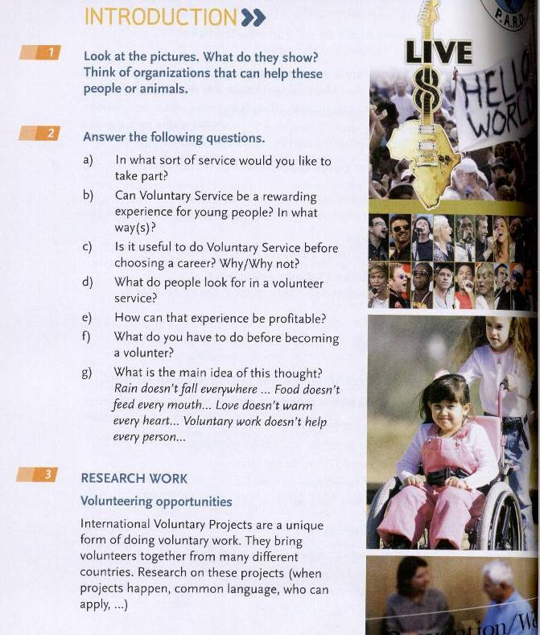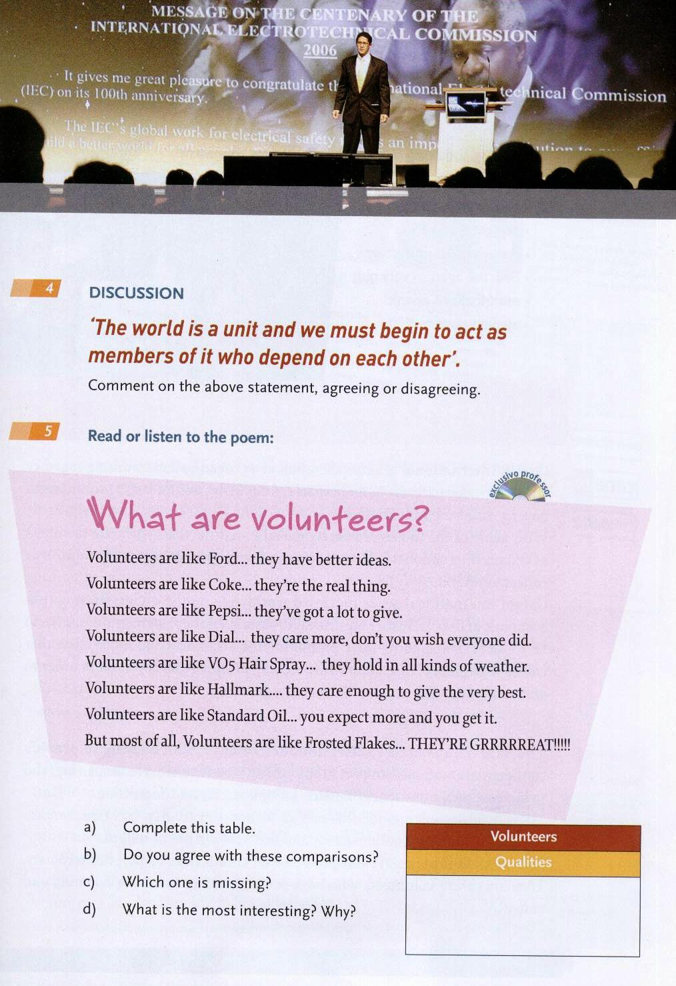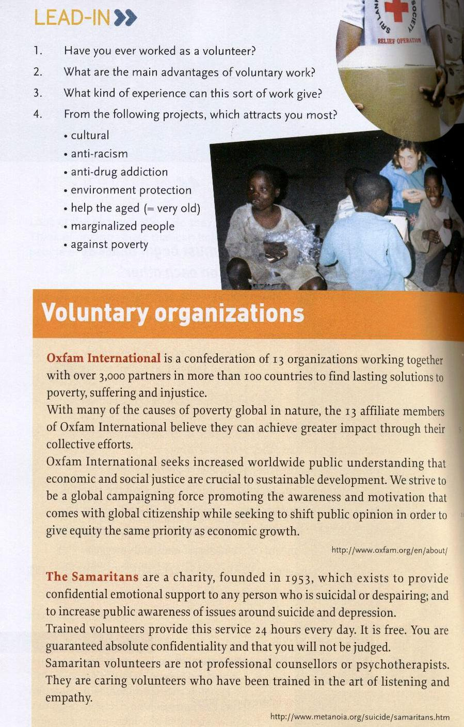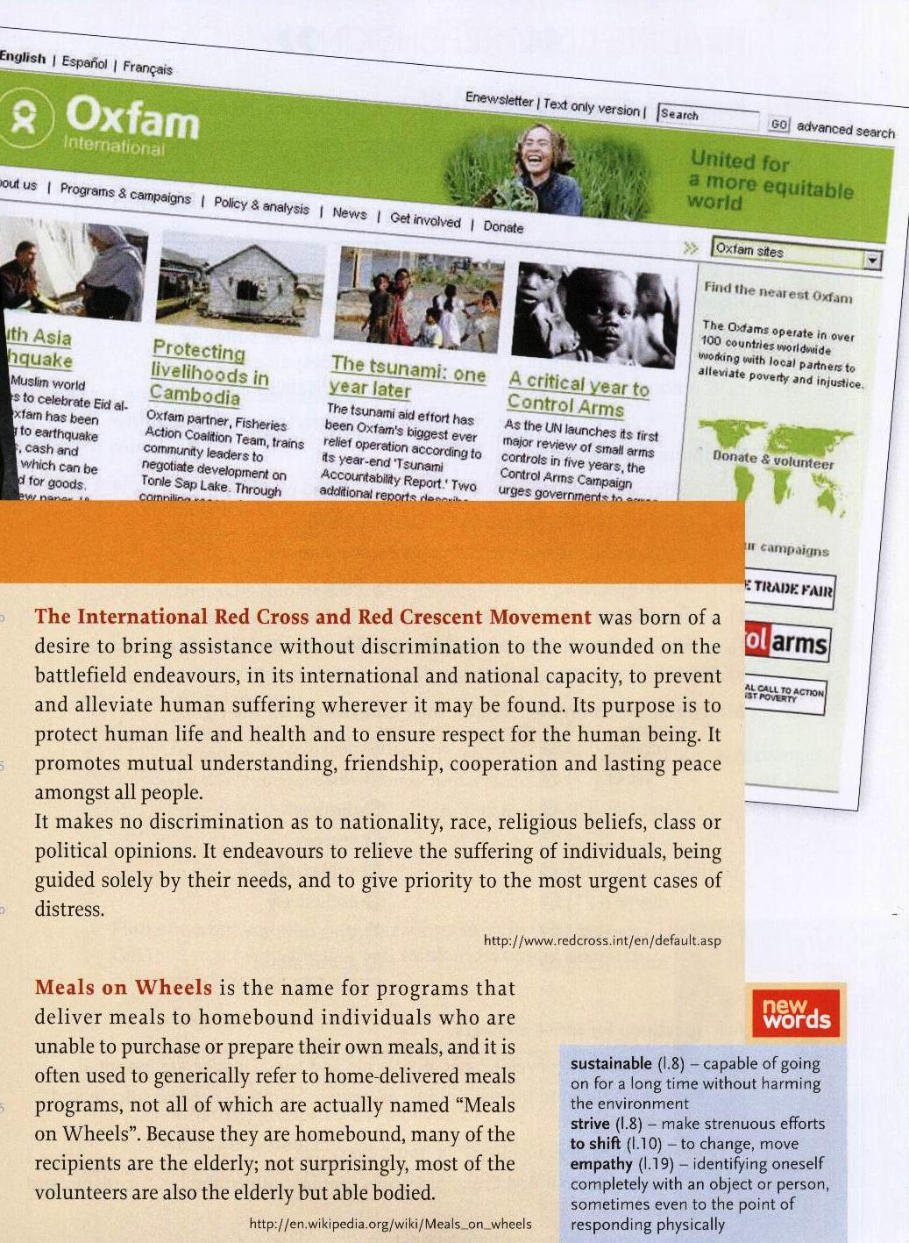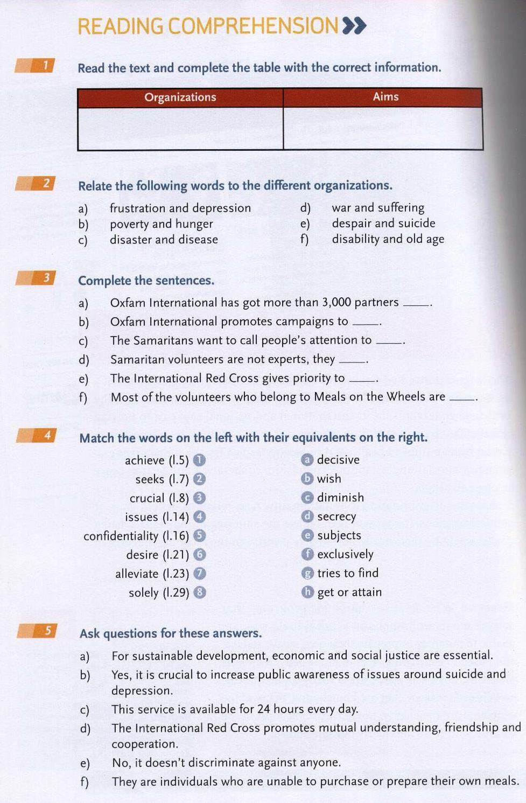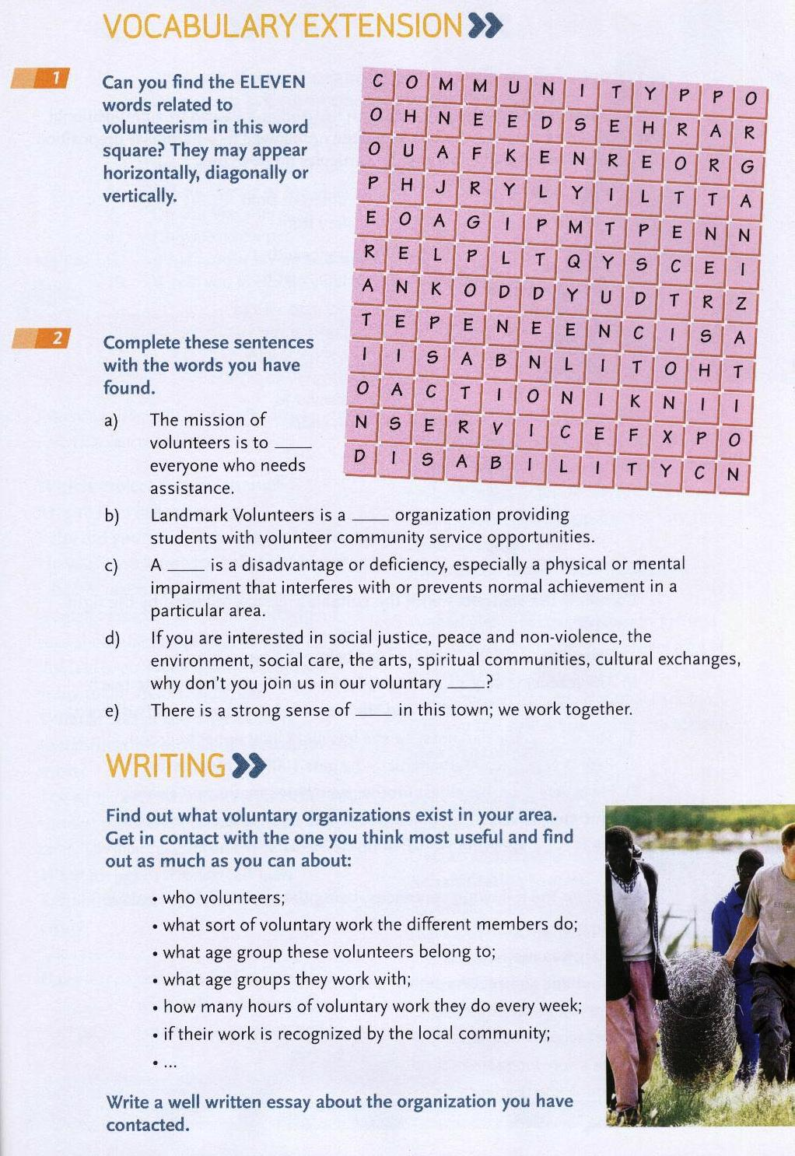

Leitura 7

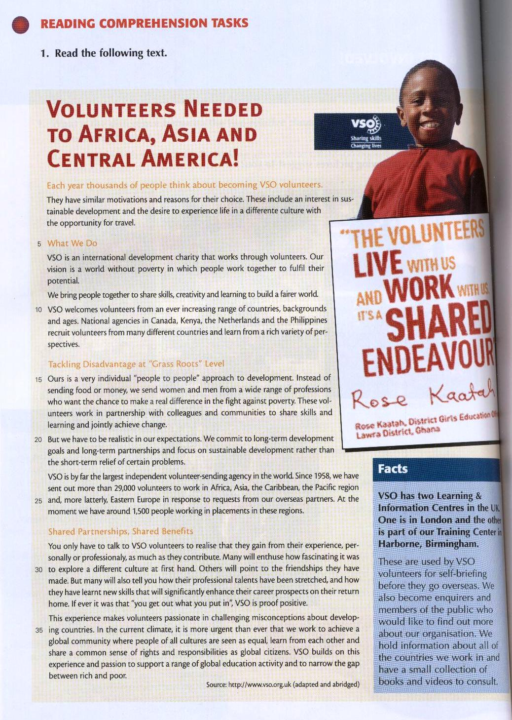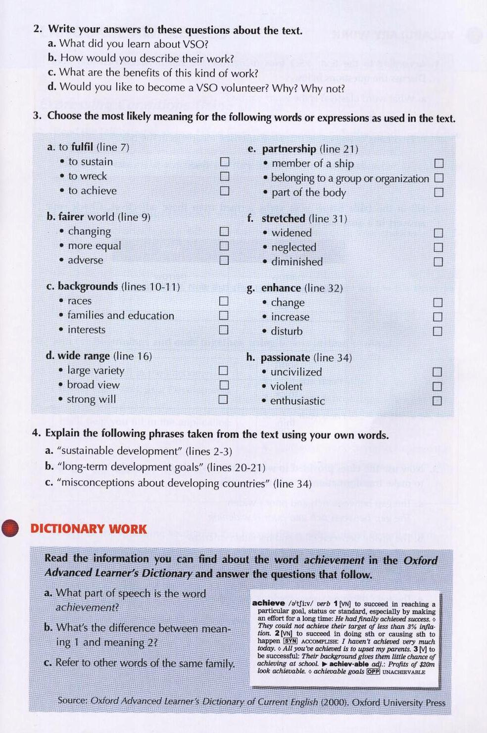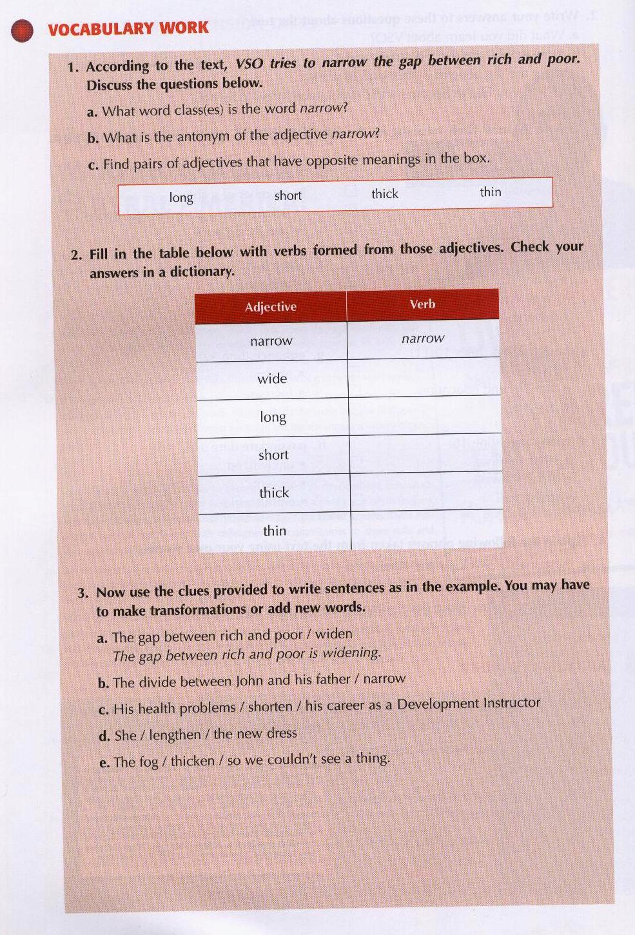

Leitura 8

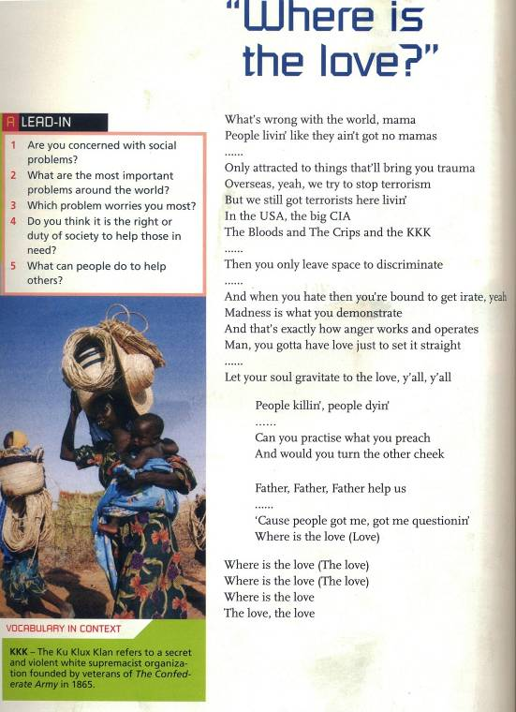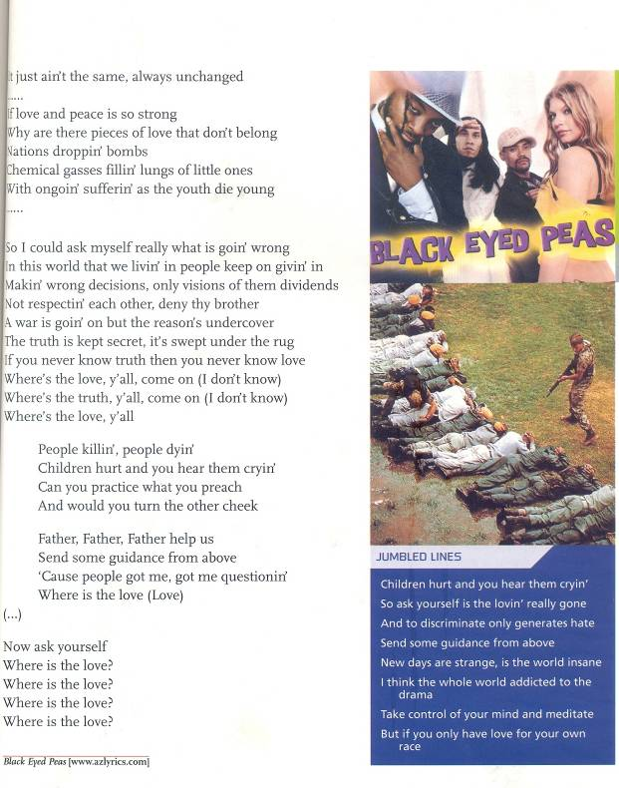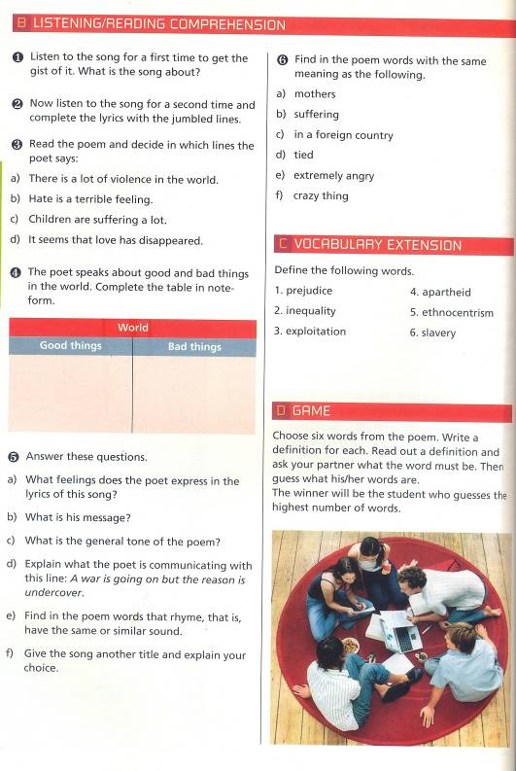

Leitura 9

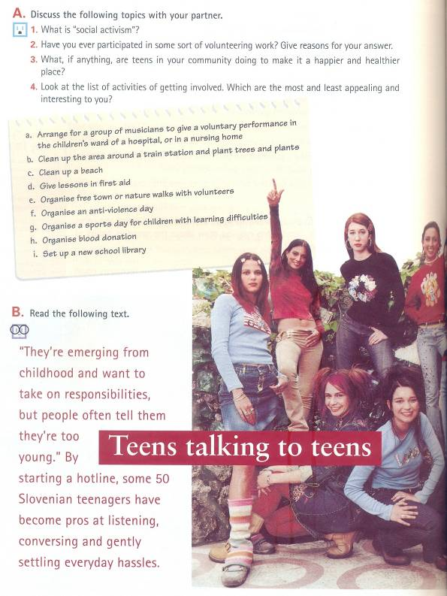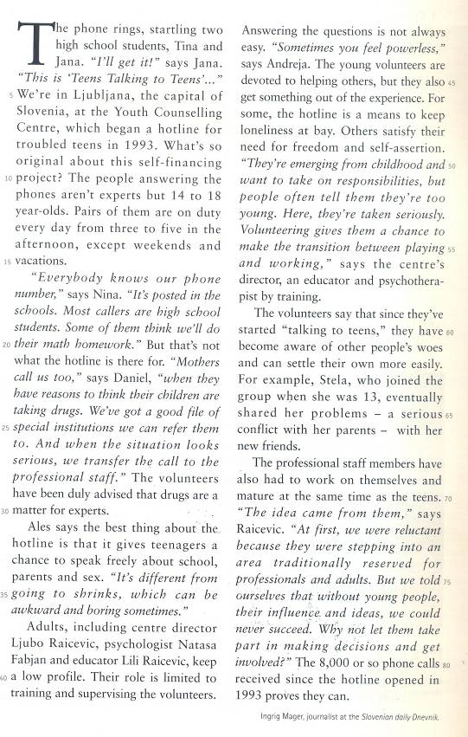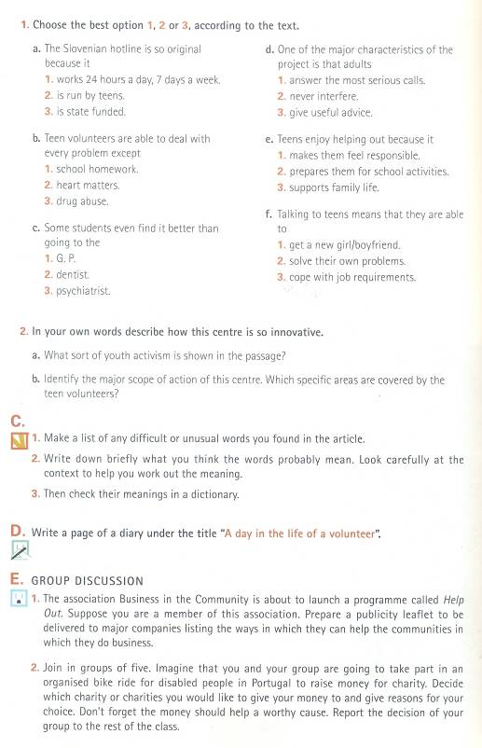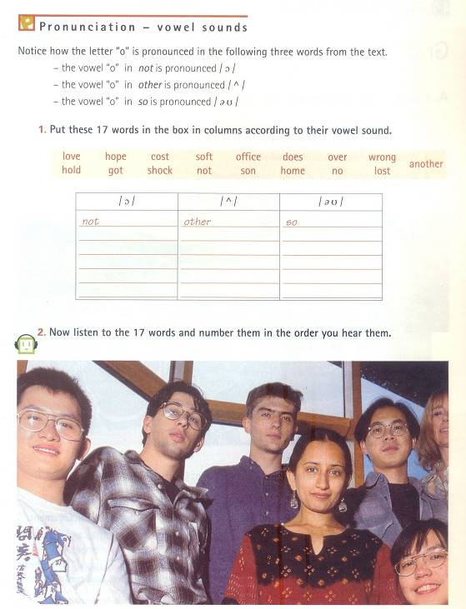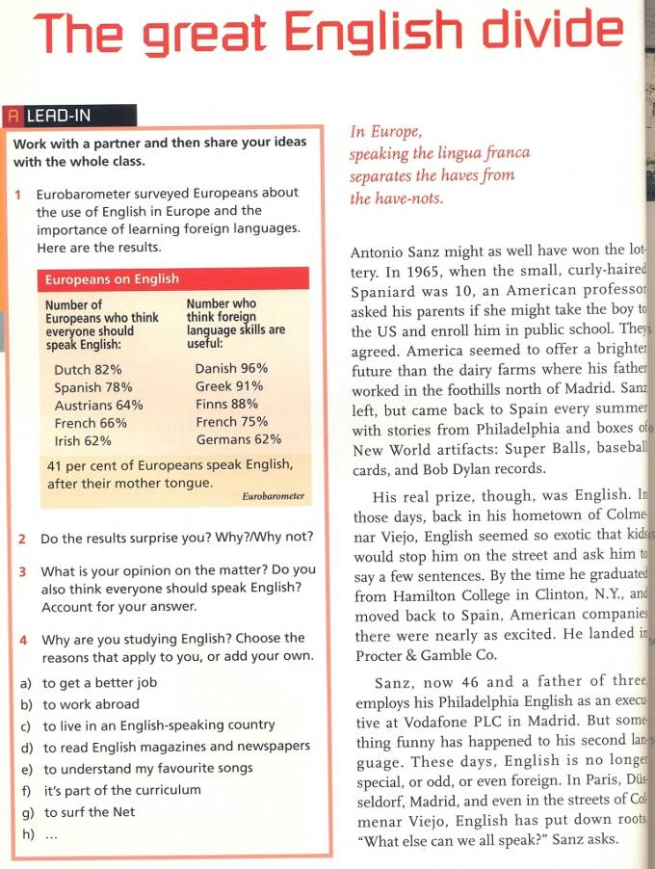

Leitura 10

Leitura 11

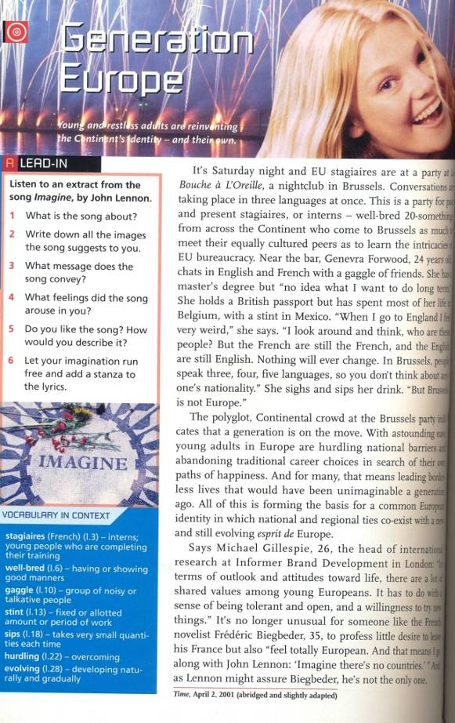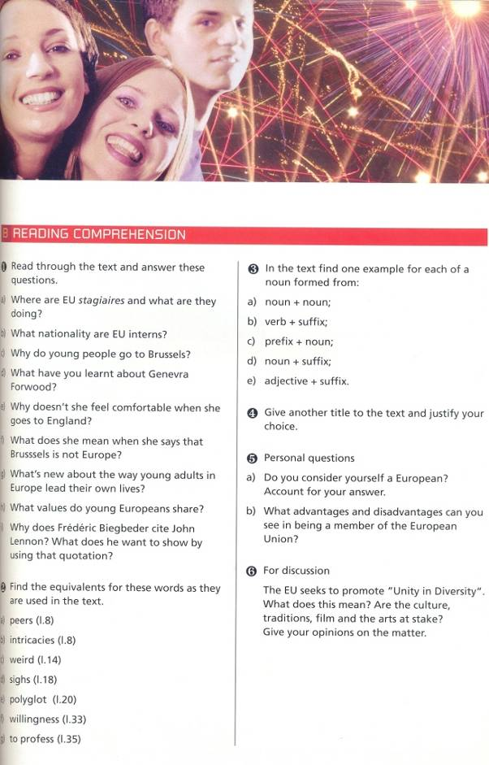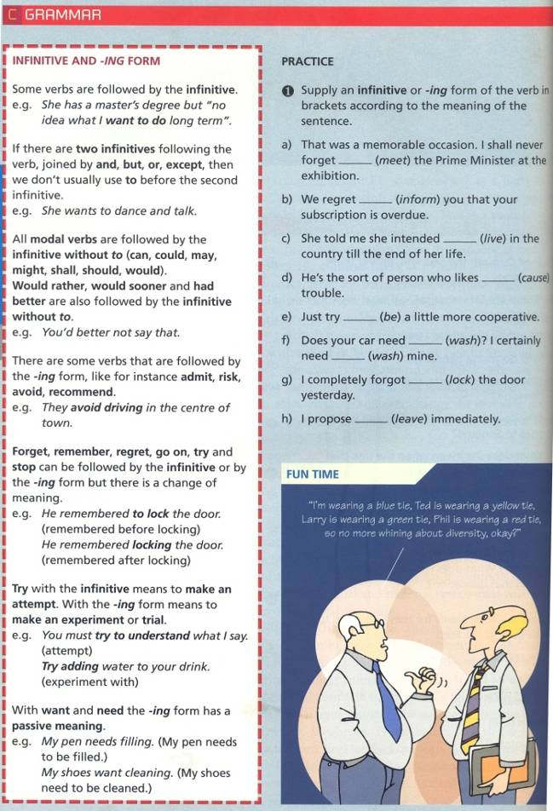

Leitura 12

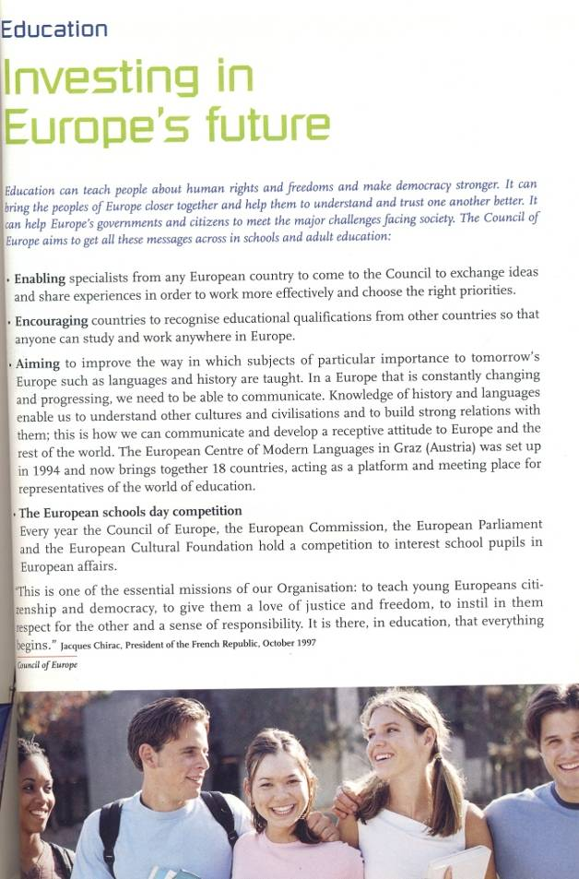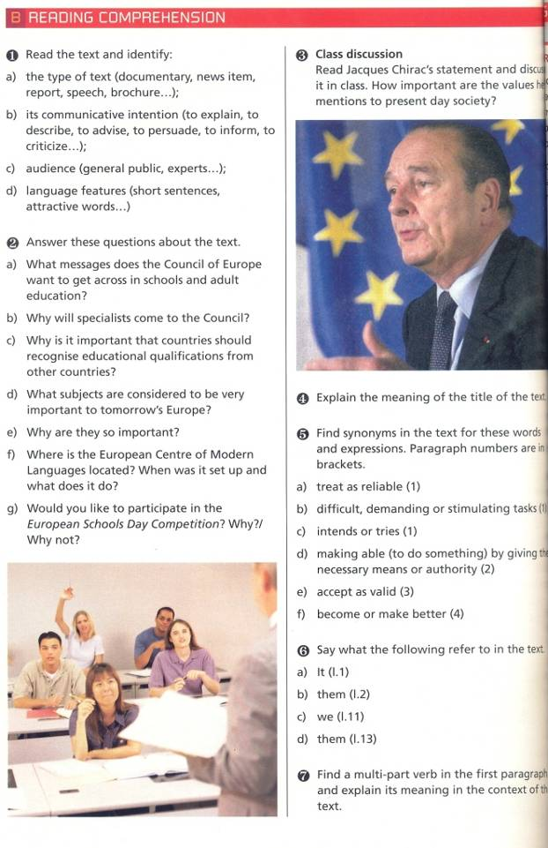

Leitura 13

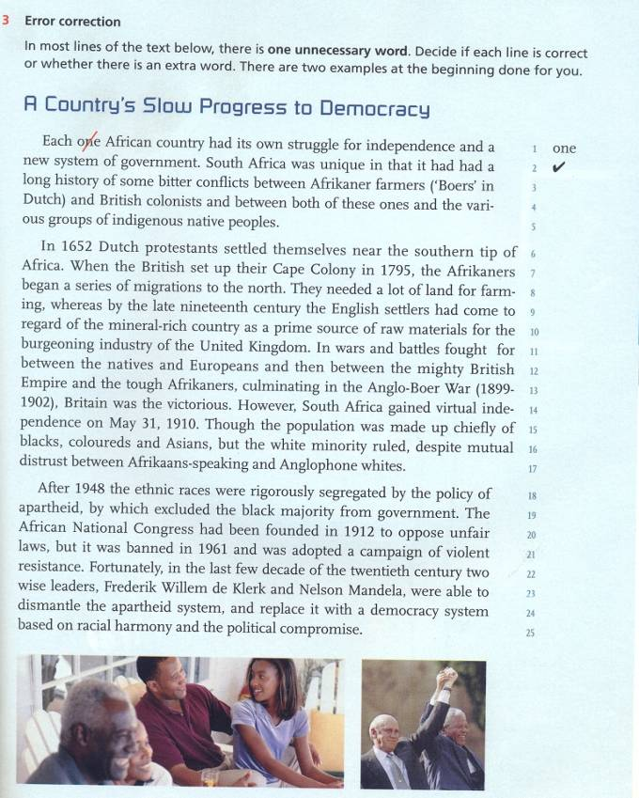

Leitura 12

Leitura 14

Formal letter

Rules for Writing Formal Letters in English

*Source: web*

1. In English there are a number of conventions that should be used when writing a formal or business letter. Furthermore, you try to write as simply and as clearly as possible, and not to make the letter longer than necessary. Remember not to use informal language like contractions.
2. Addresses:

1) Your Address

The return address should be written in the top right-hand corner of the letter.

2) The Address of the person you are writing to

The inside address should be written on the left, starting below your address.

1. Date:

Different people put the date on different sides of the page. You can write this on the right or the left on the line after the address you are writing to. Write the month as a word.

1. Salutation or greeting:

1) Dear Sir or Madam,

If you do not know the name of the person you are writing to, use this. It is always advisable to try to find out a name.

2) Dear Mr Jenkins,

If you know the name, use the title (Mr, Mrs, Miss or Ms, Dr, etc.) and the surname only. If you are writing to a woman and do not know if she uses Mrs or Miss, you can use Ms, which is for married and single women.

1. Ending a letter:

1) Yours faithfully

If you do not know the name of the person, end the letter this way.

2) Yours sincerely

If you know the name of the person, end the letter this way.

3) Your signature

Sign your name, then print it underneath the signature. If you think the person you are writing to might not know whether you are male of female, put you title in brackets after your name.

1. Content of a Formal Letter

First paragraph

The first paragraph should be short and state the purpose of the letter- to make an enquiry, complain, request something, etc.

The paragraph or paragraphs in the middle of the letter should contain the relevant information behind the writing of the letter. Most letters in English are not very long, so keep the information to the essentials and concentrate on organizing it in a clear and logical manner rather than expanding too much.

Last Paragraph

The last paragraph of a formal letter should state what action you expect the recipient to take- to refund, send you information, etc.

1. Abbreviations Used in Letter Writing

The following abbreviations are widely used in letters:

asap = as soon as possible

cc = carbon copy (when you send a copy of a letter to more than one person, you use this abbreviation to let them know)

enc. = enclosure (when you include other papers with your letter)

pp = per procurationem (A Latin phrase meaning that you are signing the letter on somebody else's behalf; if they are not there to sign it themselves, etc)

ps = postscript (when you want to add something after you've finished and signed it)

pto (informal) = please turn over (to make sure that the other person knows the letter continues on the other side of the page)

RSVP = please reply

1. Outline: A Covering Letter

A covering letter is the one that accompanies your CV when you are applying for a job. Here is a fairly conventional plan for the layout of the paragraphs.

Opening Paragraph

Briefly identify yourself and the position you are applying for. Add how you found out about the vacancy.

Paragraph 2

Give the reasons why you are interested in working for the company and why you wish to be considered for that particular post. State your relevant qualifications and experience, as well as your personal qualities that make you a suitable candidate.

Paragraph 3

Inform them that you have enclosed your current CV and add any further information that you think could help your case.

Closing Paragraph

Give your availability for interview, thank them for their consideration, restate your interest and close the letter.

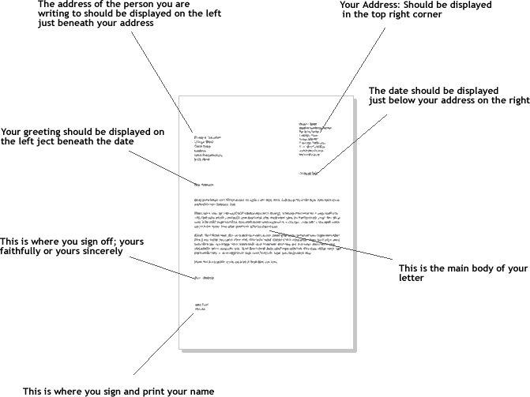

Leitura 15

Author’s rights

*Source: Wikipedia, the free encyclopedia*

1. Authors’ rights are a part of copyright law.

The term is a direct translation of the French term *droit d’auteur* (also German *Urheberrecht*), and is generally used in relation to the copyright laws of civil law countries and in European Union law.

Authors' rights are internationally protected by the Berne Convention for the Protection of Literary and Artistic Works and by other similar treaties.

“Author” is used in a very wide sense, and includes composers, artists, sculptors and even architects: in general, the author is the person whose creativity led to the protected work being created, although the exact definition varies from country to country.

Authors’ rights have two distinct components: the economic rights in the work and the moral rights of the author.

The economic rights are a property right which is limited in time and which may be transferred by the author to other people in the same way as any other property (although many countries require that the transfer must be in the form of a written contract). They are intended to allow the author or their holder to profit financially from his or her creation, and include the right to authorize the reproduction of the work in any form (Article 9, Berne Convention). The authors of dramatic works (plays, etc.) also have the right to authorize the public performance of their works (Article 11, Berne Convention).

The protection of the moral rights of an author is based on the view that a creative work is in some way an expression of the author’s personality: the moral rights are therefore personal to the author, and cannot be transferred to another person except by testament when the author dies. The moral rights regime differs greatly between countries, but typically includes the right to be identified as the author of the work and the right to object to any distortion or mutilation of the work which would be prejudicial to his or her honor or reputation (Article 6bis, Berne Convention). In many countries, the moral rights of an author are perpetual.

1. Distinction between common law copyright and civil law authors’ rights

It is common to draw a distinction in the treatment of authors and other interested parties between common law jurisdictions and civil law systems. Although there are certainly differences between national laws, the differences in effective protection should not be overstated. Both copyright and authors’ rights arose in the eighteenth century to address identical problems: the inequality in relations between authors and publishers (and between publishers themselves) if intellectual property is not recognized and protected, and the need to provide an income for authors other than patronage.

Both systems provide for a monopoly right granted to the author for a limited term which can be transferred to another person, which was initially the right to copy or otherwise reproduce the work (hence “copyright”) but has since been expanded to take account of technological developments.

It is an essential feature of authors’ rights and of many copyright laws that the object which is protected must arise from the creativity of the author rather than from his or her simple effort or investment (see Feist v. Rural in the United States): both French and German copyright laws protect “works of the mind” (*oeuvres de l'esprit* and *persönliche geistige Schöpfungen*, respectively). This has led civil law systems to adopt a strong link between the rights (at least initially) and the person of the author: the initial ownership rights by a corporation are severely restricted or even impossible (as in Germany). Common law jurisdictions are more willing to accept corporate ownership of copyright, as in the U. S. work for hire principle. Although the following comparison is simplistic and dependent on the exact laws of individual countries, it is difficult to see an effective (economic) difference in the two situations:

1. Use in European Union law

The term “authors’ rights” is used in European Union law to avoid ambiguity, in preference to the more usual translation of *droit* *d’auteur* etc. as “copyright”. The equivalent term in British and Irish law is “copyright (subsisting) in a literary, dramatic, musical or artistic work”; the term in Maltese and Cypriot law is similar, except that dramatic works are treated as a subset of literary works.

Leitura 16

Exhibition advertising examples

Source: web

